UNITED STATES
SECURITIES AND EXCHANGE COMMISSION
Washington, DC 20549
_____________

SCHEDULE 14A
_____________
(Rule 14a-101)
SCHEDULE 14A INFORMATION
Proxy Statement Pursuant to Section 14(a) of
the Securities Exchange Act of 1934
(Amendment No. 1)
Filed by the Registrant |  | ☑
Filed by a Party Other than the Registrant |  | o
Check the appropriate box:
o | Preliminary Proxy Statement
o | Confidential, for Use of the Commission Only (as permitted by Rule 14a-6(e)(2))
☑ | Definitive Proxy Statement
o | Definitive Additional Materials
o | Soliciting Material under §240.14a-12
MICROVAST HOLDINGS, INC.
(Name of Registrant as Specified in its Charter)
(Name of Person(s) Filing Proxy Statement, if other than the Registrant)
Payment of Filing Fee (Check all boxes that apply):
☑ | No fee required
o | Fee paid previously with preliminary materials
o | Fee computed on table in exhibit required by Item 25(b) per Exchange Act Rules 14a-6(i)(1) and 0-11

Explanatory Note

This Amendment No. 1 to Schedule 14A is being filed to amend the Definitive Proxy Statement filed by Microvast Holdings, Inc. (the “Company”) with the Securities and Exchange Commission on October 9, 2026 (the “Proxy Statement”) solely to file the sample proxy card. No changes have been made to the body of the Proxy Statement. The proxy card being mailed to the Company’s stockholders is in the form attached hereto.

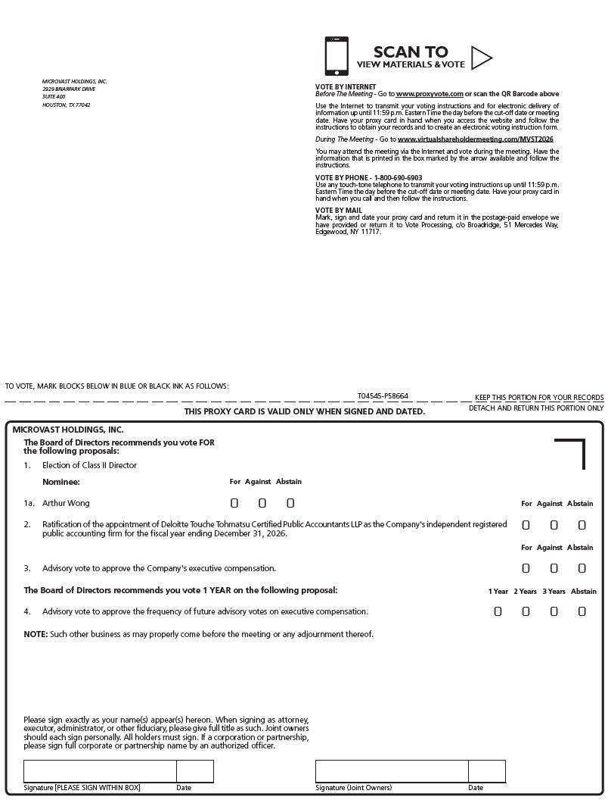
SCAN TO VIEW MATERIALS & VOTE MICROVAST HOLDINGS, INC. 2929 BRIARPARK DRIVE SUITE 400 HOUSTON, TX 77042 VOTE BY INTERNET Before The Meeting - Go to www.proxyvote.com or scan the QR Barcode above Use the Internet to transmit your voting instructions and for electronic delivery of information up until 11:59 p.m. Eastern Time the day before the cut-off date or meeting date. Have your proxy card in hand when you access the website and follow the instructions to obtain your records and to create an electronic voting instruction form. During The Meeting - Go to www.virtualshareholdermeeting.com/MVST2026 You may attend the meeting via the Internet and vote during the meeting. Have the information that is printed in the box marked by the arrow available and follow the instructions. VOTE BY PHONE - 1-800-690-6903 Use any touch-tone telephone to transmit your voting instructions up until 11:59 p.m. Eastern Time the day before the cut-off date or meeting date. Have your proxy card in hand when you call and then follow the instructions. VOTE BY MAIL Mark, sign and date your proxy card and return it in the postage-paid envelope we have provided or return it to Vote Processing, c/o Broadridge, 51 Mercedes Way, Edgewood, NY 11717. TO VOTE, MARK BLOCKS BELOW IN BLUE OR BLACK INK AS FOLLOWS: T04545-P58664 KEEP THIS PORTION FOR YOUR RECORDS THIS PROXY CARD IS VALID ONLY WHEN SIGNED AND DATED. DETACH AND RETURN THIS PORTION ONLY
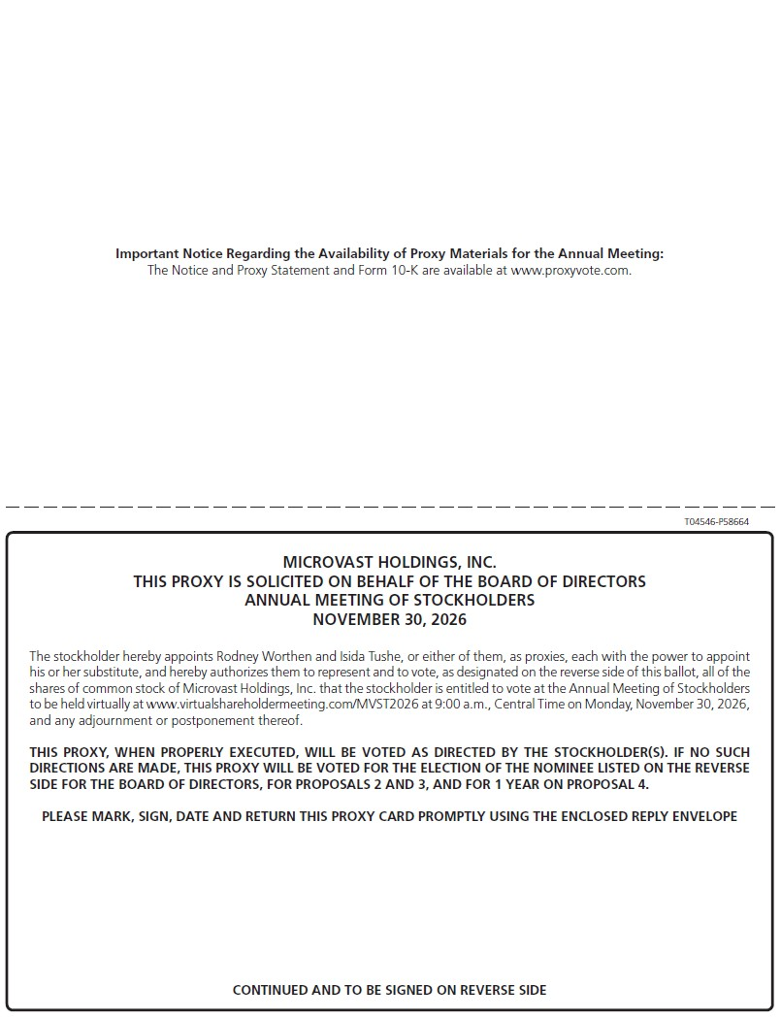
Important Notice Regarding the Availability of Proxy Materials for the Annual Meeting: The Notice and Proxy Statement and Form 10-K are available at www.proxyvote.com. T04546-P58664 MICROVAST HOLDINGS, INC. THIS PROXY IS SOLICITED ON BEHALF OF THE BOARD OF DIRECTORS ANNUAL MEETING OF STOCKHOLDERS NOVEMBER 30, 2026 The stockholder hereby appoints Rodney Worthen and Isida Tushe, or either of them, as proxies, each with the power to appoint his or her substitute, and hereby authorizes them to represent and to vote, as designated on the reverse side of this ballot, all of the shares of common stock of Microvast Holdings, Inc. that the stockholder is entitled to vote at the Annual Meeting of Stockholders to be held virtually at www.virtualshareholdermeeting.com/MVST2026 at 9:00 a.m., Central Time on Monday, November 30, 2026, and any adjournment or postponement thereof. THIS PROXY, WHEN PROPERLY EXECUTED, WILL BE VOTED AS DIRECTED BY THE STOCKHOLDER(S). IF NO SUCH DIRECTIONS ARE MADE, THIS PROXY WILL BE VOTED FOR THE ELECTION OF THE NOMINEE LISTED ON THE REVERSE SIDE FOR THE BOARD OF DIRECTORS, FOR PROPOSALS 2 AND 3, AND FOR 1 YEAR ON PROPOSAL 4. PLEASE MARK, SIGN, DATE AND RETURN THIS PROXY CARD PROMPTLY USING THE ENCLOSED REPLY ENVELOPE CONTINUED AND TO BE SIGNED ON REVERSE SIDE

