UNITED STATES
SECURITIES AND EXCHANGE COMMISSION
Washington, D.C. 20549
FORM 8-K
CURRENT REPORT
Pursuant to Section 13 or 15(d)
of the Securities Exchange Act of 1934
Date of Report (Date of earliest event reported): May 11, 2026
Microvast Holdings, Inc.
(Exact name of registrant as specified in its charter)
Delaware |  |  |  |  |  | 001-38826 |  |  |  |  |  | 83-2530757
(State or other jurisdiction  of incorporation) |  |  |  |  |  | (Commission File Number) |  |  |  |  |  | (IRS. Employer  Identification No.)
12603 Southwest Freeway, Suite 300
Stafford, Texas 77477
(Address of principal executive offices, including zip code)
281-491-9505
(Registrant’s telephone number, including area code)
Check the appropriate box below if the Form 8-K filing is intended to simultaneously satisfy the filing obligation of the registrant under any of the following provisions:
☐ |  |  | Written communications pursuant to Rule 425 under the Securities Act (17 CFR 230.425)
☐ |  |  | Soliciting material pursuant to Rule 14a-12 under the Exchange Act (17 CFR 240.14a-12)
☐ |  |  | Pre-commencement communications pursuant to Rule 14d-2(b) under the Exchange Act (17 CFR 240.14d-2(b))
☐ |  |  | Pre-commencement communications pursuant to Rule 13e-4(c) under the Exchange Act (17 CFR 240.13e-4(c))
Indicate by check mark whether the registrant is an emerging growth company as defined in Rule 405 of the Securities Act of 1933 (§230.405 of this chapter) or Rule 12b-2 of the Securities Exchange Act of 1934 (§240.12b-2 of this chapter).
Emerging growth company ☐
If an emerging growth company, indicate by check mark if the registrant has elected not to use the extended transition period for complying with any new or revised financial accounting standards provided pursuant to Section 13(a) of the Exchange Act. ☐
Securities registered pursuant to Section 12(b) of the Act:
Title of each class |  |  |  |  |  | Trading Symbol(s) |  |  |  |  |  | Name of each exchange on which registered
Common stock, par value $0.0001 per share |  |  |  |  |  | MVST |  |  |  |  |  | The NASDAQ Stock Market LLC
Redeemable warrants, exercisable for shares of common stock at an exercise price of $11.50 per share |  |  |  |  |  | MVSTW |  |  |  |  |  | The NASDAQ Stock Market LLC

Item 2.02 Results of Operations and Financial Condition.
On May 11, 2026, Microvast Holdings, Inc. (the “Company”) issued a press release announcing its unaudited condensed consolidated financial results for the period ended March 31, 2026. In addition, the Company posted an accompanying slideshow presentation to its website summarizing its results for the same period. The full text of the press release is furnished as Exhibit 99.1 and the slideshow presentation is furnished as Exhibit 99.2 to this Current Report on Form 8-K. Exhibits 99.1 and 99.2 are hereby incorporated into this Item 2.02 by reference.
The information furnished in this Current Report on Form 8-K and Exhibits 99.1 and 99.2 attached hereto shall not be deemed to be “filed” for purposes of Section 18 of the Securities Exchange Act of 1934, as amended (the “Exchange Act”), or otherwise subject to the liabilities of that section, nor shall it be deemed incorporated by reference into any filing under the Securities Act of 1933, as amended, or the Exchange Act, except as expressly set forth by specific reference in such a filing.

1

SIGNATURES
Pursuant to the requirements of the Securities Exchange Act of 1934, the registrant has duly caused this report to be signed on its behalf by the undersigned hereunto duly authorized.
Date: May 11, 2026 |  |  | MICROVAST HOLDINGS, INC.
 |  |  | By: |  |  | /s/ Rodney Worthen
 |  |  | Name: |  |  | Rodney Worthen
 |  |  | Title: |  |  | Chief Financial Officer

Item 9.01 Financial Statements and Exhibits.
(d)Exhibits
Exhibit No. |  |  |  |  |  | Description
99.1 |  |  |  |  |  | Press Release (Q1 2026) dated May 11, 2026
99.2 |  |  |  |  |  | Presentation (Q1 2026) dated May 11, 2026

2
Exhibit 99.1
Microvast Reports First Quarter 2026 Financial Results

STAFFORD, Texas, USA — Microvast Holdings, Inc. (NASDAQ:MVST) (“Microvast” or the “Company”), a global leader in advanced battery technologies, announced today its unaudited consolidated financial results for the first quarter ended March 31, 2026 (“Q1 2026”).

"Our first quarter results reflect a period of strategic agility as we navigate evolving geopolitical dynamics and a shifting global landscape. While revenue of $60.6 million was impacted by delivery timing and regional headwinds in APAC, our resilient gross margin of 31.6% underscores the value of our technology and our ability to maintain strong positioning. We are entering a pivotal phase for Microvast with the launch of our 290Ah cell-based battery packs that we expect to integrate into the KAF electric powertrain solution and the ongoing ramp-up of our Huzhou Phase 3.2 expansion. By focusing on high-barrier segments and optimizing our production cycles, we remain committed to protecting our margins and accelerating our path to consistent profitability to drive long-term value for our stockholders," said Yang Wu, Microvast’s Founder, Chairman, and Chief Executive Officer.

Q1 2026 Results

•Revenue of $60.6 million, compared to $116.5 million in Q1 2025, a decrease of 48.0%. This decrease was primarily a result of evolving regulatory and geopolitical dynamics, including in the Indian and Korean markets, demand shift towards lower-cost products in India, and OEM platform ramp-up delays.

•Gross margin decreased to 31.6% from 36.9% in Q1 2025. Non-GAAP adjusted gross margin decreased to 31.7% from 37.0% in Q1 2025, primarily due to lower production utilization, which reduced fixed cost absorption.

•Operating expenses decreased to $27.1 million, compared to $29.2 million in Q1 2025. Non-GAAP adjusted operating expenses were $26.1 million, compared to $28.5 million in Q1 2025.

•Net profit of $48.2 million, compared to net profit of $61.8 million in Q1 2025. Non-GAAP adjusted net loss was $14.6 million, compared to non-GAAP adjusted net profit of $19.3 million in Q1 2025.

•Net profit per share of $0.15, compared to net profit per share of $0.19 in Q1 2025. Non-GAAP adjusted net loss per share was $0.04, compared to non-GAAP adjusted net profit per share of $0.06 in Q1 2025.

•Non-GAAP adjusted EBITDA of negative $5.5 million in Q1 2026, compared to non-GAAP adjusted EBITDA of $28.5 million in Q1 2025.

•Capital expenditures of $4.2 million, compared to $6.6 million in Q1 2025.

•Cash, cash equivalents and restricted cash of $174.0 million as of March 31, 2026, compared to $169.2 million as of December 31, 2025, and $123.0 million as of March 31, 2025.

Please refer to the tables at the end of this press release for reconciliations of gross profit to non-GAAP adjusted gross profit, operating expenses to non-GAAP adjusted operating expenses, net profit to non-GAAP adjusted net profit/(loss), net profit per share to non-GAAP adjusted net profit/(loss) per share, net profit to non-GAAP adjusted EBITDA and gross margin to non-GAAP adjusted gross margin.

2026 Outlook & Forward-Looking Information

•While we continue to navigate evolving tariff structures and shifting geopolitical dynamics, we anticipate a recovery in delivery schedules and a steady revenue ramp through the remainder of 2026 as our production timelines align with accelerating customer demand and next generation production.

•We are targeting and committed to maintaining a resilient gross margin profile by balancing sustained operational efficiencies and premium product positioning against the planned absorption of costs related to our Phase 3.2 expansion and ongoing volatility in global raw material prices.

•Our primary operational catalyst remains the achievement of serial production at the Huzhou Phase 3.2 expansion in 2026. This expansion is expected to bring online up to 2 GWh of modular capacity, specifically designed to meet the requirements of our next-generation cell technologies.

•We remain on track to establish localized pack assembly operations at our Clarksville facility and anticipate first assemblies by year-end. This localization is a key component of our domestic strategy to provide North American commercial vehicle and transit customers with locally integrated battery solutions.

•We continue to seek new customer pipelines that span across EMEA, North America, and APAC. Our focus remains on the heavy industrial and transit markets, where we believe our vertical integration and the newly launched KAF electric powertrain will be able to provide a clear and defensible competitive advantage.

Webcast Information

Company management will host a conference call and webcast on May 11, 2026, at 4:00 p.m. Central Time, to discuss the Company's financial results. The live webcast and accompanying slide presentation will be accessible from the Events & Presentations section of Microvast’s investor relations website (https://ir.microvast.com/events-presentations/events). A replay will be available following the conclusion of the event.

About Microvast

Microvast is a global leader in providing battery technologies for electric vehicles and energy storage solutions. With a legacy of nearly 20 years, Microvast has consistently delivered cutting-edge battery systems that empower a cleaner and more sustainable future. The Company's innovative approach and dedication to excellence have positioned it as a trusted partner for customers around the world. Founded in 2006 in Stafford, Texas, Microvast holds more than 890 patents that enable solutions for today’s electrification needs.

For more information, please visit www.microvast.com or follow us on LinkedIn (@microvast).

Contact:

Investor Relations
ir@microvast.com
2

Cautionary Statement Regarding Forward-Looking Statements

This communication contains “forward-looking statements” within the meaning of the Private Securities Litigation Reform Act of 1995. Forward-looking statements are based on assumptions with respect to the future and management's current expectations, involve certain risks and uncertainties and are not guarantees. These forward-looking statements include, but are not limited to, statements about our future results of operations and financial position, our operational performance, our anticipated growth and business strategy, anticipated development, commercialization, and market adoption of Microvast's KAF™ ("Kids Are Future") integrated electric powertrain solution, our future capital expenditures and debt service obligations, the projected costs, prospects and plans and objectives of management for future operations, including regarding expected growth and demand for our products and introduction of new products, the adoption of such offerings by customers, our expectations relating to backlog, pipeline and contracted backlog, current expectations relating to legal proceedings and impacts and benefits from the Inflation Reduction Act of 2022 as well as any other proposed or recently enacted legislation. In some cases, you may also identify forward-looking statements by words such as “anticipate,” “believe,” “can,” “continue,” “could,” “estimate,” “expect,” “intend,” “may,” “might,” “objective,” “plan,” “project,” “predict,” “outlook” “should,” “will,” “would,” or the negative of these terms, or other comparable terminology intended to identify statements about the future. Such forward-looking statements are based upon the current beliefs and expectations of management and are inherently subject to significant business, economic and competitive uncertainties and contingencies, many of which are difficult to predict and generally beyond our control. Actual results and the timing of events may differ materially from the results anticipated in these forward-looking statements. We do not assume any obligation to update any forward-looking statements.

Many factors could cause actual results and the timing of events to differ materially from the anticipated results or other expectations expressed in the forward-looking statements, including, among others: (1) our ability to remain a going concern; (2) risk that we may not be able to accurately project and manage our growth and effectively execute our growth strategies or achieve profitability; (3) risk that we may be unable to meet our future capital requirements and we may require additional capital to support our business growth, and this capital might not be available on acceptable terms, or at all; (4) potential difficulties in maintaining manufacturing capacity and establishing expected mass manufacturing capacity in the future; (5) risks relating to issues or delays, disruptions and quality control problems in our manufacturing operations; (6) risks relating to being unable to control our manufacturing costs; (7) risks that we may be unable to meet our projected construction timelines, costs and production ramps, or we may experience difficulties in generating and maintaining demand for products manufactured there and related services; (8) restrictions in our existing and any future credit facilities; (9) risks of operations in China; (10) the effects of mechanics liens filed by contractors that we do not have sufficient funds to pay; (11) the effects of existing and future litigation; (12) changes in general economic conditions, including increases in interest rates and associated Federal Reserve policies, a potential economic recession, and the impact of inflation on our business; (13) changes in the highly competitive market in which we compete, including with respect to our competitive landscape, technology evolution or regulatory changes; (14) changes in availability and price of raw materials; (15) risks that our suppliers may fail to deliver components according to schedules, prices, quality and volumes that are acceptable to us, or we may be unable to manage these components effectively; (16) labor relations, including the ability to attract, hire and retain key employees and contract personnel; (17) heightened awareness of environmental issues and concern about global warming and climate change; (18) risk that we are unable to secure or protect our intellectual property; (19) risk that our customers or third-party suppliers are unable to meet their obligations fully or in a timely manner; (20) risks related to possible future reductions in pricing or order volume or loss of one or more of our significant customers; (21) risks relating to our status as a relatively low-volume purchaser as well as from supplier concentration and limited supplier capacity;
3
(22) risk that our customers will adjust, cancel or suspend their orders for our products; (23) risks relating to our ability to attract new customers and retain existing customers; (24) risks related to our lengthy sales cycle for our products; (25) risk of product liability or regulatory lawsuits or proceedings relating to our products or services; (26) our ability to maintain and enhance our reputation and brand recognition; (27) risks relating to facing strong competition for our products and services from a growing list of established and new competitors; (28) the effectiveness of our information technology and operational technology systems and practices to detect and defend against evolving cyberattacks; (29) changing laws regarding cybersecurity and data privacy, and any cybersecurity threat or event; (30) the effects and associated cost of compliance with existing and future laws and governmental regulations, such as the Inflation Reduction Act; (31) risks relating to whether renewable energy technologies are suitable for widespread adoption or if sufficient demand for our offerings does not develop or takes longer to develop than we anticipate; (32) economic, financial and other impacts such as a pandemic, including global supply chain disruptions; (33) the impacts of geopolitical events, such as the ongoing conflicts in the Middle East, including hostilities with Iran, the war between Russia and Ukraine, and other current or future conflicts; (34) risks associated with maintaining and expanding our international operations, including unfavorable and uncertain regulatory, political, economic, tax, and labor conditions; and (35) risk that tariffs imposed on products of the PRC into the United States may lead to increased costs and impact our business. Microvast’s annual, quarterly and other filings with the U.S. Securities and Exchange Commission identify, address and discuss these and other factors in the sections entitled “Risk Factors.”

The foregoing list of factors is not exhaustive and new factors may emerge from time to time that could also affect actual performance and results. For more information, please see the risk factors included in our Annual Report on Form 10-K for the year ended December 31, 2025 in Part I, Item 1A.

Actual results, performance or achievements may differ materially, and potentially adversely, from any forward-looking statements and the assumptions on which those forward-looking statements are based. There can be no assurance that the data contained herein is reflective of future performance to any degree. You are cautioned not to place undue reliance on forward-looking statements as a predictor of future performance as forward-looking statements are based on estimates and assumptions that are inherently subject to various significant risks, uncertainties and other factors, many of which are beyond our control.

All information set forth herein speaks only as of the date hereof, and we disclaim any intention or obligation to update any forward-looking statements as a result of developments occurring after the date hereof except as may be required under applicable securities laws. Forecasts and estimates regarding our industry and end markets are based on sources we believe to be reliable, however, there can be no assurance these forecasts and estimates will prove accurate in whole or in part.

All references to the “Company,” “we,” “us” or “our” refer to Microvast Holdings, Inc. and its consolidated subsidiaries other than certain historical information which refers to the business of Microvast prior to the consummation of the Business Combination.

Non-GAAP Financial Measures

To provide investors with additional information regarding our financial results, Microvast has disclosed in this earnings release non-GAAP financial measures, including non-GAAP adjusted gross profit, non-GAAP EBITDA, non-GAAP adjusted EBITDA, non-GAAP adjusted operating expenses, non-GAAP adjusted net profit/(loss), non-GAAP adjusted net profit/(loss) per share, and non-GAAP adjusted gross margin which are non-GAAP financial measures as defined under the rules of the SEC. These are intended as supplemental measures of our financial performance that are not required by, or presented in accordance with U.S. generally accepted accounting principles (“GAAP”).

4
Reconciliations to the most comparable GAAP measures, gross profit, gross margin, operating expenses, net profit/(loss), and net profit/(loss) per share, are contained in tabular form in the unaudited financial statements below. Non-GAAP adjusted gross profit is GAAP gross profit as adjusted for non-cash share-based compensation expense included in cost of revenues. Non-GAAP adjusted net profit/(loss) is GAAP net profit/(loss) as adjusted for non-cash share-based compensation expense and change in valuation of warrant liability and convertible loan. Non-GAAP adjusted net profit/(loss) per common share is GAAP net profit/(loss) per common share as adjusted for non-cash share-based compensation expense and change in valuation of warrant liability and convertible loan per common share. Non-GAAP EBITDA is defined as net profit/(loss) excluding depreciation and amortization, interest expense, interest income, and income tax expense or benefit. Non-GAAP adjusted EBITDA is defined as net profit/(loss) excluding depreciation and amortization, non-cash settled share-based compensation expense, interest expense, interest income, changes in fair value of our warrant liability and convertible loan and income tax expense or benefit. Non-GAAP adjusted operating expenses is defined as operating expenses excluding non-cash share-based compensation expense. Non-GAAP adjusted gross margin is defined as GAAP gross margin as adjusted for non-cash share-based compensation expense included in cost of revenues.

We use non-GAAP adjusted gross profit, non-GAAP EBITDA, non-GAAP adjusted EBITDA, non-GAAP adjusted operating expenses, non-GAAP adjusted net profit/(loss), non-GAAP net profit/(loss) per share and non-GAAP adjusted gross margin for financial and operational decision-making and as a means to evaluate period-to-period comparisons. We consider them to be important measures because they help illustrate underlying trends in our business and our historical operating performance on a more consistent basis. We believe that these non-GAAP financial measures, when taken together with their most directly comparable GAAP measures provide meaningful supplemental information regarding our performance by excluding certain items that may not be indicative of our recurring core business operating results.

We believe that both management and investors benefit from referring to these non-GAAP financial measures in assessing our performance and when planning, forecasting, and analyzing future periods. These non-GAAP financial measures also facilitate management’s internal comparisons to our historical performance. We believe these non-GAAP financial measures are useful to investors both because (1) they allow for greater transparency with respect to key metrics used by management in its financial and operational decision-making and (2) they are used by our institutional investors and the analyst community to help them analyze the health of our business. Accordingly, we believe that these non-GAAP financial measures provide useful information to investors and others in understanding and evaluating our operating results in the same manner as our management team and board of directors.

Non-GAAP financial measures have limitations as an analytical tool, and you should not consider them in isolation, or as a substitute for, financial information prepared in accordance with GAAP. For example, our calculation of non-GAAP adjusted EBITDA may differ from similarly titled non-GAAP measures, if any, reported by our peer companies, or our peer companies may use other measures to calculate their financial performance, and therefore our use of non-GAAP adjusted EBITDA may not be directly comparable to similarly titled measures of other companies. The principal limitation of non-GAAP adjusted EBITDA is that it excludes significant expenses and income that are required by GAAP to be recorded in our financial statements. In addition, it is subject to inherent limitations as it reflects the exercise of judgments by management about which expense and income are excluded or included in determining this non-GAAP financial measure. In order to compensate for these limitations, management presents non-GAAP financial measures in connection with GAAP results. In addition, such financial information is unaudited and does not conform to SEC Regulation S-X and as a result, such information may be presented differently in our future filings with the SEC. For example, with respect to the warrant liability resulting from the July 23, 2021 business combination with Tuscan Holdings Corp., we now exclude changes in fair value from net profit/(loss) in our non-GAAP adjusted
5
EBITDA and non-GAAP adjusted net profit/(loss) calculation, which had not been done in prior periods.

6
MICROVAST HOLDINGS, INC.
CONSOLIDATED BALANCE SHEETS
(In thousands, except per share data, unaudited)

 |  |  | March 31,  2026 |  |  |  |  |  | December 31,  2025
Assets
Current assets:
Cash and cash equivalents |  |  | $ | 126,129 |  |  |  |  | $ | 104,963
Restricted cash |  |  | 47,865 |  |  |  |  |  | 64,275
Accounts receivable (net of allowance for credit losses of $4,028 and $4,693 as of March 31, 2026 and December 31, 2025, respectively) |  |  | 123,592 |  |  |  |  |  | 155,763
Notes receivable |  |  | 5,511 |  |  |  |  |  | 5,590
Inventories, net |  |  | 95,037 |  |  |  |  |  | 89,411
Prepaid expenses and other current assets |  |  | 16,189 |  |  |  |  |  | 17,221
Assets held for sale |  |  | 11,500 |  |  |  |  |  | 11,500
Total Current Assets |  |  | 425,823 |  |  |  |  |  | 448,723
Property, plant and equipment, net |  |  | 510,050 |  |  |  |  |  | 508,057
Land use rights, net |  |  | 11,654 |  |  |  |  |  | 11,570
Acquired intangible assets, net |  |  | 2,077 |  |  |  |  |  | 2,183
Operating lease right-of-use assets |  |  | 16,769 |  |  |  |  |  | 17,336
Deferred tax assets |  |  | 5,429 |  |  |  |  |  | 5,429
Other non-current assets |  |  | 15,694 |  |  |  |  |  | 12,150
Total Assets |  |  | $ | 987,496 |  |  |  |  | $ | 1,005,448
Liabilities
Current liabilities:
Accounts payable |  |  | $ | 46,370 |  |  |  |  | $ | 47,003
Notes payable |  |  | 52,263 |  |  |  |  |  | 78,321
Advance from customers |  |  | 6,663 |  |  |  |  |  | 5,605
Accrued expenses and other current liabilities |  |  | 109,472 |  |  |  |  |  | 123,429
Amounts due to related parties |  |  | 17 |  |  |  |  |  | 2
Convertible loan measured at fair value |  |  | 76,456 |  |  |  |  |  | 140,929
Short-term bank borrowings |  |  | 111,152 |  |  |  |  |  | 93,052
Bonds payable |  |  | 41,693 |  |  |  |  |  | —
Total Current Liabilities |  |  | 444,086 |  |  |  |  |  | 488,341
Long-term bonds payable |  |  | — |  |  |  |  |  | 41,693
Long-term bank borrowings |  |  | 27,617 |  |  |  |  |  | 13,227
Operating lease liabilities |  |  | 13,984 |  |  |  |  |  | 14,476
Other non-current liabilities |  |  | 35,703 |  |  |  |  |  | 37,198
Total Liabilities |  |  | $ | 521,390 |  |  |  |  | $ | 594,935
Stockholders’ Equity
Common Stock ($0.0001 par value, 750,000 shares authorized; 334,845 and 333,474 shares issued, and 333,157 and 331,786 shares outstanding as of March 31, 2026 and December 31, 2025) |  |  | $ | 34 |  |  |  |  | $ | 34
Preferred Stock ($0.0001 par value, 50,000 shares authorized; none issued and outstanding as of March 31, 2026 and December 31, 2025) |  |  | — |  |  |  |  |  | —
Additional paid-in capital |  |  | 1,544,805 |  |  |  |  |  | 1,543,797
Statutory reserves |  |  | 6,032 |  |  |  |  |  | 6,032
Accumulated deficit |  |  | (1,073,965) |  |  |  |  |  | (1,122,176)
Accumulated other comprehensive loss |  |  | (10,800) |  |  |  |  |  | (17,174)
Total Equity |  |  | $ | 466,106 |  |  |  |  | $ | 410,513
Total Liabilities and Equity |  |  | $ | 987,496 |  |  |  |  | $ | 1,005,448

7

MICROVAST HOLDINGS, INC.
CONSOLIDATED STATEMENTS OF OPERATIONS
(In thousands, except per share data, unaudited)

Three Months Ended
March 31,
 |  |  | 2026 |  |  |  |  |  | 2025
Revenues |  |  | $ | 60,612 |  |  |  |  | $ | 116,491
Cost of revenues |  |  | (41,456) |  |  |  |  |  | (73,475)
Gross profit |  |  | 19,156 |  |  |  |  |  | 43,016
Operating expenses:
General and administrative expenses |  |  | (12,941) |  |  |  |  |  | (14,120)
Research and development expenses |  |  | (8,810) |  |  |  |  |  | (8,248)
Selling and marketing expenses |  |  | (5,342) |  |  |  |  |  | (6,799)
Total operating expenses |  |  | (27,093) |  |  |  |  |  | (29,167)
Subsidy income |  |  | 3 |  |  |  |  |  | 1,416
(Loss) profit from operations |  |  | (7,934) |  |  |  |  |  | 15,265
Other income and expenses:
Interest income |  |  | 382 |  |  |  |  |  | 177
Interest expense |  |  | (1,227) |  |  |  |  |  | (1,188)
Changes in fair value of warrant liability and convertible loan |  |  | 63,838 |  |  |  |  |  | 43,160
Foreign exchange (loss) gain |  |  | (6,900) |  |  |  |  |  | 3,667
Other income, net |  |  | 52 |  |  |  |  |  | 709
Profit before provision for income taxes |  |  | 48,211 |  |  |  |  |  | 61,790
Income tax expense |  |  | — |  |  |  |  |  | —
Net profit |  |  | $ | 48,211 |  |  |  |  | $ | 61,790
Net profit attributable to common stockholders |  |  | $ | 48,211 |  |  |  |  | $ | 61,790
Net profit per common share
Net profit per share - Basic |  |  | $ | 0.15 |  |  |  |  | $ | 0.19
Net (loss) profit per share - Diluted |  |  | $ | (0.04) |  |  |  |  | $ | 0.05
Weighted average shares outstanding - Basic |  |  | 332,360 |  |  |  |  |  | 323,431
Weighted average shares outstanding - Diluted |  |  | 385,272 |  |  |  |  |  | 374,425

8

MICROVAST HOLDINGS, INC.
CONSOLIDATED STATEMENTS OF CASH FLOWS
(In thousands, unaudited)

 |  |  | Three Months Ended March 31,
 |  |  | 2026 |  |  |  |  |  | 2025
Cash flows from operating activities
Net profit |  |  | $ | 48,211 |  |  |  |  | $ | 61,790
Adjustments to reconcile net profit to net cash used in operating activities:
Depreciation of property, plant and equipment |  |  | 8,082 |  |  |  |  |  | 7,985
Noncash lease expenses |  |  | 717 |  |  |  |  |  | 666
Share-based compensation |  |  | 1,008 |  |  |  |  |  | 703
Changes in fair value of warrant liability and convertible loan |  |  | (63,838) |  |  |  |  |  | (43,160)
(Reversal) provision of credit losses |  |  | (799) |  |  |  |  |  | 1,358
Product warranty |  |  | 2,417 |  |  |  |  |  | 4,825
Other, net |  |  | 1,680 |  |  |  |  |  | (102)
Changes in operating assets and liabilities:
Notes receivable |  |  | (3,277) |  |  |  |  |  | (5,263)
Accounts receivable |  |  | 33,464 |  |  |  |  |  | (14,108)
Inventories |  |  | (7,000) |  |  |  |  |  | 15,783
Prepaid expenses and other current assets |  |  | 918 |  |  |  |  |  | (2,402)
Amounts due from/to related parties |  |  | 15 |  |  |  |  |  | (5)
Operating lease right-of-use assets |  |  | (401) |  |  |  |  |  | (654)
Other non-current assets |  |  | 1,754 |  |  |  |  |  | (1,388)
Notes payable |  |  | (27,045) |  |  |  |  |  | (4,150)
Accounts payable |  |  | (1,262) |  |  |  |  |  | (8,547)
Advance from customers |  |  | 980 |  |  |  |  |  | 462
Accrued expenses and other liabilities |  |  | (16,290) |  |  |  |  |  | (6,812)
Operating lease liabilities |  |  | (255) |  |  |  |  |  | (340)
Other non-current liabilities |  |  | (1,875) |  |  |  |  |  | 528
Net cash (used in) generated from operating activities |  |  | (22,796) |  |  |  |  |  | 7,169
Cash flows from investing activities
Purchases of property, plant and equipment |  |  | (2,855) |  |  |  |  |  | (2,346)
Proceeds on disposal of property, plant and equipment |  |  | 51 |  |  |  |  |  | 14
Net cash used in investing activities |  |  | (2,804) |  |  |  |  |  | (2,332)
Cash flows from financing activities
Proceeds from bank borrowings |  |  | 51,721 |  |  |  |  |  | 28,187
Repayment of bank borrowings |  |  | (20,804) |  |  |  |  |  | (13,062)
Repayment of bonds payable |  |  | — |  |  |  |  |  | (1,375)
Payment for equity issuance costs |  |  | (224) |  |  |  |  |  | —
Deferred payment related to purchases of property, plant and equipment |  |  | (1,368) |  |  |  |  |  | (4,287)
Net cash generated from financing activities |  |  | 29,325 |  |  |  |  |  | 9,463
Effect of exchange rate changes on cash, cash equivalents and restricted cash |  |  | 1,031 |  |  |  |  |  | (907)
Increase in cash, cash equivalents and restricted cash |  |  | 4,756 |  |  |  |  |  | 13,393
Cash, cash equivalents and restricted cash at beginning of the period |  |  | 169,238 |  |  |  |  |  | 109,601
Cash, cash equivalents and restricted cash at end of the period |  |  | $ | 173,994 |  |  |  |  | $ | 122,994

9

MICROVAST HOLDINGS, INC.
CONSOLIDATED STATEMENTS OF CASH FLOWS
(In thousands, unaudited)

Three Months Ended
March 31,
 |  |  | 2026 |  |  |  |  |  | 2025
Reconciliation to amounts on consolidated balance sheets
Cash and cash equivalents |  |  | $ | 126,129 |  |  |  |  | $ | 90,898
Restricted cash |  |  | 47,865 |  |  |  |  |  | 32,096
Total cash, cash equivalents and restricted cash |  |  | $ | 173,994 |  |  |  |  | $ | 122,994

10

MICROVAST HOLDINGS, INC.
RECONCILIATION OF GROSS PROFIT TO ADJUSTED GROSS PROFIT
(In thousands, except percentages, unaudited)

Three Months Ended
March 31,
 |  |  | 2026 |  |  |  |  |  | 2025
Revenues |  |  | $ | 60,612 |  |  |  |  | $ | 116,491
Cost of revenues |  |  | (41,456) |  |  |  |  |  | (73,475)
Gross profit (GAAP) |  |  | $ | 19,156 |  |  |  |  | $ | 43,016
Gross margin |  |  | 31.6 |  | % |  |  |  | 36.9 |  | %
Non-cash settled share-based compensation (included in cost of revenues) |  |  | 41 |  |  |  |  |  | 62
Adjusted gross profit (non-GAAP) |  |  | $ | 19,197 |  |  |  |  | $ | 43,078
Adjusted gross margin (non-GAAP) |  |  | 31.7 |  | % |  |  |  | 37.0 |  | %

11

MICROVAST HOLDINGS, INC.
RECONCILIATION OF OPERATING EXPENSES TO ADJUSTED OPERATING EXPENSES
(In thousands, unaudited)

Three Months Ended
March 31,
 |  |  | 2026 |  |  |  |  |  | 2025
General and administrative expenses |  |  | (12,941) |  |  |  |  |  | (14,120)
Research and development expenses |  |  | (8,810) |  |  |  |  |  | (8,248)
Selling and marketing expenses |  |  | (5,342) |  |  |  |  |  | (6,799)
Operating expenses (GAAP) |  |  | $ | (27,093) |  |  |  |  | $ | (29,167)
Non-cash settled share-based compensation (included in operating expenses) |  |  | 967 |  |  |  |  |  | 641
Adjusted operating expenses (non-GAAP) |  |  | $ | (26,126) |  |  |  |  | $ | (28,526)

12

MICROVAST HOLDINGS, INC.
RECONCILIATION OF NET (LOSS)/ PROFIT TO ADJUSTED NET PROFIT/ (LOSS)
(In thousands, except per share data, unaudited)

Three Months Ended
March 31,
 |  |  | 2026 |  |  |  |  |  | 2025
Net profit (GAAP) |  |  | $ | 48,211 |  |  |  |  | $ | 61,790
Changes in fair value of warrant liability and convertible loan* |  |  | (63,838) |  |  |  |  |  | (43,160)
Non-cash settled share-based compensation* |  |  | 1,008 |  |  |  |  |  | 703
Adjusted net (loss)/profit (non-GAAP) |  |  | $ | (14,619) |  |  |  |  | $ | 19,333

*The tax effect of the adjustments was nil.

Three Months Ended
March 31,
 |  |  | 2026 |  |  |  |  |  | 2025
Net profit per common share-Basic (GAAP) |  |  | $ | 0.15 |  |  |  |  | $ | 0.19
Changes in fair value of warrant liability and convertible loan per common share |  |  | (0.19) |  |  |  |  |  | (0.13)
Non-cash settled share-based compensation per common share |  |  | — |  |  |  |  |  | —
Adjusted net (loss) profit per common share-Basic (non-GAAP) |  |  | $ | (0.04) |  |  |  |  | $ | 0.06

13

MICROVAST HOLDINGS, INC.
RECONCILIATION OF NET LOSS TO EBITDA AND ADJUSTED EBITDA
(In thousands, unaudited)

Three Months Ended
March 31,
 |  |  | 2026 |  |  |  |  |  | 2025
Net profit (GAAP) |  |  | $ | 48,211 |  |  |  |  | $ | 61,790
Interest expense (income), net |  |  | 845 |  |  |  |  |  | 1,011
Income tax expense |  |  | — |  |  |  |  |  | —
Depreciation and amortization |  |  | 8,280 |  |  |  |  |  | 8,177
EBITDA (non-GAAP) |  |  | $ | 57,336 |  |  |  |  | $ | 70,978
Changes in fair value of warrant liability and convertible loan |  |  | (63,838) |  |  |  |  |  | (43,160)
Non-cash settled share-based compensation |  |  | 1,008 |  |  |  |  |  | 703
Adjusted EBITDA (non-GAAP) |  |  | $ | (5,494) |  |  |  |  | $ | 28,521
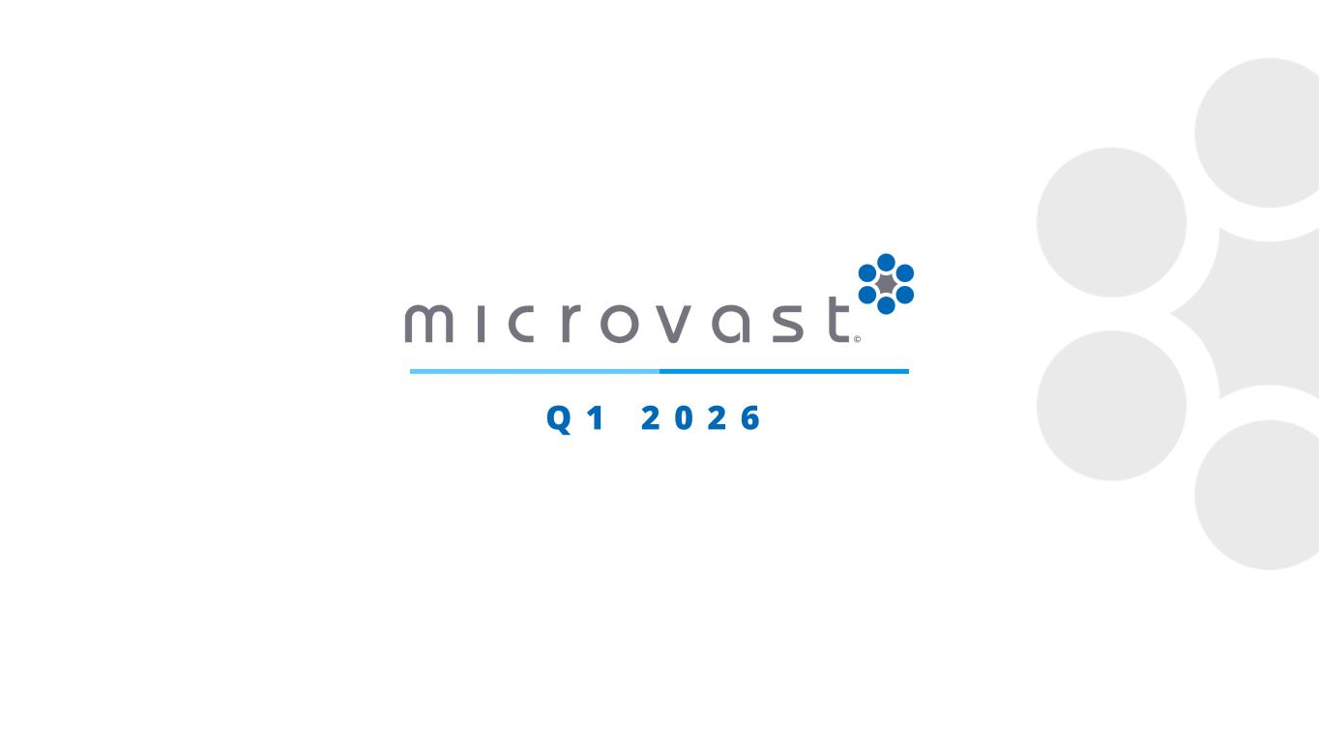
14
Q 1 2 0 2 6

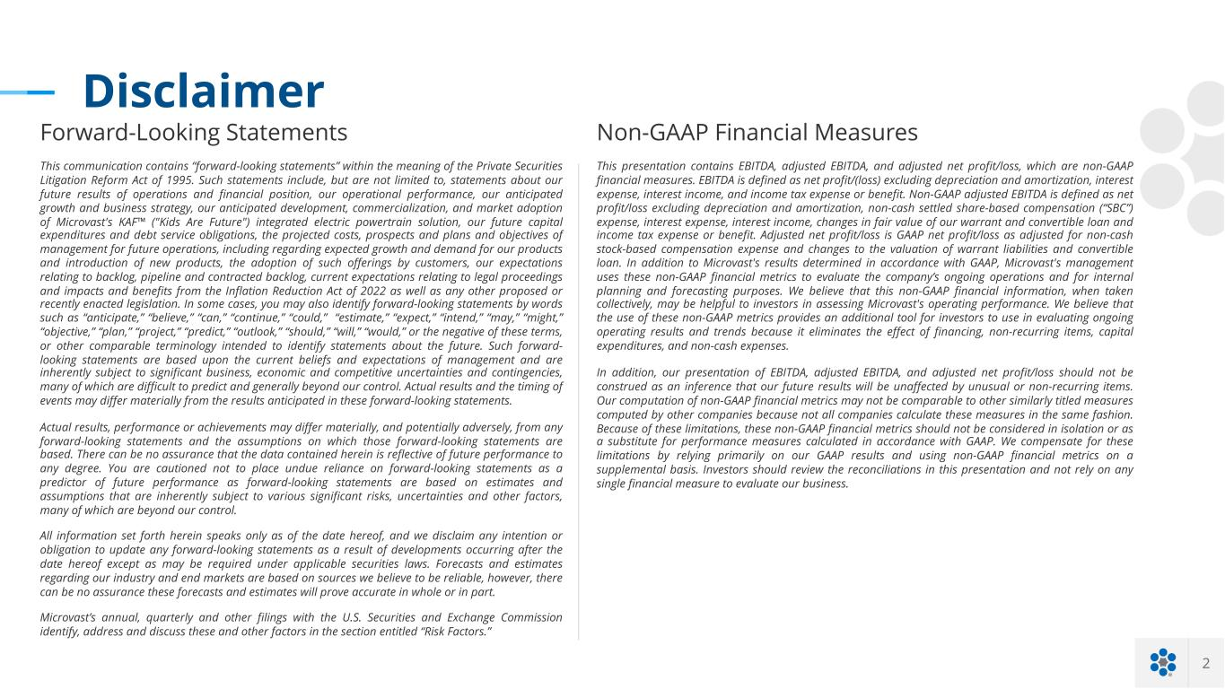
2 Disclaimer Forward-Looking Statements This communication contains “forward-looking statements” within the meaning of the Private Securities Litigation Reform Act of 1995. Such statements include, but are not limited to, statements about our future results of operations and financial position, our operational performance, our anticipated growth and business strategy, our anticipated development, commercialization, and market adoption of Microvast's KAF™ ("Kids Are Future") integrated electric powertrain solution, our future capital expenditures and debt service obligations, the projected costs, prospects and plans and objectives of management for future operations, including regarding expected growth and demand for our products and introduction of new products, the adoption of such offerings by customers, our expectations relating to backlog, pipeline and contracted backlog, current expectations relating to legal proceedings and impacts and benefits from the Inflation Reduction Act of 2022 as well as any other proposed or recently enacted legislation. In some cases, you may also identify forward-looking statements by words such as “anticipate,” “believe,” “can,” “continue,” “could,” “estimate,” “expect,” “intend,” “may,” “might,” “objective,” “plan,” “project,” “predict,” “outlook,” “should,” “will,” “would,” or the negative of these terms, or other comparable terminology intended to identify statements about the future. Such forward- looking statements are based upon the current beliefs and expectations of management and are inherently subject to significant business, economic and competitive uncertainties and contingencies, many of which are difficult to predict and generally beyond our control. Actual results and the timing of events may differ materially from the results anticipated in these forward-looking statements. Actual results, performance or achievements may differ materially, and potentially adversely, from any forward-looking statements and the assumptions on which those forward-looking statements are based. There can be no assurance that the data contained herein is reflective of future performance to any degree. You are cautioned not to place undue reliance on forward-looking statements as a predictor of future performance as forward-looking statements are based on estimates and assumptions that are inherently subject to various significant risks, uncertainties and other factors, many of which are beyond our control. All information set forth herein speaks only as of the date hereof, and we disclaim any intention or obligation to update any forward-looking statements as a result of developments occurring after the date hereof except as may be required under applicable securities laws. Forecasts and estimates regarding our industry and end markets are based on sources we believe to be reliable, however, there can be no assurance these forecasts and estimates will prove accurate in whole or in part. Microvast’s annual, quarterly and other filings with the U.S. Securities and Exchange Commission identify, address and discuss these and other factors in the section entitled “Risk Factors.” Non-GAAP Financial Measures This presentation contains EBITDA, adjusted EBITDA, and adjusted net profit/loss, which are non-GAAP financial measures. EBITDA is defined as net profit/(loss) excluding depreciation and amortization, interest expense, interest income, and income tax expense or benefit. Non-GAAP adjusted EBITDA is defined as net profit/loss excluding depreciation and amortization, non-cash settled share-based compensation (“SBC”) expense, interest expense, interest income, changes in fair value of our warrant and convertible loan and income tax expense or benefit. Adjusted net profit/loss is GAAP net profit/loss as adjusted for non-cash stock-based compensation expense and changes to the valuation of warrant liabilities and convertible loan. In addition to Microvast's results determined in accordance with GAAP, Microvast's management uses these non-GAAP financial metrics to evaluate the company’s ongoing operations and for internal planning and forecasting purposes. We believe that this non-GAAP financial information, when taken collectively, may be helpful to investors in assessing Microvast's operating performance. We believe that the use of these non-GAAP metrics provides an additional tool for investors to use in evaluating ongoing operating results and trends because it eliminates the effect of financing, non-recurring items, capital expenditures, and non-cash expenses. In addition, our presentation of EBITDA, adjusted EBITDA, and adjusted net profit/loss should not be construed as an inference that our future results will be unaffected by unusual or non-recurring items. Our computation of non-GAAP financial metrics may not be comparable to other similarly titled measures computed by other companies because not all companies calculate these measures in the same fashion. Because of these limitations, these non-GAAP financial metrics should not be considered in isolation or as a substitute for performance measures calculated in accordance with GAAP. We compensate for these limitations by relying primarily on our GAAP results and using non-GAAP financial metrics on a supplemental basis. Investors should review the reconciliations in this presentation and not rely on any single financial measure to evaluate our business.

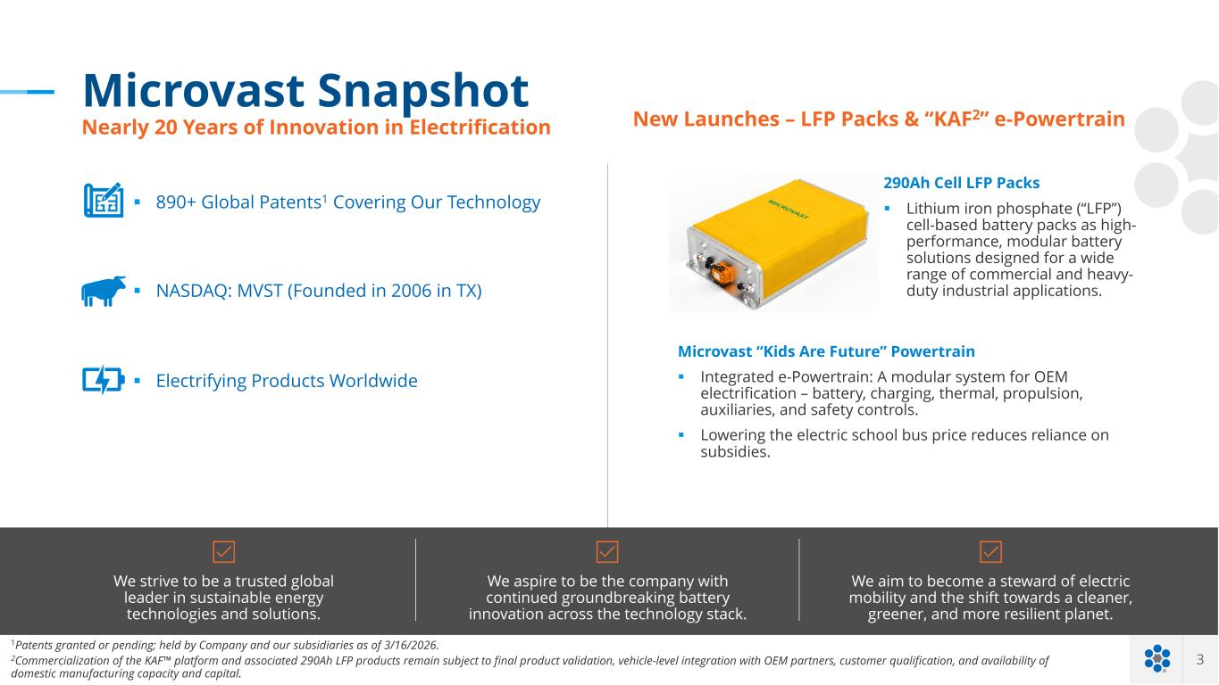
3 Click to edit text Microvast Snapshot Nearly 20 Years of Innovation in Electrification We strive to be a trusted global leader in sustainable energy technologies and solutions. We aspire to be the company with continued groundbreaking battery innovation across the technology stack. We aim to become a steward of electric mobility and the shift towards a cleaner, greener, and more resilient planet. § 890+ Global Patents1 Covering Our Technology § NASDAQ: MVST (Founded in 2006 in TX) § Electrifying Products Worldwide New Launches – LFP Packs & “KAF2” e-Powertrain Microvast “Kids Are Future” Powertrain § Integrated e-Powertrain: A modular system for OEM electrification – battery, charging, thermal, propulsion, auxiliaries, and safety controls. § Lowering the electric school bus price reduces reliance on subsidies. 1Patents granted or pending; held by Company and our subsidiaries as of 3/16/2026. 2Commercialization of the KAF™ platform and associated 290Ah LFP products remain subject to final product validation, vehicle-level integration with OEM partners, customer qualification, and availability of domestic manufacturing capacity and capital. 290Ah Cell LFP Packs § Lithium iron phosphate (“LFP”) cell-based battery packs as high- performance, modular battery solutions designed for a wide range of commercial and heavy- duty industrial applications.

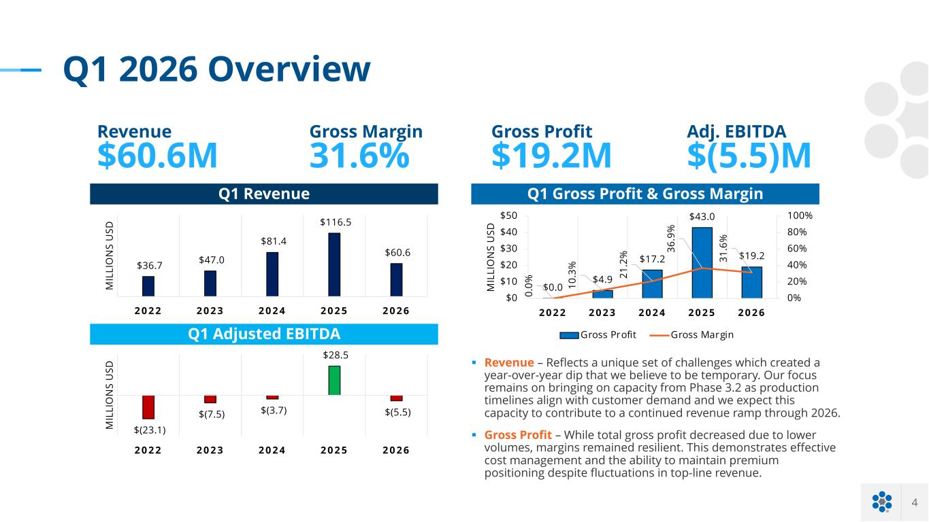
4 Q1 2026 Overview Q1 Revenue Q1 Gross Profit & Gross Margin § Revenue – Reflects a unique set of challenges which created a year-over-year dip that we believe to be temporary. Our focus remains on bringing on capacity from Phase 3.2 as production timelines align with customer demand and we expect this capacity to contribute to a continued revenue ramp through 2026. § Gross Profit – While total gross profit decreased due to lower volumes, margins remained resilient. This demonstrates effective cost management and the ability to maintain premium positioning despite fluctuations in top-line revenue. Revenue $60.6M Gross Margin 31.6% Adj. EBITDA $(5.5)M Q1 Adjusted EBITDA Gross Profit $19.2M $36.7 $47.0 $81.4 $116.5 $60.6 2 0 2 2 2 0 2 3 2 0 2 4 2 0 2 5 2 0 2 6 M IL LI O N S U SD $0.0 $4.9 $17.2 $43.0 $19.2 0. 0% 10 .3 % 21 .2 % 36 .9 % 31 .6 % 0% 20% 40% 60% 80% 100% $0 $10 $20 $30 $40 $50 2 0 2 2 2 0 2 3 2 0 2 4 2 0 2 5 2 0 2 6 M IL LI O N S U SD Gross Profit Gross Margin $(23.1) $(7.5) $(3.7) $28.5 $(5.5) 2 0 2 2 2 0 2 3 2 0 2 4 2 0 2 5 2 0 2 6 M IL LI O N S U SD

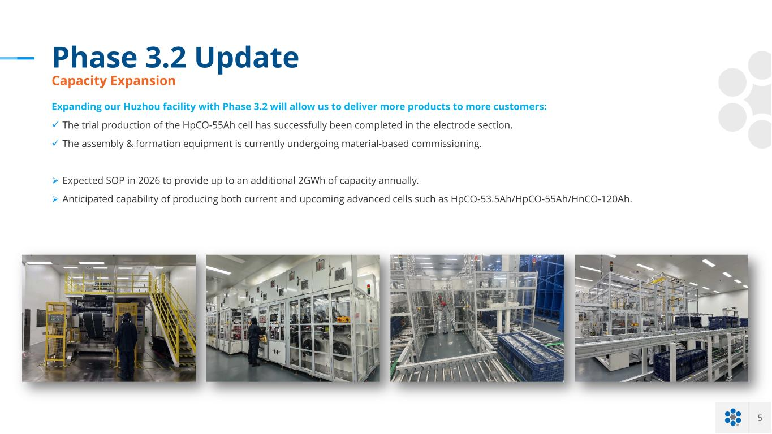
5 Phase 3.2 Update Capacity Expansion Expanding our Huzhou facility with Phase 3.2 will allow us to deliver more products to more customers: ü The trial production of the HpCO-55Ah cell has successfully been completed in the electrode section. ü The assembly & formation equipment is currently undergoing material-based commissioning. Ø Expected SOP in 2026 to provide up to an additional 2GWh of capacity annually. Ø Anticipated capability of producing both current and upcoming advanced cells such as HpCO-53.5Ah/HpCO-55Ah/HnCO-120Ah.

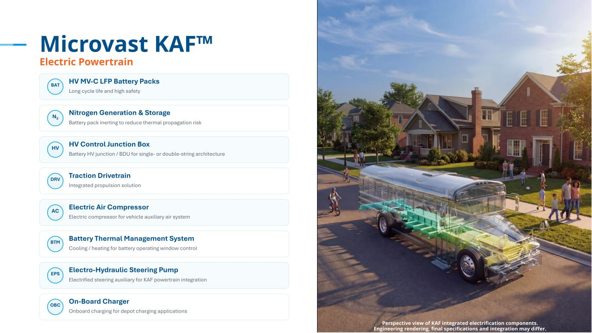
6 Microvast KAF™ Electric Powertrain Perspective view of KAF integrated electrification components. Engineering rendering, final specifications and integration may differ. BAT HV MV-C LFP Battery Packs Long cycle life and high safety N₂ Nitrogen Generation & Storage Battery pack inerting to reduce thermal propagation risk HV HV Control Junction Box Battery HV junction / BDU for single- or double-string architecture DRV Traction Drivetrain Integrated propulsion solution AC Electric Air Compressor Electric compressor for vehicle auxiliary air system BTM Battery Thermal Management System Cooling / heating for battery operating window control EPS Electro-Hydraulic Steering Pump Electrified steering auxiliary for KAF powertrain integration OBC On-Board Charger Onboard charging for depot charging applications

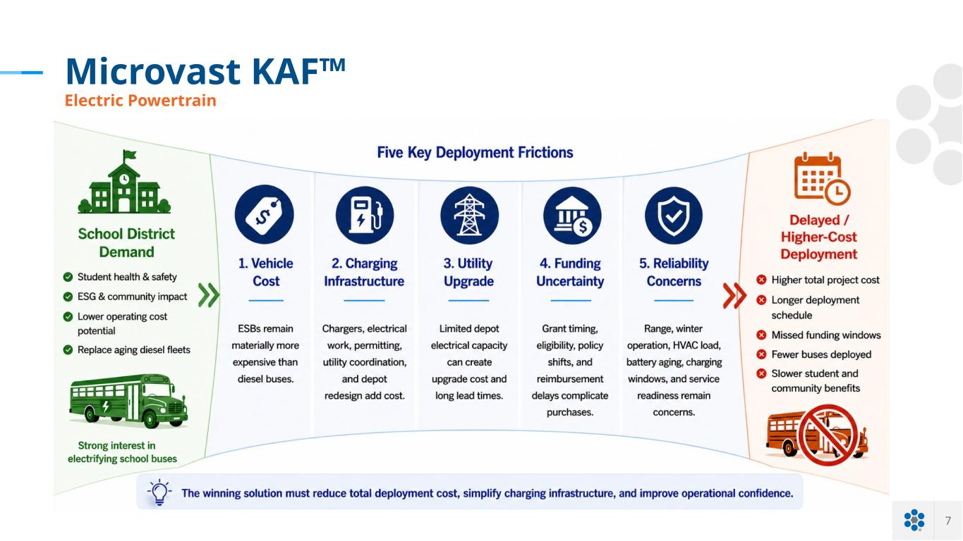
7 Microvast KAF™ Electric Powertrain Perspective view of KAF integrated electrification components.

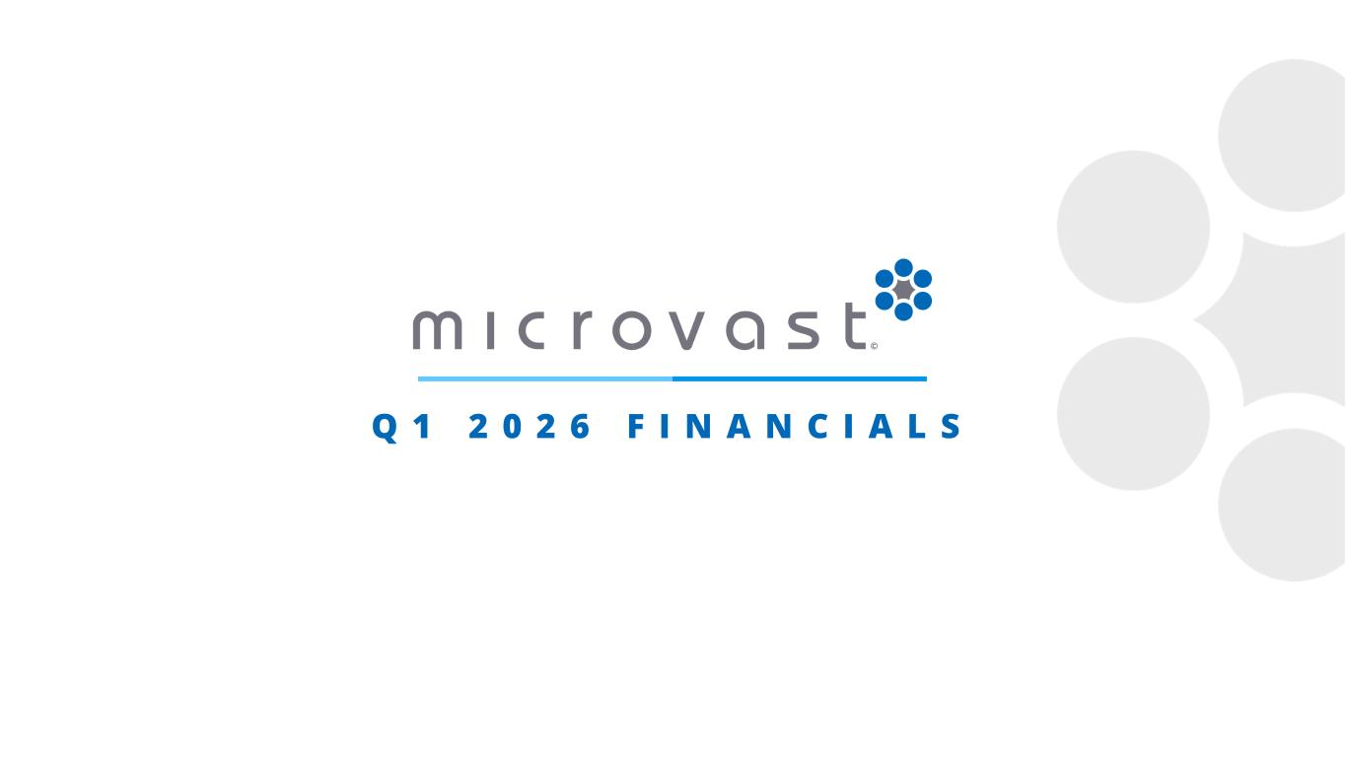
Q 1 2 0 2 6 F I N A N C I A L S

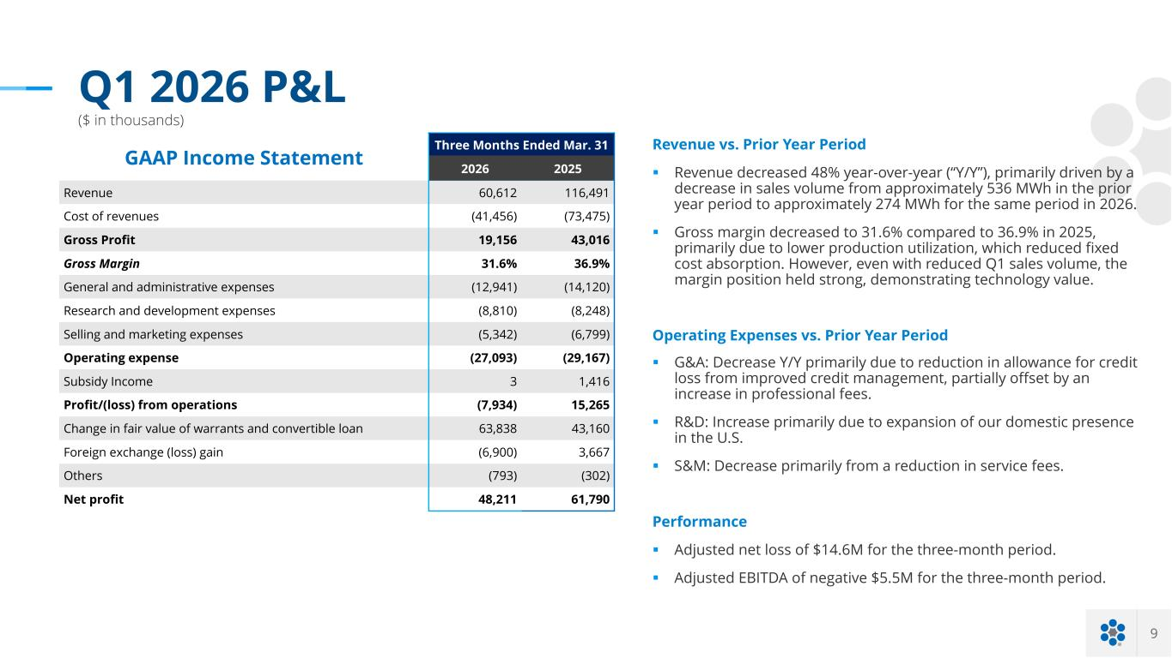
9 Q1 2026 P&L ($ in thousands) GAAP Income Statement Three Months Ended Mar. 31 2026 2025 Revenue 60,612 116,491 Cost of revenues (41,456) (73,475) Gross Profit 19,156 43,016 Gross Margin 31.6% 36.9% General and administrative expenses (12,941) (14,120) Research and development expenses (8,810) (8,248) Selling and marketing expenses (5,342) (6,799) Operating expense (27,093) (29,167) Subsidy Income 3 1,416 Profit/(loss) from operations (7,934) 15,265 Change in fair value of warrants and convertible loan 63,838 43,160 Foreign exchange (loss) gain (6,900) 3,667 Others (793) (302) Net profit 48,211 61,790 Revenue vs. Prior Year Period § Revenue decreased 48% year-over-year (“Y/Y”), primarily driven by a decrease in sales volume from approximately 536 MWh in the prior year period to approximately 274 MWh for the same period in 2026. § Gross margin decreased to 31.6% compared to 36.9% in 2025, primarily due to lower production utilization, which reduced fixed cost absorption. However, even with reduced Q1 sales volume, the margin position held strong, demonstrating technology value. Operating Expenses vs. Prior Year Period § G&A: Decrease Y/Y primarily due to reduction in allowance for credit loss from improved credit management, partially offset by an increase in professional fees. § R&D: Increase primarily due to expansion of our domestic presence in the U.S. § S&M: Decrease primarily from a reduction in service fees. Performance § Adjusted net loss of $14.6M for the three-month period. § Adjusted EBITDA of negative $5.5M for the three-month period.

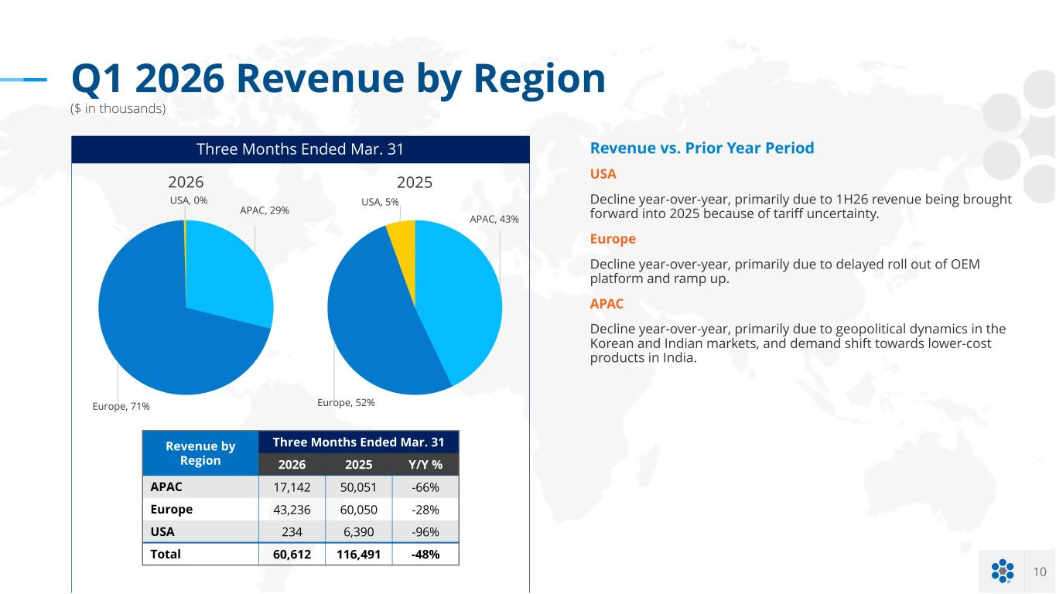
10 Q1 2026 Revenue by Region ($ in thousands) Revenue by Region Three Months Ended Mar. 31 2026 2025 Y/Y % APAC 17,142 50,051 -66% Europe 43,236 60,050 -28% USA 234 6,390 -96% Total 60,612 116,491 -48% Three Months Ended Mar. 31 Revenue vs. Prior Year Period USA Decline year-over-year, primarily due to 1H26 revenue being brought forward into 2025 because of tariff uncertainty. Europe Decline year-over-year, primarily due to delayed roll out of OEM platform and ramp up. APAC Decline year-over-year, primarily due to geopolitical dynamics in the Korean and Indian markets, and demand shift towards lower-cost products in India. APAC, 29% Europe, 71% USA, 0% 2026 APAC, 43% Europe, 52% USA, 5% 2025

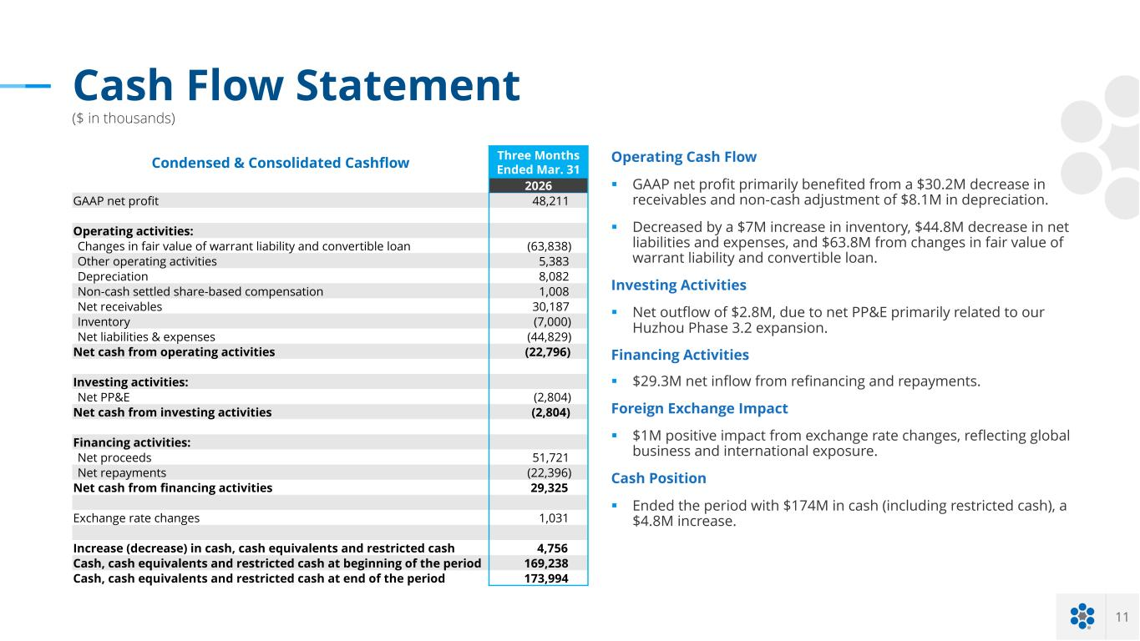
11 Cash Flow Statement ($ in thousands) Operating Cash Flow § GAAP net profit primarily benefited from a $30.2M decrease in receivables and non-cash adjustment of $8.1M in depreciation. § Decreased by a $7M increase in inventory, $44.8M decrease in net liabilities and expenses, and $63.8M from changes in fair value of warrant liability and convertible loan. Investing Activities § Net outflow of $2.8M, due to net PP&E primarily related to our Huzhou Phase 3.2 expansion. Financing Activities § $29.3M net inflow from refinancing and repayments. Foreign Exchange Impact § $1M positive impact from exchange rate changes, reflecting global business and international exposure. Cash Position § Ended the period with $174M in cash (including restricted cash), a $4.8M increase. Condensed & Consolidated Cashflow Three Months Ended Mar. 31 2026 GAAP net profit 48,211 Operating activities: Changes in fair value of warrant liability and convertible loan (63,838) Other operating activities 5,383 Depreciation 8,082 Non-cash settled share-based compensation 1,008 Net receivables 30,187 Inventory (7,000) Net liabilities & expenses (44,829) Net cash from operating activities (22,796) Investing activities: Net PP&E (2,804) Net cash from investing activities (2,804) Financing activities: Net proceeds 51,721 Net repayments (22,396) Net cash from financing activities 29,325 Exchange rate changes 1,031 Increase (decrease) in cash, cash equivalents and restricted cash 4,756 Cash, cash equivalents and restricted cash at beginning of the period 169,238 Cash, cash equivalents and restricted cash at end of the period 173,994


O U T L O O K

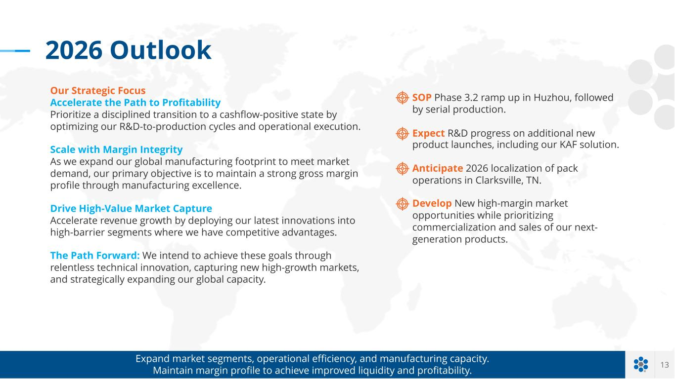
13 SOP Phase 3.2 ramp up in Huzhou, followed by serial production. Expect R&D progress on additional new product launches, including our KAF solution. Anticipate 2026 localization of pack operations in Clarksville, TN. Develop New high-margin market opportunities while prioritizing commercialization and sales of our next- generation products. Expand market segments, operational efficiency, and manufacturing capacity. Maintain margin profile to achieve improved liquidity and profitability. 2026 Outlook Our Strategic Focus Accelerate the Path to Profitability Prioritize a disciplined transition to a cashflow-positive state by optimizing our R&D-to-production cycles and operational execution. Scale with Margin Integrity As we expand our global manufacturing footprint to meet market demand, our primary objective is to maintain a strong gross margin profile through manufacturing excellence. Drive High-Value Market Capture Accelerate revenue growth by deploying our latest innovations into high-barrier segments where we have competitive advantages. The Path Forward: We intend to achieve these goals through relentless technical innovation, capturing new high-growth markets, and strategically expanding our global capacity.

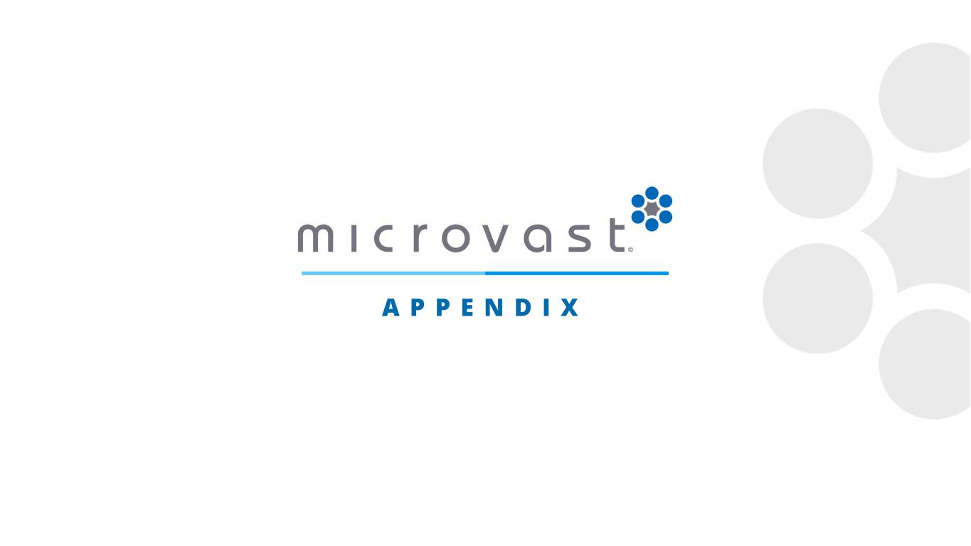
A P P E N D I X

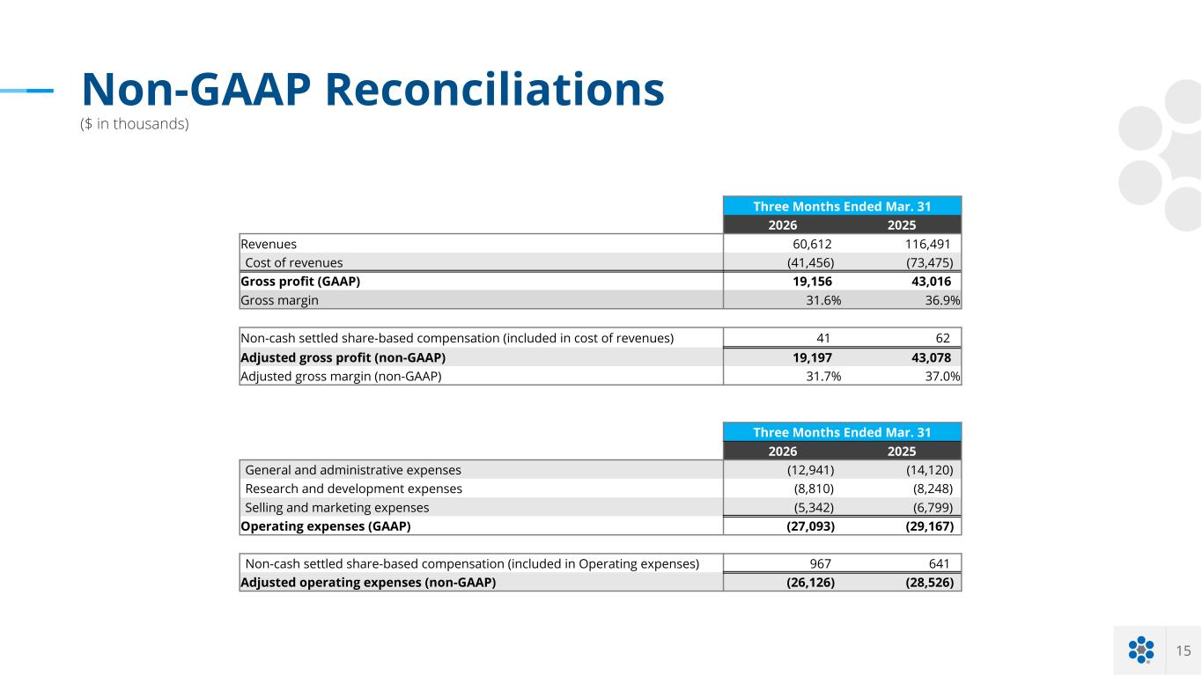
15 Non-GAAP Reconciliations ($ in thousands) Three Months Ended Mar. 31 2026 2025 Revenues 60,612 116,491 Cost of revenues (41,456) (73,475) Gross profit (GAAP) 19,156 43,016 Gross margin 31.6% 36.9% Non-cash settled share-based compensation (included in cost of revenues) 41 62 Adjusted gross profit (non-GAAP) 19,197 43,078 Adjusted gross margin (non-GAAP) 31.7% 37.0% Three Months Ended Mar. 31 2026 2025 General and administrative expenses (12,941) (14,120) Research and development expenses (8,810) (8,248) Selling and marketing expenses (5,342) (6,799) Operating expenses (GAAP) (27,093) (29,167) Non-cash settled share-based compensation (included in Operating expenses) 967 641 Adjusted operating expenses (non-GAAP) (26,126) (28,526)

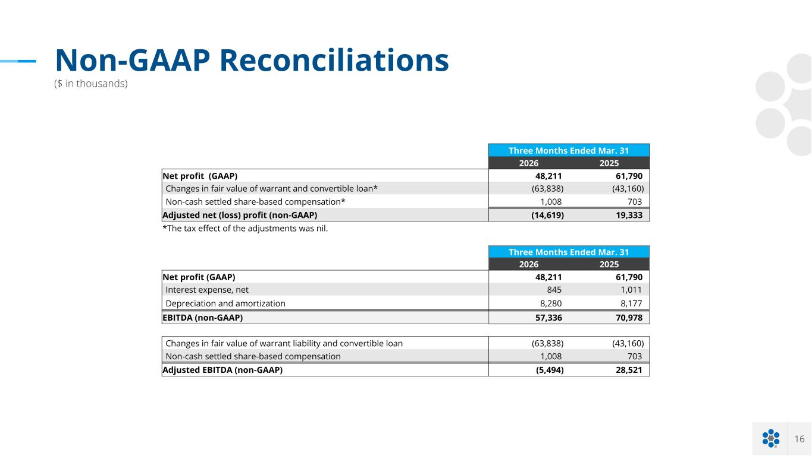
16 Non-GAAP Reconciliations ($ in thousands) Three Months Ended Mar. 31 2026 2025 Net profit (GAAP) 48,211 61,790 Changes in fair value of warrant and convertible loan* (63,838) (43,160) Non-cash settled share-based compensation* 1,008 703 Adjusted net (loss) profit (non-GAAP) (14,619) 19,333 *The tax effect of the adjustments was nil. Three Months Ended Mar. 31 2026 2025 Net profit (GAAP) 48,211 61,790 Interest expense, net 845 1,011 Depreciation and amortization 8,280 8,177 EBITDA (non-GAAP) 57,336 70,978 Changes in fair value of warrant liability and convertible loan (63,838) (43,160) Non-cash settled share-based compensation 1,008 703 Adjusted EBITDA (non-GAAP) (5,494) 28,521

