UNITED STATES
SECURITIES AND EXCHANGE COMMISSION
Washington, D.C. 20549
FORM 8-K
CURRENT REPORT
Pursuant to Section 13 or 15(d)
of the Securities Exchange Act of 1934
Date of Report (Date of earliest event reported): August 10, 2026
Microvast Holdings, Inc.
(Exact name of registrant as specified in its charter)
Delaware |  |  |  |  |  | 001-38826 |  |  |  |  |  | 83-2530757
(State or other jurisdiction  of incorporation) |  |  |  |  |  | (Commission File Number) |  |  |  |  |  | (IRS. Employer  Identification No.)
2929 Briarpark Drive, Suite 400
Houston, Texas 77042
(Address of principal executive offices, including zip code)
281-491-9505
(Registrant’s telephone number, including area code)
Check the appropriate box below if the Form 8-K filing is intended to simultaneously satisfy the filing obligation of the registrant under any of the following provisions:
☐ |  |  | Written communications pursuant to Rule 425 under the Securities Act (17 CFR 230.425)
☐ |  |  | Soliciting material pursuant to Rule 14a-12 under the Exchange Act (17 CFR 240.14a-12)
☐ |  |  | Pre-commencement communications pursuant to Rule 14d-2(b) under the Exchange Act (17 CFR 240.14d-2(b))
☐ |  |  | Pre-commencement communications pursuant to Rule 13e-4(c) under the Exchange Act (17 CFR 240.13e-4(c))
Indicate by check mark whether the registrant is an emerging growth company as defined in Rule 405 of the Securities Act of 1933 (§230.405 of this chapter) or Rule 12b-2 of the Securities Exchange Act of 1934 (§240.12b-2 of this chapter).
Emerging growth company ☐
If an emerging growth company, indicate by check mark if the registrant has elected not to use the extended transition period for complying with any new or revised financial accounting standards provided pursuant to Section 13(a) of the Exchange Act. ☐
Securities registered pursuant to Section 12(b) of the Act:
Title of each class |  |  |  |  |  | Trading Symbol(s) |  |  |  |  |  | Name of each exchange on which registered
Common stock, par value $0.0001 per share |  |  |  |  |  | MVST |  |  |  |  |  | The NASDAQ Stock Market LLC

Item 2.02 Results of Operations and Financial Condition.
On August 10, 2026, Microvast Holdings, Inc. (the “Company”) issued a press release announcing its unaudited condensed consolidated financial results for the period ended June 30, 2026. In addition, the Company posted an accompanying slideshow presentation to its website summarizing its results for the same period. The full text of the press release is furnished as Exhibit 99.1 and the slideshow presentation is furnished as Exhibit 99.2 to this Current Report on Form 8-K. Exhibits 99.1 and 99.2 are hereby incorporated into this Item 2.02 by reference.
The information furnished in this Current Report on Form 8-K and Exhibits 99.1 and 99.2 attached hereto shall not be deemed to be “filed” for purposes of Section 18 of the Securities Exchange Act of 1934, as amended (the “Exchange Act”), or otherwise subject to the liabilities of that section, nor shall it be deemed incorporated by reference into any filing under the Securities Act of 1933, as amended, or the Exchange Act, except as expressly set forth by specific reference in such a filing.

1

SIGNATURES
Pursuant to the requirements of the Securities Exchange Act of 1934, the registrant has duly caused this report to be signed on its behalf by the undersigned hereunto duly authorized.
Date: August 10, 2026 |  |  | MICROVAST HOLDINGS, INC.
 |  |  | By: |  |  | /s/ Rodney Worthen
 |  |  | Name: |  |  | Rodney Worthen
 |  |  | Title: |  |  | Chief Financial Officer

Item 9.01 Financial Statements and Exhibits.
(d)Exhibits
Exhibit No. |  |  |  |  |  | Description
99.1 |  |  |  |  |  | Press Release (Q2 2026) dated August 10, 2026
99.2 |  |  |  |  |  | Presentation (Q2 2026) dated August 10, 2026

2
Exhibit 99.1
Microvast Reports Second Quarter 2026 Financial Results

Houston, Texas, USA — Microvast Holdings, Inc. (NASDAQ:MVST) (“Microvast” or the “Company”), a global leader in advanced battery technologies, announced today its unaudited consolidated financial results for the second quarter ended June 30, 2026 (“Q2 2026”).

“In the second quarter, Microvast progressed through a pivotal phase of our global capacity expansion. Delivering $87.3 million in revenue and maintaining a 29.5% gross margin highlights our ability to navigate raw material fluctuations and production utilization cycles. While it impacted our net revenue, returning $2.7 million in IEEPA(1) tariff refunds to our U.S. customers reinforces the strength of our long-term commercial partnerships. With Huzhou Phase 3.2 expected to be on track to deliver up to 2 GWh of next-generation modular capacity and Clarksville pack line localization anticipated to commence operations by year end, we are working to position our business to meet capacity demand across high-barrier commercial and transit markets,” said Yang Wu, Microvast’s Founder, Chairman, and Chief Executive Officer.

Q2 2026 Results

•Revenues of $87.3 million, compared to $91.3 million in Q2 2025, decreasing by $4.1 million, or 4.5%. This decrease was primarily driven by $2.7 million in IEEPA(1) tariff refunds issued to a U.S. customer, recorded as a reduction to revenue in the current period.

•Gross margin decreased to 29.5% from 34.7% in Q2 2025. Non-GAAP adjusted gross margin* decreased to 29.6% from 34.8% in Q2 2025, primarily due to higher raw material prices, and lower production utilization, which reduced fixed cost absorption, slightly offset by recognition of the IEEPA(1) tariff refunds received.

•Operating expenses increased to $27.5 million, compared to $23.7 million in Q2 2025. Non-GAAP adjusted operating expenses* were $26.7 million, compared to $22.9 million in Q2 2025.

•Net loss of $12.0 million, compared to net loss of $106.1 million in Q2 2025, primarily due to a reduction in negative impacts from changes in fair value of warrant liability and convertible loan. Non-GAAP adjusted net loss* was $5.3 million, compared to non-GAAP adjusted net profit* of $16.3 million in Q2 2025.

•Net loss per share of $0.03, compared to net loss per share of $0.33 in Q2 2025. Non-GAAP adjusted net loss per share* was $0.01, compared to non-GAAP adjusted net profit per share* of $0.05 in Q2 2025.

•Non-GAAP adjusted EBITDA* of $3.6 million in Q2 2026, compared to non-GAAP adjusted EBITDA* of $25.9 million in Q2 2025.

•Capital expenditures of $11.3 million, compared to $7.4 million in Q2 2025.

•Cash, cash equivalents and restricted cash of $143.1 million as of June 30, 2026, compared to $169.2 million as of December 31, 2025, and $138.8 million as of June 30, 2025.

Six Months Ended June 30, 2026 Results (“YTD 2026”)

•Revenues of $147.9 million compared to $207.8 million in the six months ended June 30, 2025 (“YTD 2025”), a decrease of 28.8%. This decrease was primarily a result of evolving regulatory and geopolitical dynamics, including in the Indian and Korean markets, demand shift towards lower-cost products in India, OEM platform ramp-up delays, and a $2.7 million IEEPA(1) tariff refund issued to a customer recorded as a reduction to our revenue in the current period.

•Gross margin decreased to 30.4% from 36.0% in YTD 2025. Non-GAAP adjusted gross margin* decreased to 30.4% from 36.0% in YTD 2025, primarily due to higher raw material prices, lower production utilization, which reduced fixed cost absorption, slightly offset by recognition of the IEEPA(1) tariff refunds received.

•Operating expenses increased to $54.6 million, compared to $52.9 million in YTD 2025. Non-GAAP adjusted operating expenses* were $52.8 million, compared to $51.4 million in YTD 2025.

•Net profit of $36.2 million, compared to net loss of $44.3 million in YTD 2025, primarily due to a reduction in negative impacts from changes in fair value of warrant liability and convertible loan. Non-GAAP adjusted net loss* was $19.9 million, compared to non-GAAP adjusted net profit of $35.6 million in YTD 2025.

•Net profit per share of $0.11, compared to net loss per share of $0.14 in YTD 2025. Non-GAAP adjusted net loss per share* was $0.06, compared to non-GAAP adjusted net profit per share* of $0.11 in YTD 2025.

•Non-GAAP adjusted EBITDA* of negative $1.9 million in YTD 2026, compared to non-GAAP adjusted EBITDA* of $54.4 million in YTD 2025.

•Capital expenditures of $15.5 million, compared to $14.0 million in YTD 2025.

*The Company presents its financial results in accordance with generally accepted accounting principles in the United States of America (“GAAP”). However, management believes that using additional non-GAAP measures will enhance the evaluation of the profitability of the Company and its ongoing operations. Please see the tables on pages 12-15 below for reconciliations of GAAP to non-GAAP financial measures. The Consolidated Balance Sheets, Consolidated Statements of Operations, and Consolidated Statements of Cash Flows are derived from the consolidated financial statements presented in our Quarterly Report on Form 10-Q as of and for the three- and six-month periods ended June 30, 2026.

(1)In February 2026, the United States Supreme Court ruled that certain tariffs imposed under the International Emergency Economic Powers Act (“IEEPA”) were not authorized by statute. Following the ruling, the U.S. Court of International Trade ordered U.S. Customs and Border Protection to suspend collection of such tariffs and to establish a process to refund amounts previously collected. As a result of this ruling, the Company is eligible to receive refunds of tariffs previously paid on qualifying imports. In May 2026, the Company received $4.3 million in tariff refunds, excluding interest. Of this amount, $2.7 million was issued in tariff refunds to a customer. The IEEPA tariff refunds received were recognized as a reduction to the cost of revenue, while the refund issued to our customer was recognized as a reduction of revenue for the three and six months ended June 30, 2026.

2
2026 Outlook & Forward-Looking Information

•We continue to target a stable gross margin profile through sustained operational discipline and premium product positioning. This approach seeks to balance external pressures including inflationary raw material pricing, duties and tariffs, and elevated logistics and freight expenses against the planned absorption of ramp-up expenses tied to our Phase 3.2 expansion.

•Huzhou Phase 3.2 production capacity ramp up remains our primary operational milestone in 2026. The expansion is anticipated to bring online up to 2 GWh of modular capacity to support next-generation cell demand.

•Localized pack assembly at our Clarksville facility remains on schedule, with initial operations anticipated by year-end. This footprint advances our domestic strategy to supply North American commercial vehicle and transit partners with locally integrated battery systems.

•We continue to seek new commercial momentum across EMEA, North America, and APAC. Our long-term focus remains centered on heavy industrial and transit markets, where our vertical integration and newly launched KAF electric powertrain position us to deliver a durable competitive advantage, subject to final product validation, vehicle-level integration with OEM partners, customer qualification, and availability of domestic manufacturing capacity and capital.

Webcast Information

Company management will host a conference call and webcast on August 10, 2026, at 4:00 p.m. Central Time, to discuss the Company's financial results. The live webcast and accompanying slide presentation will be accessible from the Events & Presentations section of Microvast’s investor relations website (https://ir.microvast.com/events-presentations/events). A replay will be available following the conclusion of the event.

About Microvast

Microvast strives to be a global leader in advanced battery technologies, with a portfolio of more than 890 patents. Founded in Texas in 2006 and headquartered in Houston, the company has spent two decades engineering cutting-edge battery systems that are intended to power a cleaner future. Microvast stands as a trusted global partner with the mission to provide the high-performance solutions required for today’s electrification needs.

For more information, please visit www.microvast.com or follow us on LinkedIn (@microvast).

Contact:

Investor Relations
ir@microvast.com

Cautionary Statement Regarding Forward-Looking Statements

This communication contains “forward-looking statements” within the meaning of the Private Securities Litigation Reform Act of 1995. Forward-looking statements are based on assumptions with respect to the future and management's current expectations, involve certain risks and uncertainties
3
and are not guarantees. These forward-looking statements include, but are not limited to, statements about our future results of operations and financial position, our operational performance, our anticipated growth and business strategy, anticipated development, commercialization, and market adoption of Microvast's KAF™ ("Kids Are Future") integrated electric powertrain solution, our future capital expenditures and debt service obligations, the projected costs, prospects and plans and objectives of management for future operations, including regarding expected growth and demand for our products and introduction of new products, the adoption of such offerings by customers, our expectations relating to backlog, pipeline and contracted backlog, current expectations relating to legal proceedings and potential impacts from any proposed or recently enacted legislation. In some cases, you may also identify forward-looking statements by words such as “anticipate,” “believe,” “can,” “continue,” “could,” “estimate,” “expect,” “intend,” “may,” “might,” “objective,” “plan,” “project,” “predict,” “outlook” “should,” “will,” “would,” or the negative of these terms, or other comparable terminology intended to identify statements about the future. Such forward-looking statements are based upon the current beliefs and expectations of management and are inherently subject to significant business, economic and competitive uncertainties and contingencies, many of which are difficult to predict and generally beyond our control. Actual results and the timing of events may differ materially from the results anticipated in these forward-looking statements. We do not assume any obligation to update any forward-looking statements.

Many factors could cause actual results and the timing of events to differ materially from the anticipated results or other expectations expressed in the forward-looking statements, including, among others: (1) substantial doubt about our ability to continue as a going concern, which has not been alleviated, and the risk that our plans intended to alleviate that substantial doubt will not be effectively implemented within one year after the date the financial statements are issued or, when implemented, will not mitigate the conditions and events that raise substantial doubt; (2) the effect of the substantial doubt about our ability to continue as a going concern on our relationships with customers, suppliers and channel partners, our ability to attract and retain qualified personnel and our ability to raise capital; (3) risk that we may not be able to accurately project and manage our growth and effectively execute our growth strategies or achieve profitability; (4) risk that we may be unable to meet our future capital requirements and we may require additional capital to support our business growth, and this capital might not be available on acceptable terms, or at all; (5) potential difficulties in maintaining manufacturing capacity and establishing expected mass manufacturing capacity in the future; (6) risks relating to issues or delays, disruptions and quality control problems in our manufacturing operations; (7) risks relating to being unable to control our manufacturing costs; (8) risks that we may be unable to meet our projected construction timelines, costs and production ramps, or we may experience difficulties in generating and maintaining demand for products manufactured there and related services; (9) restrictions in our existing and any future credit facilities, our ability to comply with financial covenants and the risk of cross-default, the risk that waivers or amendments may not be obtained from our lenders and the risk that our indebtedness may be accelerated or classified as current; (10) risks of operations in China; (11) the effects of mechanics liens filed by contractors that we do not have sufficient funds to pay; (12) the effects of existing and future litigation; (13) changes in general economic conditions, including increases in interest rates and associated Federal Reserve policies, a potential economic recession, and the impact of inflation on our business; (14) changes in the highly competitive market in which we compete, including with respect to our competitive landscape, technology evolution or regulatory changes; (15) changes in availability and price of raw materials; (16) risks that our suppliers may fail to deliver components according to schedules, prices, quality and volumes that are acceptable to us, or we may be unable to manage these components effectively; (17) labor relations, including the ability to attract, hire and retain key employees and contract personnel; (18) heightened awareness of environmental issues and concern about global warming and climate change; (19) risk that we are unable to secure or protect our intellectual property; (20) risk that our customers or third-party suppliers are unable to meet their obligations fully or in a timely manner; (21) risks related to possible future reductions in pricing or order volume or loss of one or more of our significant customers; (22) risks relating to our
4
status as a relatively low-volume purchaser as well as from supplier concentration and limited supplier capacity; (23) risk that our customers will adjust, cancel or suspend their orders for our products; (24) risks relating to our ability to attract new customers and retain existing customers; (25) risks related to our lengthy sales cycle for our products; (26) risk of product liability or regulatory lawsuits or proceedings relating to our products or services; (27) our ability to maintain and enhance our reputation and brand recognition; (28) risks relating to facing strong competition for our products and services from a growing list of established and new competitors; (29) the effectiveness of our information technology and operational technology systems and practices to detect and defend against evolving cyberattacks; (30) changing laws regarding cybersecurity and data privacy, and any cybersecurity threat or event; (31) the effects and associated cost of compliance with existing and future laws and governmental regulations; (32) risks relating to whether renewable energy technologies are suitable for widespread adoption or if sufficient demand for our offerings does not develop or takes longer to develop than we anticipate; (33) economic, financial and other impacts such as a pandemic, including global supply chain disruptions; (34) the impacts of geopolitical events, such as the ongoing conflicts in the Middle East, including hostilities with Iran, the war between Russia and Ukraine, and other current or future conflicts; (35) risks associated with maintaining and expanding our international operations, including unfavorable and uncertain regulatory, political, economic, tax, and labor conditions; (36) risk that tariffs imposed on products of the PRC into the United States may lead to increased costs and impact our business; (37) the risk that the unavailability, reduction, or elimination of, or uncertainty regarding government and economic incentives or subsidies available to us, end-users or OEMs could have a material adverse effect on our business, financial condition, operating results and prospects; and (38) our ability to maintain compliance with Nasdaq listing requirements. Microvast’s annual, quarterly and other filings with the U.S. Securities and Exchange Commission (the “SEC”) identify, address and discuss these and other factors in the sections entitled “Risk Factors.”

The foregoing list of factors is not exhaustive and new factors may emerge from time to time that could also affect actual performance and results. For more information, please see the risk factors included in our Annual Report on Form 10-K for the year ended December 31, 2025 in Part I, Item 1A and our Quarterly Report on Form 10-Q for the quarter ended June 30, 2026 in Part II, Item 1A.

Actual results, performance or achievements may differ materially, and potentially adversely, from any forward-looking statements and the assumptions on which those forward-looking statements are based. There can be no assurance that the data contained herein is reflective of future performance to any degree. You are cautioned not to place undue reliance on forward-looking statements as a predictor of future performance as forward-looking statements are based on estimates and assumptions that are inherently subject to various significant risks, uncertainties and other factors, many of which are beyond our control.

All information set forth herein speaks only as of the date hereof, and we disclaim any intention or obligation to update any forward-looking statements as a result of developments occurring after the date hereof except as may be required under applicable securities laws. Forecasts and estimates regarding our industry and end markets are based on sources we believe to be reliable, however, there can be no assurance these forecasts and estimates will prove accurate in whole or in part.

All references to the “Company,” “we,” “us,” or “our” refer to Microvast Holdings, Inc. and its consolidated subsidiaries other than certain historical information which refers to the business of Microvast prior to the consummation of the Business Combination.

Non-GAAP Financial Measures

To provide investors with additional information regarding our financial results, Microvast has disclosed in this earnings release non-GAAP financial measures, including non-GAAP adjusted gross
5
profit, non-GAAP EBITDA, non-GAAP adjusted EBITDA, non-GAAP adjusted operating expenses, non-GAAP adjusted net profit/(loss), non-GAAP adjusted net profit/(loss) per share, and non-GAAP adjusted gross margin which are non-GAAP financial measures as defined under the rules of the SEC. These are intended as supplemental measures of our financial performance that are not required by, or presented in accordance with GAAP.

Reconciliations to the most comparable GAAP measures, gross profit, gross margin, operating expenses, net profit/(loss), and net profit/(loss) per share, are contained in tabular form in the unaudited financial statements below. Non-GAAP adjusted gross profit is GAAP gross profit as adjusted for non-cash share-based compensation expense included in cost of revenues. Non-GAAP adjusted net profit/(loss) is GAAP net profit/(loss) as adjusted for non-cash share-based compensation expense and change in valuation of warrant liability and convertible loan. Non-GAAP adjusted net profit/(loss) per common share is GAAP net profit/(loss) per common share as adjusted for non-cash share-based compensation expense and change in valuation of warrant liability and convertible loan per common share. Non-GAAP EBITDA is defined as net profit/(loss) excluding depreciation and amortization, interest expense, interest income, and income tax expense or benefit. Non-GAAP adjusted EBITDA is defined as net profit/(loss) excluding depreciation and amortization, non-cash settled share-based compensation expense, interest expense, interest income, changes in fair value of our warrant liability and convertible loan and income tax expense or benefit. Non-GAAP adjusted operating expenses is defined as operating expenses excluding non-cash share-based compensation expense. Non-GAAP adjusted gross margin is defined as GAAP gross margin as adjusted for non-cash share-based compensation expense included in cost of revenues.

We use non-GAAP adjusted gross profit, non-GAAP EBITDA, non-GAAP adjusted EBITDA, non-GAAP adjusted operating expenses, non-GAAP adjusted net profit/(loss), non-GAAP adjusted net profit/(loss) per share and non-GAAP adjusted gross margin for financial and operational decision-making and as a means to evaluate period-to-period comparisons. We consider them to be important measures because they help illustrate underlying trends in our business and our historical operating performance on a more consistent basis. We believe that these non-GAAP financial measures, when taken together with their most directly comparable GAAP measures provide meaningful supplemental information regarding our performance by excluding certain items that may not be indicative of our recurring core business operating results.

We believe that both management and investors benefit from referring to these non-GAAP financial measures in assessing our performance and when planning, forecasting, and analyzing future periods. These non-GAAP financial measures also facilitate management’s internal comparisons to our historical performance. We believe these non-GAAP financial measures are useful to investors both because (1) they allow for greater transparency with respect to key metrics used by management in its financial and operational decision-making and (2) they are used by our institutional investors and the analyst community to help them analyze the health of our business. Accordingly, we believe that these non-GAAP financial measures provide useful information to investors and others in understanding and evaluating our operating results in the same manner as our management team and board of directors.

Non-GAAP financial measures have limitations as an analytical tool, and you should not consider them in isolation, or as a substitute for, financial information prepared in accordance with GAAP. For example, our calculation of non-GAAP adjusted EBITDA may differ from similarly titled non-GAAP measures, if any, reported by our peer companies, or our peer companies may use other measures to calculate their financial performance, and therefore our use of non-GAAP adjusted EBITDA may not be directly comparable to similarly titled measures of other companies. The principal limitation of non-GAAP adjusted EBITDA is that it excludes significant expenses and income that are required by GAAP to be recorded in our financial statements. In addition, it is subject to inherent limitations as it reflects the exercise of judgments by management about which expense and income are excluded or
6
included in determining this non-GAAP financial measure. In order to compensate for these limitations, management presents non-GAAP financial measures in connection with GAAP results. In addition, such financial information is unaudited and does not conform to SEC Regulation S-X and as a result, such information may be presented differently in our future filings with the SEC. For example, with respect to the warrant liability resulting from the July 23, 2021 business combination with Tuscan Holdings Corp., we now exclude changes in fair value from net profit/(loss) in our non-GAAP adjusted EBITDA and non-GAAP adjusted net profit/(loss) calculation, which had not been done in prior periods.

7
MICROVAST HOLDINGS, INC.
CONSOLIDATED BALANCE SHEETS
(In thousands, except per share data, unaudited)

 |  |  | June 30,  2026 |  |  |  |  |  | December 31,  2025
Assets
Current assets:
Cash and cash equivalents |  |  | $ | 127,828 |  |  |  |  | $ | 104,963
Restricted cash |  |  | 15,257 |  |  |  |  |  | 64,275
Accounts receivable (net of allowance for credit losses of $4,130 and $4,693 as of June 30, 2026 and December 31, 2025, respectively) |  |  | 121,181 |  |  |  |  |  | 155,763
Notes receivable |  |  | 1,334 |  |  |  |  |  | 5,590
Inventories, net |  |  | 93,594 |  |  |  |  |  | 89,411
Prepaid expenses and other current assets |  |  | 15,727 |  |  |  |  |  | 17,221
Assets held for sale |  |  | — |  |  |  |  |  | 11,500
Total Current Assets |  |  | 374,921 |  |  |  |  |  | 448,723
Property, plant and equipment, net |  |  | 526,050 |  |  |  |  |  | 508,057
Land use rights, net |  |  | 11,771 |  |  |  |  |  | 11,570
Acquired intangible assets, net |  |  | 1,974 |  |  |  |  |  | 2,183
Operating lease right-of-use assets |  |  | 17,399 |  |  |  |  |  | 17,336
Deferred tax assets |  |  | 5,429 |  |  |  |  |  | 5,429
Other non-current assets |  |  | 14,649 |  |  |  |  |  | 12,150
Total Assets |  |  | $ | 952,193 |  |  |  |  | $ | 1,005,448
Liabilities
Current liabilities:
Accounts payable |  |  | $ | 62,639 |  |  |  |  | $ | 47,003
Notes payable |  |  | 15,246 |  |  |  |  |  | 78,321
Advance from customers |  |  | 4,991 |  |  |  |  |  | 5,605
Accrued expenses and other current liabilities |  |  | 114,817 |  |  |  |  |  | 123,429
Amounts due to related parties |  |  | 181 |  |  |  |  |  | 2
Convertible loan measured at fair value |  |  | — |  |  |  |  |  | 140,929
Short-term bank borrowings |  |  | 104,179 |  |  |  |  |  | 93,052
Bonds payable |  |  | 41,693 |  |  |  |  |  | —
Total Current Liabilities |  |  | 343,746 |  |  |  |  |  | 488,341
Long-term bonds payable |  |  | — |  |  |  |  |  | 41,693
Long-term bank borrowings |  |  | 14,443 |  |  |  |  |  | 13,227
Operating lease liabilities |  |  | 13,996 |  |  |  |  |  | 14,476
Other non-current liabilities |  |  | 36,914 |  |  |  |  |  | 37,198
Total Liabilities |  |  | $ | 409,099 |  |  |  |  | $ | 594,935
Stockholders’ Equity
Common Stock ($0.0001 par value, 750,000 shares authorized; 386,222 and 333,474 shares issued, and 384,534 and 331,786 shares outstanding as of June 30, 2026 and December 31, 2025) |  |  | $ | 39 |  |  |  |  | $ | 34
Preferred Stock ($0.0001 par value, 50,000 shares authorized; none issued and outstanding as of June 30, 2026 and December 31, 2025) |  |  | — |  |  |  |  |  | —
Additional paid-in capital |  |  | 1,627,198 |  |  |  |  |  | 1,543,797
Statutory reserves |  |  | 6,032 |  |  |  |  |  | 6,032
Accumulated deficit |  |  | (1,085,953) |  |  |  |  |  | (1,122,176)
Accumulated other comprehensive loss |  |  | (4,222) |  |  |  |  |  | (17,174)
Total Equity |  |  | $ | 543,094 |  |  |  |  | $ | 410,513
Total Liabilities and Equity |  |  | $ | 952,193 |  |  |  |  | $ | 1,005,448

8

MICROVAST HOLDINGS, INC.
CONSOLIDATED STATEMENTS OF OPERATIONS
(In thousands, except per share data, unaudited)

 |  |  | Three Months Ended  June 30, |  |  |  |  |  |  |  |  |  |  |  | Six Months Ended  June 30,
 |  |  | 2026 |  |  |  |  |  | 2025 |  |  |  |  |  | 2026 |  |  |  |  |  | 2025
Revenues |  |  | $ | 87,262 |  |  |  |  | $ | 91,339 |  |  |  |  | $ | 147,874 |  |  |  |  | $ | 207,830
Cost of revenues |  |  | (61,484) |  |  |  |  |  | (59,616) |  |  |  |  |  | (102,940) |  |  |  |  |  | (133,091)
Gross profit |  |  | 25,778 |  |  |  |  |  | 31,723 |  |  |  |  |  | 44,934 |  |  |  |  |  | 74,739
Operating expenses:
General and administrative expenses |  |  | (13,886) |  |  |  |  |  | (11,184) |  |  |  |  |  | (26,827) |  |  |  |  |  | (25,304)
Research and development expenses |  |  | (8,860) |  |  |  |  |  | (7,719) |  |  |  |  |  | (17,670) |  |  |  |  |  | (15,967)
Selling and marketing expenses |  |  | (4,743) |  |  |  |  |  | (3,424) |  |  |  |  |  | (10,085) |  |  |  |  |  | (10,223)
Impairment loss of long-lived assets |  |  | (24) |  |  |  |  |  | (1,364) |  |  |  |  |  | (24) |  |  |  |  |  | (1,364)
Total operating expenses |  |  | (27,513) |  |  |  |  |  | (23,691) |  |  |  |  |  | (54,606) |  |  |  |  |  | (52,858)
Subsidy income |  |  | 15 |  |  |  |  |  | 995 |  |  |  |  |  | 18 |  |  |  |  |  | 2,411
(Loss) profit from operations |  |  | (1,720) |  |  |  |  |  | 9,027 |  |  |  |  |  | (9,654) |  |  |  |  |  | 24,292
Other income and expenses:
Interest income |  |  | 733 |  |  |  |  |  | 198 |  |  |  |  |  | 1,115 |  |  |  |  |  | 375
Interest expense |  |  | (1,328) |  |  |  |  |  | (1,252) |  |  |  |  |  | (2,555) |  |  |  |  |  | (2,440)
Changes in fair value of warrant liability and convertible loan |  |  | (5,837) |  |  |  |  |  | (121,521) |  |  |  |  |  | 58,001 |  |  |  |  |  | (78,361)
Foreign exchange (loss) gain |  |  | (4,705) |  |  |  |  |  | 7,187 |  |  |  |  |  | (11,605) |  |  |  |  |  | 10,854
Other income, net |  |  | 869 |  |  |  |  |  | 523 |  |  |  |  |  | 921 |  |  |  |  |  | 1,232
(Loss) profit before provision for income taxes |  |  | (11,988) |  |  |  |  |  | (105,838) |  |  |  |  |  | 36,223 |  |  |  |  |  | (44,048)
Income tax expense |  |  | — |  |  |  |  |  | (220) |  |  |  |  |  | — |  |  |  |  |  | (220)
Net (loss) profit |  |  | $ | (11,988) |  |  |  |  | $ | (106,058) |  |  |  |  | $ | 36,223 |  |  |  |  | $ | (44,268)
Net (loss) profit per share - Basic |  |  | $ | (0.03) |  |  |  |  | $ | (0.33) |  |  |  |  | $ | 0.11 |  |  |  |  | $ | (0.14)
Net loss per share - Diluted |  |  | $ | (0.03) |  |  |  |  | $ | (0.33) |  |  |  |  | $ | (0.06) |  |  |  |  | $ | (0.14)
Weighted average shares outstanding - Basic |  |  | 348,949 |  |  |  |  |  | 323,643 |  |  |  |  |  | 340,726 |  |  |  |  |  | 323,538
Weighted average shares outstanding - Diluted |  |  | 348,949 |  |  |  |  |  | 323,643 |  |  |  |  |  | 382,948 |  |  |  |  |  | 323,538

9

MICROVAST HOLDINGS, INC.
CONSOLIDATED STATEMENTS OF CASH FLOWS
(In thousands, unaudited)

 |  |  | Six Months Ended June 30,
 |  |  | 2026 |  |  |  |  |  | 2025
Cash flows from operating activities
Net profit (loss) |  |  | $ | 36,223 |  |  |  |  | $ | (44,268)
Adjustments to reconcile net profit (loss) to net cash used in operating activities:
Depreciation of property, plant and equipment |  |  | 16,161 |  |  |  |  |  | 16,091
Noncash lease expenses |  |  | 1,418 |  |  |  |  |  | 1,311
Share-based compensation |  |  | 1,850 |  |  |  |  |  | 1,549
Changes in fair value of warrant liability and convertible loan |  |  | (58,001) |  |  |  |  |  | 78,361
(Reversal) provision of credit losses |  |  | (873) |  |  |  |  |  | 2,191
Impairment loss of long-lived assets |  |  | 24 |  |  |  |  |  | 1,364
Product warranty |  |  | 5,982 |  |  |  |  |  | 8,512
Other, net |  |  | 1,470 |  |  |  |  |  | (261)
Changes in operating assets and liabilities:
Notes receivable |  |  | (2,934) |  |  |  |  |  | (13,957)
Accounts receivable |  |  | 37,127 |  |  |  |  |  | (513)
Inventories |  |  | (4,612) |  |  |  |  |  | 7,051
Prepaid expenses and other current assets |  |  | 1,324 |  |  |  |  |  | 8,830
Amounts due from/to related parties |  |  | 178 |  |  |  |  |  | (5)
Other non-current assets |  |  | 2,315 |  |  |  |  |  | 312
Notes payable |  |  | (64,821) |  |  |  |  |  | (8,801)
Accounts payable |  |  | 14,203 |  |  |  |  |  | 6,264
Advance from customers |  |  | (793) |  |  |  |  |  | (2,279)
Accrued expenses and other liabilities |  |  | (17,153) |  |  |  |  |  | (16,876)
Operating lease liabilities |  |  | (1,265) |  |  |  |  |  | (1,350)
Other non-current liabilities |  |  | (1,132) |  |  |  |  |  | 797
Net cash (used in) generated from operating activities |  |  | (33,309) |  |  |  |  |  | 44,323
Cash flows from investing activities
Purchases of property, plant and equipment |  |  | (14,170) |  |  |  |  |  | (5,207)
Proceeds on disposal of property, plant and equipment |  |  | 10,864 |  |  |  |  |  | 129
Net cash used in investing activities |  |  | (3,306) |  |  |  |  |  | (5,078)
Cash flows from financing activities
Proceeds from bank borrowings |  |  | 69,356 |  |  |  |  |  | 59,571
Repayment of bank borrowings |  |  | (60,829) |  |  |  |  |  | (56,184)
Repayment of bonds payable |  |  | — |  |  |  |  |  | (1,375)
Proceeds from sale of common stocks |  |  | 1,350 |  |  |  |  |  | —
Payment for equity issuance costs |  |  | (329) |  |  |  |  |  | —
Deferred payment related to purchases of property, plant and equipment |  |  | (1,368) |  |  |  |  |  | (8,811)
Net cash generated from (used in) financing activities |  |  | 8,180 |  |  |  |  |  | (6,799)
Effect of exchange rate changes on cash, cash equivalents and restricted cash |  |  | 2,282 |  |  |  |  |  | (3,227)
(Decrease) increase in cash, cash equivalents and restricted cash |  |  | (26,153) |  |  |  |  |  | 29,219
Cash, cash equivalents and restricted cash at beginning of the period |  |  | 169,238 |  |  |  |  |  | 109,601
Cash, cash equivalents and restricted cash at end of the period |  |  | $ | 143,085 |  |  |  |  | $ | 138,820

10

MICROVAST HOLDINGS, INC.
CONSOLIDATED STATEMENTS OF CASH FLOWS
(In thousands, unaudited)

Six Months Ended
June 30,
 |  |  | 2026 |  |  |  |  |  | 2025
Reconciliation to amounts on consolidated balance sheets
Cash and cash equivalents |  |  | $ | 127,828 |  |  |  |  | $ | 99,721
Restricted cash |  |  | 15,257 |  |  |  |  |  | 39,099
Total cash, cash equivalents and restricted cash |  |  | $ | 143,085 |  |  |  |  | $ | 138,820

11

MICROVAST HOLDINGS, INC.
RECONCILIATION OF GROSS PROFIT TO ADJUSTED GROSS PROFIT
(In thousands, except percentages, unaudited)

 |  |  | Three Months Ended  June 30, |  |  |  |  |  |  |  |  |  |  |  | Six Months Ended  June 30,
 |  |  | 2026 |  |  |  |  |  | 2025 |  |  |  |  |  | 2026 |  |  |  |  |  | 2025
Revenues |  |  | $ | 87,262 |  |  |  |  | $ | 91,339 |  |  |  |  | $ | 147,874 |  |  |  |  | $ | 207,830
Cost of revenues |  |  | (61,484) |  |  |  |  |  | (59,616) |  |  |  |  |  | (102,940) |  |  |  |  |  | (133,091)
Gross profit (GAAP) |  |  | $ | 25,778 |  |  |  |  | $ | 31,723 |  |  |  |  | $ | 44,934 |  |  |  |  | $ | 74,739
Gross margin |  |  | 29.5 |  | % |  |  |  | 34.7 |  | % |  |  |  | 30.4 |  | % |  |  |  | 36.0 |  | %
Non-cash settled share-based compensation (included in cost of revenues) |  |  | 31 |  |  |  |  |  | 62 |  |  |  |  |  | 72 |  |  |  |  |  | 124
Adjusted gross profit (non-GAAP) |  |  | $ | 25,809 |  |  |  |  | $ | 31,785 |  |  |  |  | $ | 45,006 |  |  |  |  | $ | 74,863
Adjusted gross margin (non-GAAP) |  |  | 29.6 |  | % |  |  |  | 34.8 |  | % |  |  |  | 30.4 |  | % |  |  |  | 36.0 |  | %

12

MICROVAST HOLDINGS, INC.
RECONCILIATION OF OPERATING EXPENSES TO ADJUSTED OPERATING EXPENSES
(In thousands, unaudited)

 |  |  | Three Months Ended  June 30, |  |  |  |  |  |  |  |  |  |  |  | Six Months Ended  June 30,
 |  |  | 2026 |  |  |  |  |  | 2025 |  |  |  |  |  | 2026 |  |  |  |  |  | 2025
General and administrative expenses |  |  | $ | (13,886) |  |  |  |  | $ | (11,184) |  |  |  |  | $ | (26,827) |  |  |  |  | $ | (25,304)
Research and development expenses |  |  | (8,860) |  |  |  |  |  | (7,719) |  |  |  |  |  | (17,670) |  |  |  |  |  | (15,967)
Selling and marketing expenses |  |  | (4,743) |  |  |  |  |  | (3,424) |  |  |  |  |  | (10,085) |  |  |  |  |  | (10,223)
Impairment loss of long-lived assets |  |  | (24) |  |  |  |  |  | (1,364) |  |  |  |  |  | (24) |  |  |  |  |  | (1,364)
Operating expenses (GAAP) |  |  | $ | (27,513) |  |  |  |  | $ | (23,691) |  |  |  |  | $ | (54,606) |  |  |  |  | $ | (52,858)
Non-cash settled share-based compensation (included in operating expenses) |  |  | 811 |  |  |  |  |  | 784 |  |  |  |  |  | 1,778 |  |  |  |  |  | 1,425
Adjusted operating expenses (non-GAAP) |  |  | $ | (26,702) |  |  |  |  | $ | (22,907) |  |  |  |  | $ | (52,828) |  |  |  |  | $ | (51,433)

13

MICROVAST HOLDINGS, INC.
RECONCILIATION OF NET (LOSS) PROFIT TO ADJUSTED NET (LOSS) PROFIT
(In thousands, except per share data, unaudited)

 |  |  | Three Months Ended  June 30, |  |  |  |  |  |  |  |  |  |  |  | Six Months Ended  June 30,
 |  |  | 2026 |  |  |  |  |  | 2025 |  |  |  |  |  | 2026 |  |  |  |  |  | 2025
Net (loss) profit (GAAP) |  |  | $ | (11,988) |  |  |  |  | $ | (106,058) |  |  |  |  | $ | 36,223 |  |  |  |  | $ | (44,268)
Changes in fair value of warrant liability and convertible loan* |  |  | 5,837 |  |  |  |  |  | 121,521 |  |  |  |  |  | (58,001) |  |  |  |  |  | 78,361
Non-cash settled share-based compensation* |  |  | 842 |  |  |  |  |  | 846 |  |  |  |  |  | 1,850 |  |  |  |  |  | 1,549
Adjusted net (loss) profit (non-GAAP) |  |  | $ | (5,309) |  |  |  |  | $ | 16,309 |  |  |  |  | $ | (19,928) |  |  |  |  | $ | 35,642

*The tax effect of the adjustments was nil.

 |  |  | Three Months Ended  June 30, |  |  |  |  |  |  |  |  |  |  |  | Six Months Ended  June 30,
 |  |  | 2026 |  |  |  |  |  | 2025 |  |  |  |  |  | 2026 |  |  |  |  |  | 2025
Net (loss) profit per common share-Basic (GAAP) |  |  | $ | (0.03) |  |  |  |  | $ | (0.33) |  |  |  |  | $ | 0.11 |  |  |  |  | $ | (0.14)
Changes in fair value of warrant liability and convertible loan per common share |  |  | 0.02 |  |  |  |  |  | 0.38 |  |  |  |  |  | (0.17) |  |  |  |  |  | 0.24
Non-cash settled share-based compensation per common share |  |  | — |  |  |  |  |  | — |  |  |  |  |  | — |  |  |  |  |  | 0.01
Adjusted net (loss) profit per common share-Basic (non-GAAP) |  |  | $ | (0.01) |  |  |  |  | $ | 0.05 |  |  |  |  | $ | (0.06) |  |  |  |  | $ | 0.11

14

MICROVAST HOLDINGS, INC.
RECONCILIATION OF NET (LOSS) PROFIT TO EBITDA AND ADJUSTED EBITDA
(In thousands, unaudited)

 |  |  | Three Months Ended  June 30, |  |  |  |  |  |  |  |  |  |  |  | Six Months Ended  June 30,
 |  |  | 2026 |  |  |  |  |  | 2025 |  |  |  |  |  | 2026 |  |  |  |  |  | 2025
Net (loss) profit (GAAP) |  |  | $ | (11,988) |  |  |  |  | $ | (106,058) |  |  |  |  | $ | 36,223 |  |  |  |  | $ | (44,268)
Interest expense (income), net |  |  | 595 |  |  |  |  |  | 1,054 |  |  |  |  |  | 1,440 |  |  |  |  |  | 2,065
Income tax expense |  |  | — |  |  |  |  |  | 220 |  |  |  |  |  | — |  |  |  |  |  | 220
Depreciation and amortization |  |  | 8,279 |  |  |  |  |  | 8,298 |  |  |  |  |  | 16,559 |  |  |  |  |  | 16,475
EBITDA (non-GAAP) |  |  | $ | (3,114) |  |  |  |  | $ | (96,486) |  |  |  |  | $ | 54,222 |  |  |  |  | $ | (25,508)
Changes in fair value of warrant liability and convertible loan |  |  | 5,837 |  |  |  |  |  | 121,521 |  |  |  |  |  | (58,001) |  |  |  |  |  | 78,361
Non-cash settled share-based compensation |  |  | 842 |  |  |  |  |  | 846 |  |  |  |  |  | 1,850 |  |  |  |  |  | 1,549
Adjusted EBITDA (non-GAAP) |  |  | $ | 3,565 |  |  |  |  | $ | 25,881 |  |  |  |  | $ | (1,929) |  |  |  |  | $ | 54,402
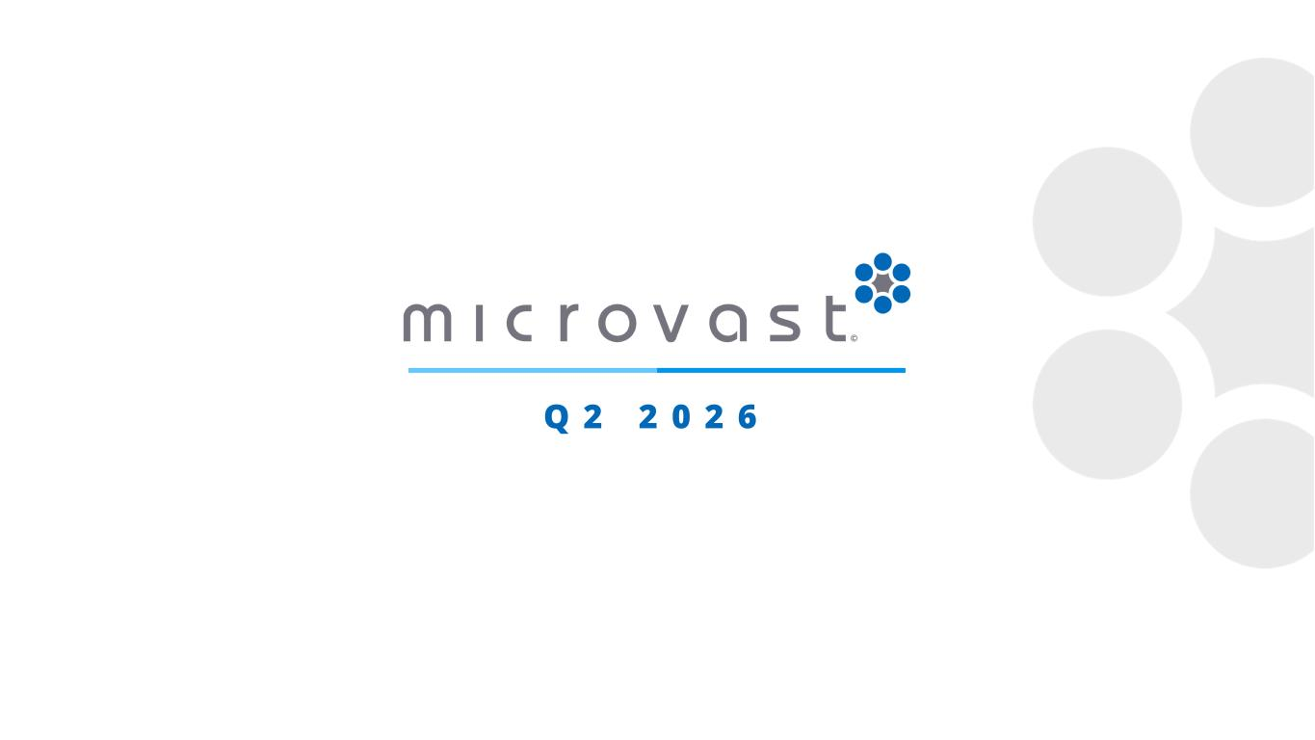
15
Q 2 2 0 2 6

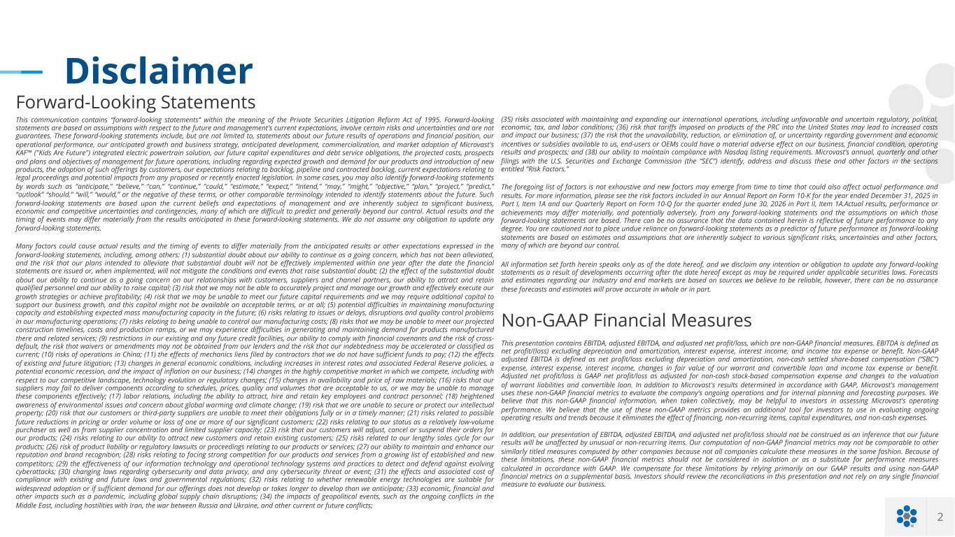
2 Disclaimer Forward-Looking Statements This communication contains “forward-looking statements” within the meaning of the Private Securities Litigation Reform Act of 1995. Forward-looking statements are based on assumptions with respect to the future and management's current expectations, involve certain risks and uncertainties and are not guarantees. These forward-looking statements include, but are not limited to, statements about our future results of operations and financial position, our operational performance, our anticipated growth and business strategy, anticipated development, commercialization, and market adoption of Microvast's KAF™ ("Kids Are Future") integrated electric powertrain solution, our future capital expenditures and debt service obligations, the projected costs, prospects and plans and objectives of management for future operations, including regarding expected growth and demand for our products and introduction of new products, the adoption of such offerings by customers, our expectations relating to backlog, pipeline and contracted backlog, current expectations relating to legal proceedings and potential impacts from any proposed or recently enacted legislation. In some cases, you may also identify forward-looking statements by words such as “anticipate,” “believe,” “can,” “continue,” “could,” “estimate,” “expect,” “intend,” “may,” “might,” “objective,” “plan,” “project,” “predict,” “outlook” “should,” “will,” “would,” or the negative of these terms, or other comparable terminology intended to identify statements about the future. Such forward-looking statements are based upon the current beliefs and expectations of management and are inherently subject to significant business, economic and competitive uncertainties and contingencies, many of which are difficult to predict and generally beyond our control. Actual results and the timing of events may differ materially from the results anticipated in these forward-looking statements. We do not assume any obligation to update any forward-looking statements. Many factors could cause actual results and the timing of events to differ materially from the anticipated results or other expectations expressed in the forward-looking statements, including, among others: (1) substantial doubt about our ability to continue as a going concern, which has not been alleviated, and the risk that our plans intended to alleviate that substantial doubt will not be effectively implemented within one year after the date the financial statements are issued or, when implemented, will not mitigate the conditions and events that raise substantial doubt; (2) the effect of the substantial doubt about our ability to continue as a going concern on our relationships with customers, suppliers and channel partners, our ability to attract and retain qualified personnel and our ability to raise capital; (3) risk that we may not be able to accurately project and manage our growth and effectively execute our growth strategies or achieve profitability; (4) risk that we may be unable to meet our future capital requirements and we may require additional capital to support our business growth, and this capital might not be available on acceptable terms, or at all; (5) potential difficulties in maintaining manufacturing capacity and establishing expected mass manufacturing capacity in the future; (6) risks relating to issues or delays, disruptions and quality control problems in our manufacturing operations; (7) risks relating to being unable to control our manufacturing costs; (8) risks that we may be unable to meet our projected construction timelines, costs and production ramps, or we may experience difficulties in generating and maintaining demand for products manufactured there and related services; (9) restrictions in our existing and any future credit facilities, our ability to comply with financial covenants and the risk of cross- default, the risk that waivers or amendments may not be obtained from our lenders and the risk that our indebtedness may be accelerated or classified as current; (10) risks of operations in China; (11) the effects of mechanics liens filed by contractors that we do not have sufficient funds to pay; (12) the effects of existing and future litigation; (13) changes in general economic conditions, including increases in interest rates and associated Federal Reserve policies, a potential economic recession, and the impact of inflation on our business; (14) changes in the highly competitive market in which we compete, including with respect to our competitive landscape, technology evolution or regulatory changes; (15) changes in availability and price of raw materials; (16) risks that our suppliers may fail to deliver components according to schedules, prices, quality and volumes that are acceptable to us, or we may be unable to manage these components effectively; (17) labor relations, including the ability to attract, hire and retain key employees and contract personnel; (18) heightened awareness of environmental issues and concern about global warming and climate change; (19) risk that we are unable to secure or protect our intellectual property; (20) risk that our customers or third-party suppliers are unable to meet their obligations fully or in a timely manner; (21) risks related to possible future reductions in pricing or order volume or loss of one or more of our significant customers; (22) risks relating to our status as a relatively low-volume purchaser as well as from supplier concentration and limited supplier capacity; (23) risk that our customers will adjust, cancel or suspend their orders for our products; (24) risks relating to our ability to attract new customers and retain existing customers; (25) risks related to our lengthy sales cycle for our products; (26) risk of product liability or regulatory lawsuits or proceedings relating to our products or services; (27) our ability to maintain and enhance our reputation and brand recognition; (28) risks relating to facing strong competition for our products and services from a growing list of established and new competitors; (29) the effectiveness of our information technology and operational technology systems and practices to detect and defend against evolving cyberattacks; (30) changing laws regarding cybersecurity and data privacy, and any cybersecurity threat or event; (31) the effects and associated cost of compliance with existing and future laws and governmental regulations; (32) risks relating to whether renewable energy technologies are suitable for widespread adoption or if sufficient demand for our offerings does not develop or takes longer to develop than we anticipate; (33) economic, financial and other impacts such as a pandemic, including global supply chain disruptions; (34) the impacts of geopolitical events, such as the ongoing conflicts in the Middle East, including hostilities with Iran, the war between Russia and Ukraine, and other current or future conflicts; Non-GAAP Financial Measures This presentation contains EBITDA, adjusted EBITDA, and adjusted net profit/loss, which are non-GAAP financial measures. EBITDA is defined as net profit/(loss) excluding depreciation and amortization, interest expense, interest income, and income tax expense or benefit. Non-GAAP adjusted EBITDA is defined as net profit/loss excluding depreciation and amortization, non-cash settled share-based compensation (“SBC”) expense, interest expense, interest income, changes in fair value of our warrant and convertible loan and income tax expense or benefit. Adjusted net profit/loss is GAAP net profit/loss as adjusted for non-cash stock-based compensation expense and changes to the valuation of warrant liabilities and convertible loan. In addition to Microvast's results determined in accordance with GAAP, Microvast's management uses these non-GAAP financial metrics to evaluate the company’s ongoing operations and for internal planning and forecasting purposes. We believe that this non-GAAP financial information, when taken collectively, may be helpful to investors in assessing Microvast's operating performance. We believe that the use of these non-GAAP metrics provides an additional tool for investors to use in evaluating ongoing operating results and trends because it eliminates the effect of financing, non-recurring items, capital expenditures, and non-cash expenses. In addition, our presentation of EBITDA, adjusted EBITDA, and adjusted net profit/loss should not be construed as an inference that our future results will be unaffected by unusual or non-recurring items. Our computation of non-GAAP financial metrics may not be comparable to other similarly titled measures computed by other companies because not all companies calculate these measures in the same fashion. Because of these limitations, these non-GAAP financial metrics should not be considered in isolation or as a substitute for performance measures calculated in accordance with GAAP. We compensate for these limitations by relying primarily on our GAAP results and using non-GAAP financial metrics on a supplemental basis. Investors should review the reconciliations in this presentation and not rely on any single financial measure to evaluate our business. (35) risks associated with maintaining and expanding our international operations, including unfavorable and uncertain regulatory, political, economic, tax, and labor conditions; (36) risk that tariffs imposed on products of the PRC into the United States may lead to increased costs and impact our business; (37) the risk that the unavailability, reduction, or elimination of, or uncertainty regarding government and economic incentives or subsidies available to us, end-users or OEMs could have a material adverse effect on our business, financial condition, operating results and prospects; and (38) our ability to maintain compliance with Nasdaq listing requirements. Microvast’s annual, quarterly and other filings with the U.S. Securities and Exchange Commission (the “SEC”) identify, address and discuss these and other factors in the sections entitled “Risk Factors.” The foregoing list of factors is not exhaustive and new factors may emerge from time to time that could also affect actual performance and results. For more information, please see the risk factors included in our Annual Report on Form 10-K for the year ended December 31, 2025 in Part I, Item 1A and our Quarterly Report on Form 10-Q for the quarter ended June 30, 2026 in Part II, Item 1A.Actual results, performance or achievements may differ materially, and potentially adversely, from any forward-looking statements and the assumptions on which those forward-looking statements are based. There can be no assurance that the data contained herein is reflective of future performance to any degree. You are cautioned not to place undue reliance on forward-looking statements as a predictor of future performance as forward-looking statements are based on estimates and assumptions that are inherently subject to various significant risks, uncertainties and other factors, many of which are beyond our control. All information set forth herein speaks only as of the date hereof, and we disclaim any intention or obligation to update any forward-looking statements as a result of developments occurring after the date hereof except as may be required under applicable securities laws. Forecasts and estimates regarding our industry and end markets are based on sources we believe to be reliable, however, there can be no assurance these forecasts and estimates will prove accurate in whole or in part.

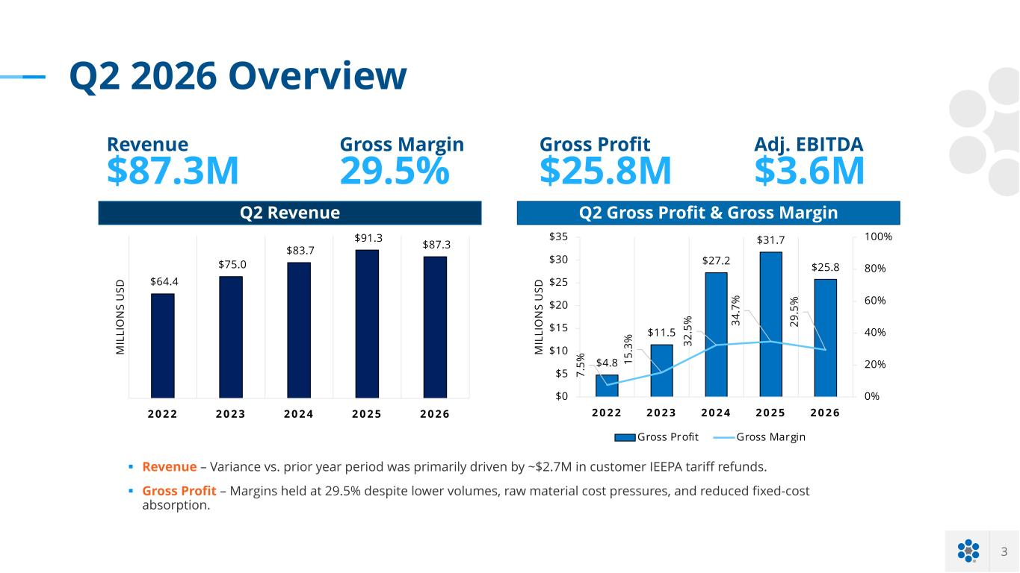
3 Q2 2026 Overview Q2 Revenue Q2 Gross Profit & Gross Margin § Revenue – Variance vs. prior year period was primarily driven by ~$2.7M in customer IEEPA tariff refunds. § Gross Profit – Margins held at 29.5% despite lower volumes, raw material cost pressures, and reduced fixed-cost absorption. Revenue $87.3M Gross Margin 29.5% Adj. EBITDA $3.6M Gross Profit $25.8M $64.4 $75.0 $83.7 $91.3 $87.3 2 0 2 2 2 0 2 3 2 0 2 4 2 0 2 5 2 0 2 6 M IL LI O N S U SD $4.8 $11.5 $27.2 $31.7 $25.8 7. 5% 15 .3 % 32 .5 % 34 .7 % 29 .5 % 0% 20% 40% 60% 80% 100% $0 $5 $10 $15 $20 $25 $30 $35 2 0 2 2 2 0 2 3 2 0 2 4 2 0 2 5 2 0 2 6 M IL LI O N S U SD Gross Profit Gross Margin

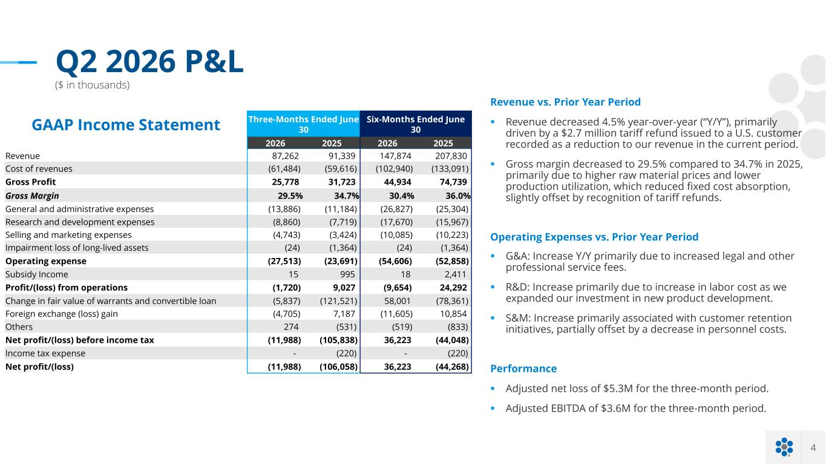
4 Q2 2026 P&L ($ in thousands) Revenue vs. Prior Year Period § Revenue decreased 4.5% year-over-year (“Y/Y”), primarily driven by a $2.7 million tariff refund issued to a U.S. customer recorded as a reduction to our revenue in the current period. § Gross margin decreased to 29.5% compared to 34.7% in 2025, primarily due to higher raw material prices and lower production utilization, which reduced fixed cost absorption, slightly offset by recognition of tariff refunds. Operating Expenses vs. Prior Year Period § G&A: Increase Y/Y primarily due to increased legal and other professional service fees. § R&D: Increase primarily due to increase in labor cost as we expanded our investment in new product development. § S&M: Increase primarily associated with customer retention initiatives, partially offset by a decrease in personnel costs. Performance § Adjusted net loss of $5.3M for the three-month period. § Adjusted EBITDA of $3.6M for the three-month period. GAAP Income Statement Three-Months Ended June 30 Six-Months Ended June 30 2026 2025 2026 2025 Revenue 87,262 91,339 147,874 207,830 Cost of revenues (61,484) (59,616) (102,940) (133,091) Gross Profit 25,778 31,723 44,934 74,739 Gross Margin 29.5% 34.7% 30.4% 36.0% General and administrative expenses (13,886) (11,184) (26,827) (25,304) Research and development expenses (8,860) (7,719) (17,670) (15,967) Selling and marketing expenses (4,743) (3,424) (10,085) (10,223) Impairment loss of long-lived assets (24) (1,364) (24) (1,364) Operating expense (27,513) (23,691) (54,606) (52,858) Subsidy Income 15 995 18 2,411 Profit/(loss) from operations (1,720) 9,027 (9,654) 24,292 Change in fair value of warrants and convertible loan (5,837) (121,521) 58,001 (78,361) Foreign exchange (loss) gain (4,705) 7,187 (11,605) 10,854 Others 274 (531) (519) (833) Net profit/(loss) before income tax (11,988) (105,838) 36,223 (44,048) Income tax expense - (220) - (220) Net profit/(loss) (11,988) (106,058) 36,223 (44,268)

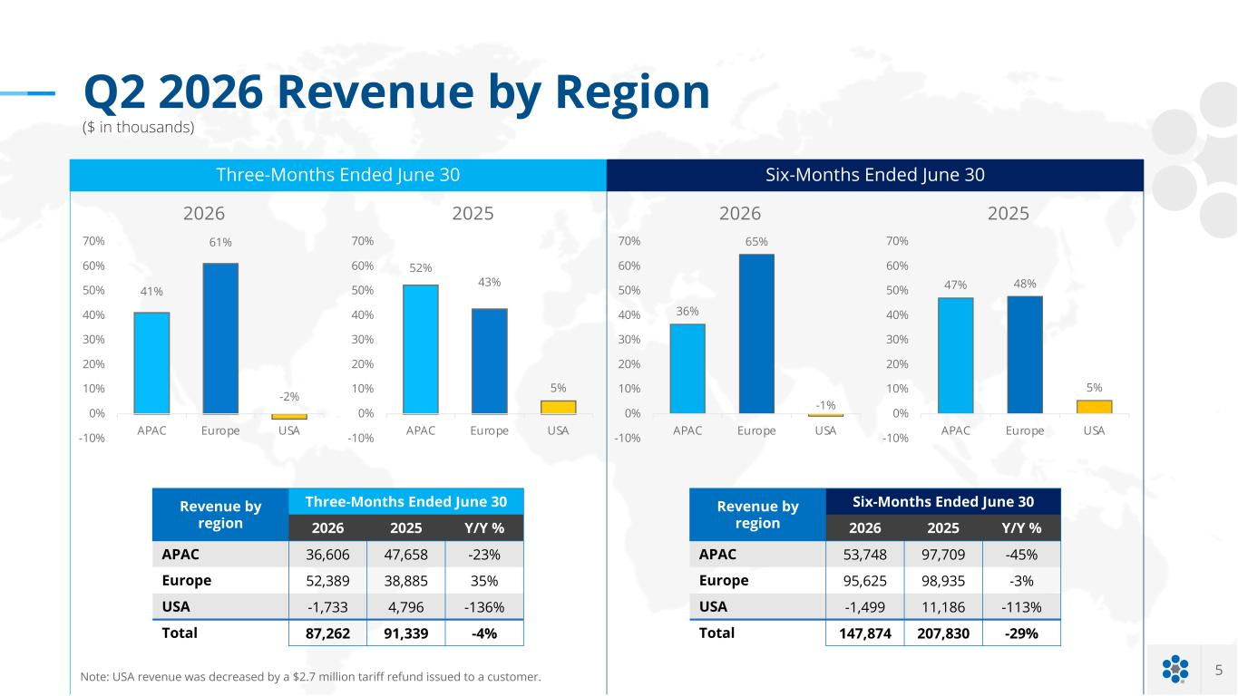
5 Q2 2026 Revenue by Region ($ in thousands) Revenue by region Three-Months Ended June 30 2026 2025 Y/Y % APAC 36,606 47,658 -23% Europe 52,389 38,885 35% USA -1,733 4,796 -136% Total 87,262 91,339 -4% Three-Months Ended June 30 Revenue by region Six-Months Ended June 30 2026 2025 Y/Y % APAC 53,748 97,709 -45% Europe 95,625 98,935 -3% USA -1,499 11,186 -113% Total 147,874 207,830 -29% Six-Months Ended June 30 41% 61% -2% APAC Europe USA-10% 0% 10% 20% 30% 40% 50% 60% 70% 2026 52% 43% 5% -10% 0% 10% 20% 30% 40% 50% 60% 70% APAC Europe USA 2025 36% 65% -1% -10% 0% 10% 20% 30% 40% 50% 60% 70% APAC Europe USA 2026 47% 48% 5% APAC Europe USA-10% 0% 10% 20% 30% 40% 50% 60% 70% 2025 Note: USA revenue was decreased by a $2.7 million tariff refund issued to a customer.

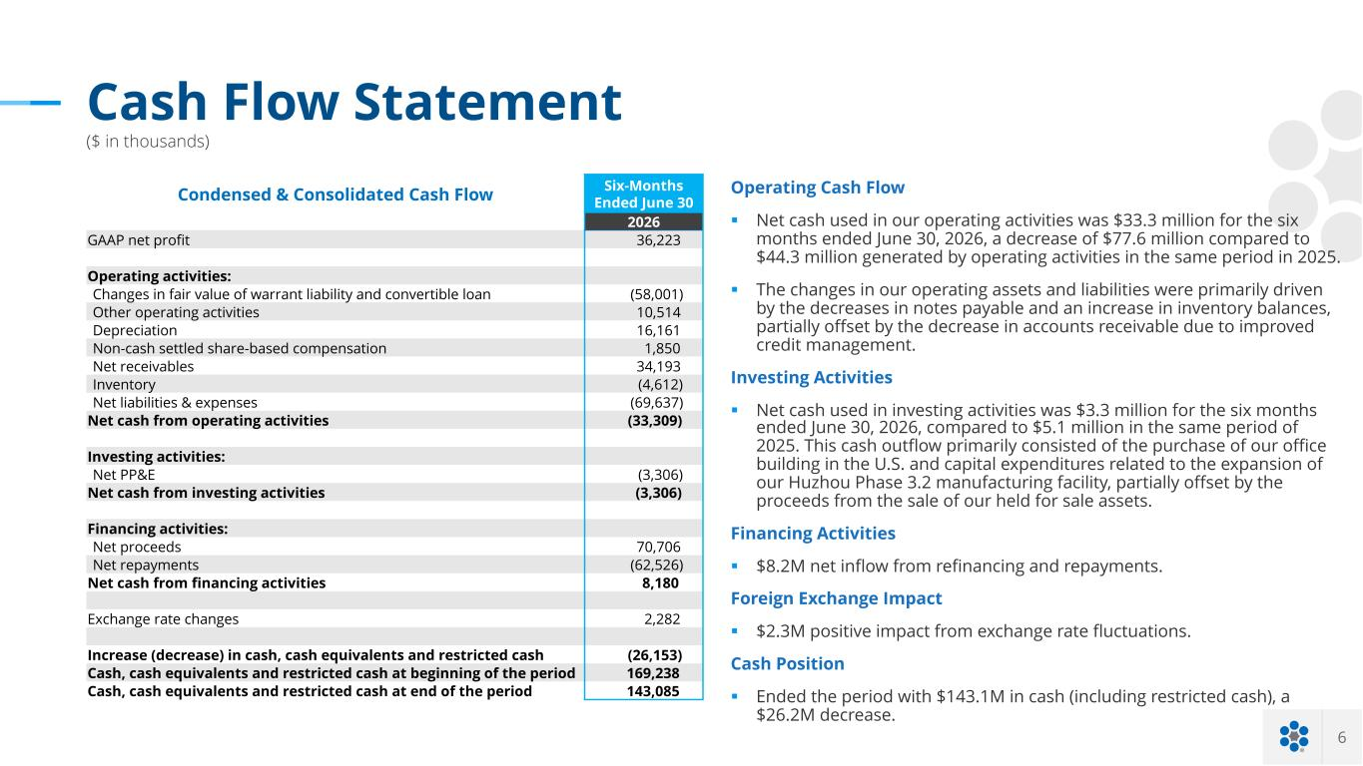
6 Cash Flow Statement ($ in thousands) Operating Cash Flow § Net cash used in our operating activities was $33.3 million for the six months ended June 30, 2026, a decrease of $77.6 million compared to $44.3 million generated by operating activities in the same period in 2025. § The changes in our operating assets and liabilities were primarily driven by the decreases in notes payable and an increase in inventory balances, partially offset by the decrease in accounts receivable due to improved credit management. Investing Activities § Net cash used in investing activities was $3.3 million for the six months ended June 30, 2026, compared to $5.1 million in the same period of 2025. This cash outflow primarily consisted of the purchase of our office building in the U.S. and capital expenditures related to the expansion of our Huzhou Phase 3.2 manufacturing facility, partially offset by the proceeds from the sale of our held for sale assets. Financing Activities § $8.2M net inflow from refinancing and repayments. Foreign Exchange Impact § $2.3M positive impact from exchange rate fluctuations. Cash Position § Ended the period with $143.1M in cash (including restricted cash), a $26.2M decrease. Condensed & Consolidated Cash Flow Six-Months Ended June 30 2026 GAAP net profit 36,223 Operating activities: Changes in fair value of warrant liability and convertible loan (58,001) Other operating activities 10,514 Depreciation 16,161 Non-cash settled share-based compensation 1,850 Net receivables 34,193 Inventory (4,612) Net liabilities & expenses (69,637) Net cash from operating activities (33,309) Investing activities: Net PP&E (3,306) Net cash from investing activities (3,306) Financing activities: Net proceeds 70,706 Net repayments (62,526) Net cash from financing activities 8,180 Exchange rate changes 2,282 Increase (decrease) in cash, cash equivalents and restricted cash (26,153) Cash, cash equivalents and restricted cash at beginning of the period 169,238 Cash, cash equivalents and restricted cash at end of the period 143,085


U P D A T E S & L O N G - T E R M S T R A T E G Y

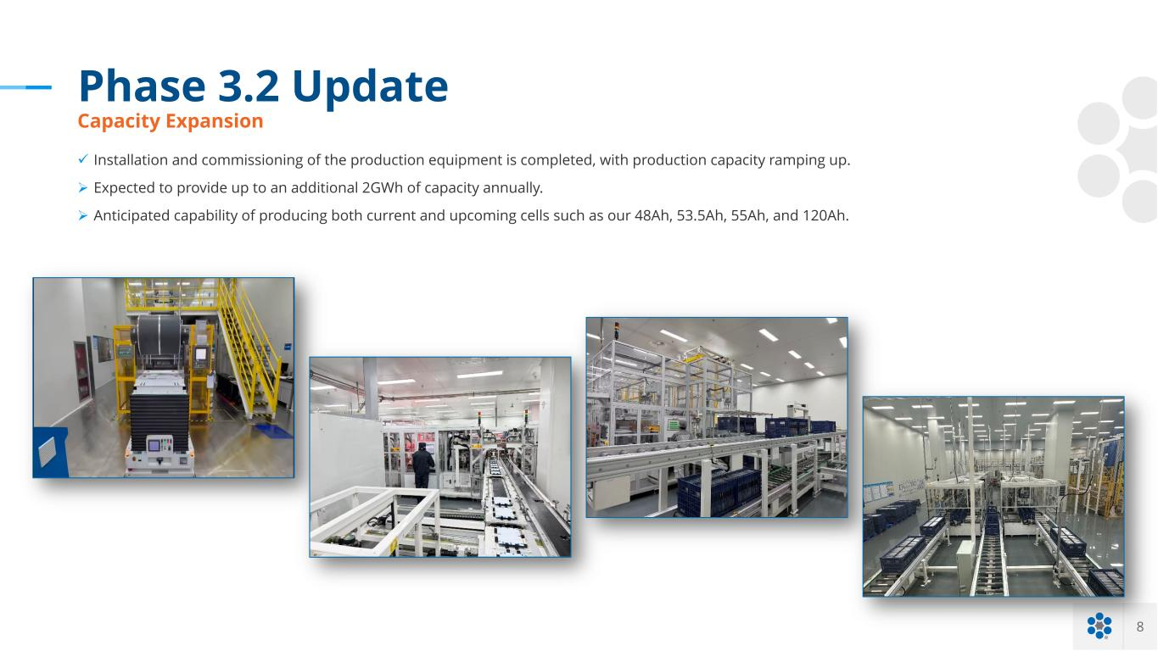
8 Phase 3.2 Update Capacity Expansion ü Installation and commissioning of the production equipment is completed, with production capacity ramping up. Ø Expected to provide up to an additional 2GWh of capacity annually. Ø Anticipated capability of producing both current and upcoming cells such as our 48Ah, 53.5Ah, 55Ah, and 120Ah.

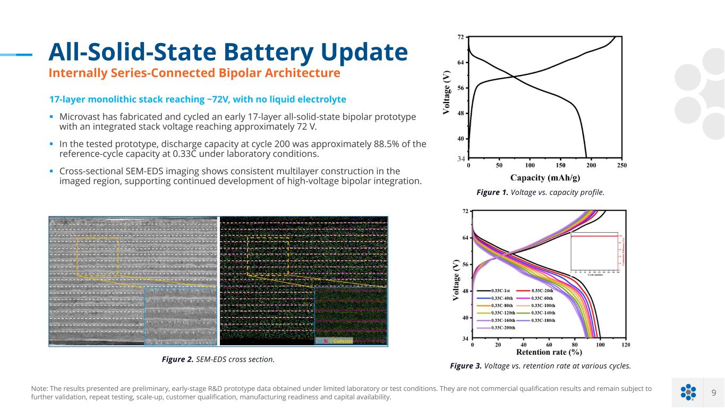
9 All-Solid-State Battery Update Internally Series-Connected Bipolar Architecture Figure 2. SEM-EDS cross section. Figure 1. Voltage vs. capacity profile. 34 Figure 3. Voltage vs. retention rate at various cycles. Note: The results presented are preliminary, early-stage R&D prototype data obtained under limited laboratory or test conditions. They are not commercial qualification results and remain subject to further validation, repeat testing, scale-up, customer qualification, manufacturing readiness and capital availability. 17-layer monolithic stack reaching ~72V, with no liquid electrolyte § Microvast has fabricated and cycled an early 17-layer all-solid-state bipolar prototype with an integrated stack voltage reaching approximately 72 V. § In the tested prototype, discharge capacity at cycle 200 was approximately 88.5% of the reference-cycle capacity at 0.33C under laboratory conditions. § Cross-sectional SEM-EDS imaging shows consistent multilayer construction in the imaged region, supporting continued development of high-voltage bipolar integration.

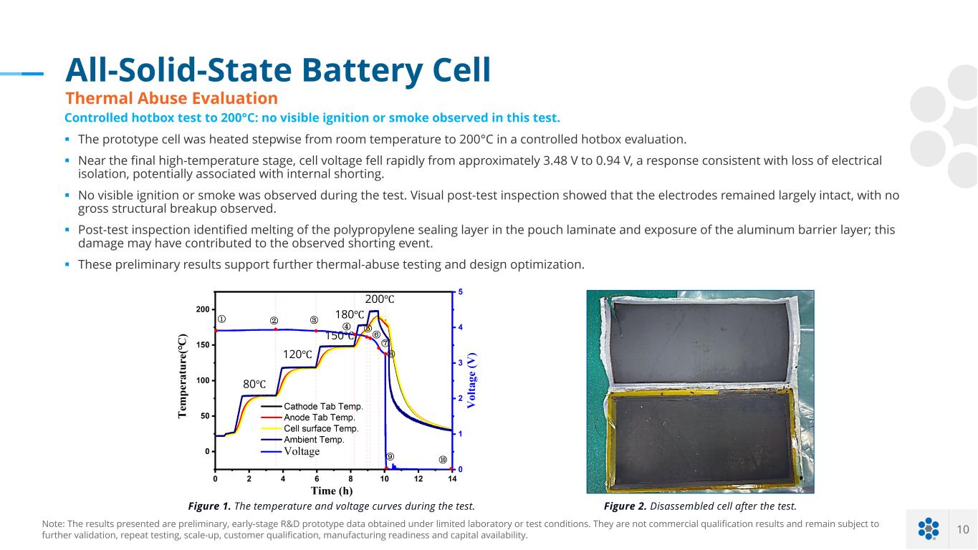
10 All-Solid-State Battery Cell Thermal Abuse Evaluation 80℃ 120℃ 150℃ 180℃ 200℃ ① ② ③ ④ ⑤ ⑥ ⑦ ⑧ ⑩⑨ Figure 1. The temperature and voltage curves during the test. Figure 2. Disassembled cell after the test. Note: The results presented are preliminary, early-stage R&D prototype data obtained under limited laboratory or test conditions. They are not commercial qualification results and remain subject to further validation, repeat testing, scale-up, customer qualification, manufacturing readiness and capital availability. Controlled hotbox test to 200°C: no visible ignition or smoke observed in this test. § The prototype cell was heated stepwise from room temperature to 200°C in a controlled hotbox evaluation. § Near the final high-temperature stage, cell voltage fell rapidly from approximately 3.48 V to 0.94 V, a response consistent with loss of electrical isolation, potentially associated with internal shorting. § No visible ignition or smoke was observed during the test. Visual post-test inspection showed that the electrodes remained largely intact, with no gross structural breakup observed. § Post-test inspection identified melting of the polypropylene sealing layer in the pouch laminate and exposure of the aluminum barrier layer; this damage may have contributed to the observed shorting event. § These preliminary results support further thermal-abuse testing and design optimization.

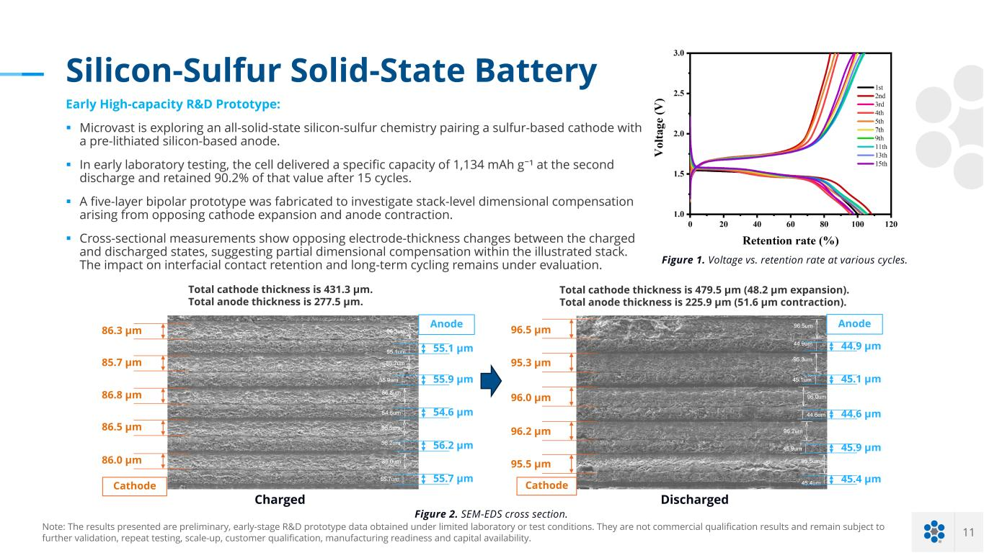
11 Silicon-Sulfur Solid-State Battery Figure 1. Voltage vs. retention rate at various cycles. 55.1 µm 86.3 µm 85.7 µm 86.8 µm 86.5 µm 86.0 µm 55.9 µm 54.6 µm 56.2 µm 55.7 µm 44.9 µm 45.1 µm 44.6 µm 45.9 µm 45.4 µm Anode Figure 2. SEM-EDS cross section. Anode Cathode Charged Discharged 96.5 µm 95.3 µm 96.0 µm 96.2 µm 95.5 µm Cathode Total cathode thickness is 431.3 µm. Total anode thickness is 277.5 µm. Total cathode thickness is 479.5 µm (48.2 µm expansion). Total anode thickness is 225.9 µm (51.6 µm contraction). Note: The results presented are preliminary, early-stage R&D prototype data obtained under limited laboratory or test conditions. They are not commercial qualification results and remain subject to further validation, repeat testing, scale-up, customer qualification, manufacturing readiness and capital availability. Early High-capacity R&D Prototype: § Microvast is exploring an all-solid-state silicon-sulfur chemistry pairing a sulfur-based cathode with a pre-lithiated silicon-based anode. § In early laboratory testing, the cell delivered a specific capacity of 1,134 mAh g⁻¹ at the second discharge and retained 90.2% of that value after 15 cycles. § A five-layer bipolar prototype was fabricated to investigate stack-level dimensional compensation arising from opposing cathode expansion and anode contraction. § Cross-sectional measurements show opposing electrode-thickness changes between the charged and discharged states, suggesting partial dimensional compensation within the illustrated stack. The impact on interfacial contact retention and long-term cycling remains under evaluation.

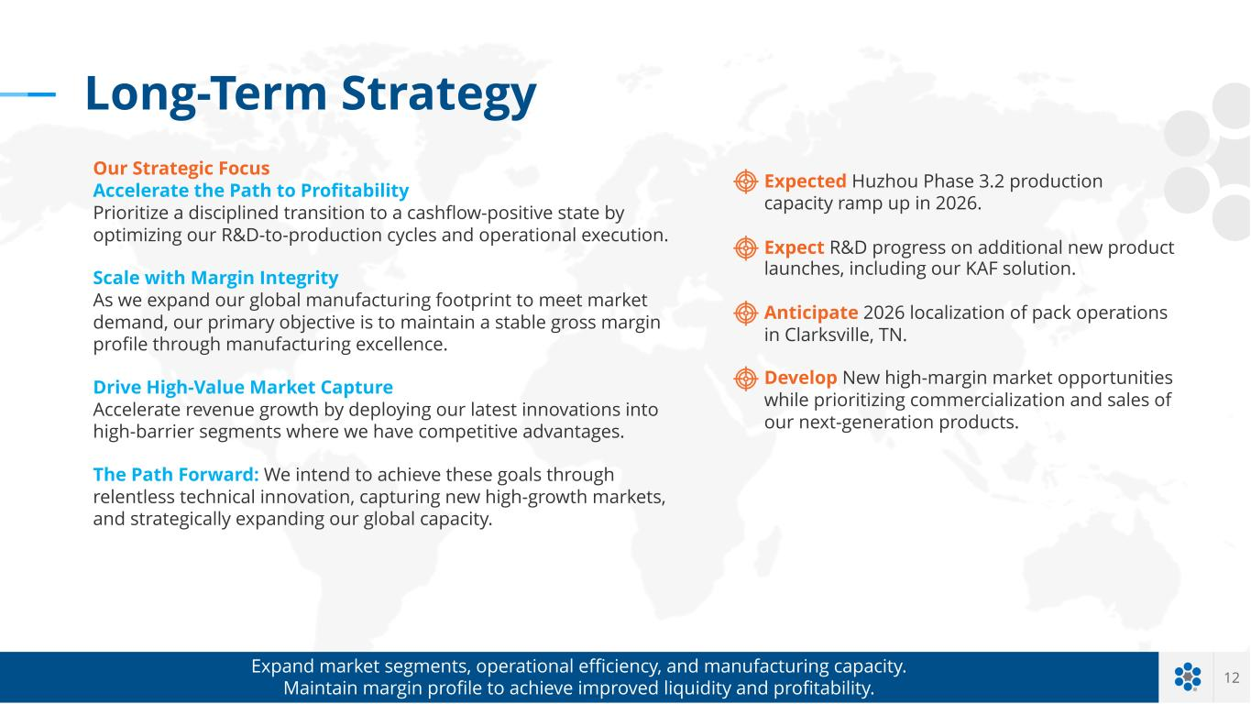
12 Expected Huzhou Phase 3.2 production capacity ramp up in 2026. Expect R&D progress on additional new product launches, including our KAF solution. Anticipate 2026 localization of pack operations in Clarksville, TN. Develop New high-margin market opportunities while prioritizing commercialization and sales of our next-generation products. Expand market segments, operational efficiency, and manufacturing capacity. Maintain margin profile to achieve improved liquidity and profitability. Long-Term Strategy Our Strategic Focus Accelerate the Path to Profitability Prioritize a disciplined transition to a cashflow-positive state by optimizing our R&D-to-production cycles and operational execution. Scale with Margin Integrity As we expand our global manufacturing footprint to meet market demand, our primary objective is to maintain a stable gross margin profile through manufacturing excellence. Drive High-Value Market Capture Accelerate revenue growth by deploying our latest innovations into high-barrier segments where we have competitive advantages. The Path Forward: We intend to achieve these goals through relentless technical innovation, capturing new high-growth markets, and strategically expanding our global capacity.


A P P E N D I X

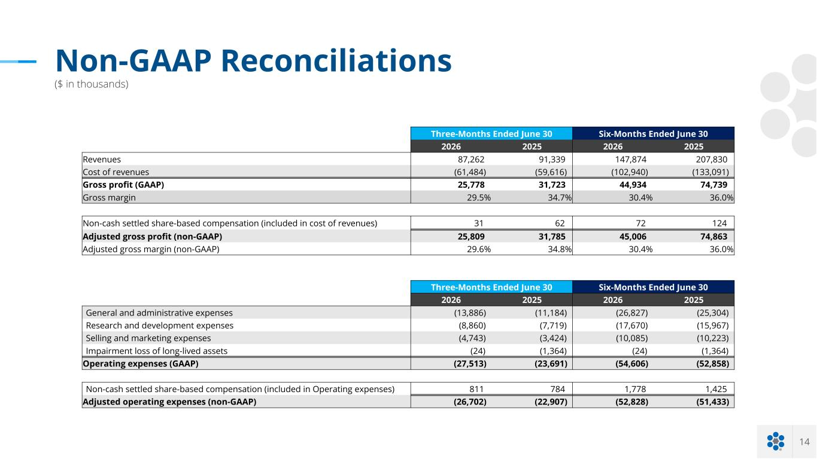
14 Non-GAAP Reconciliations ($ in thousands) Three-Months Ended June 30 Six-Months Ended June 30 2026 2025 2026 2025 Revenues 87,262 91,339 147,874 207,830 Cost of revenues (61,484) (59,616) (102,940) (133,091) Gross profit (GAAP) 25,778 31,723 44,934 74,739 Gross margin 29.5% 34.7% 30.4% 36.0% Non-cash settled share-based compensation (included in cost of revenues) 31 62 72 124 Adjusted gross profit (non-GAAP) 25,809 31,785 45,006 74,863 Adjusted gross margin (non-GAAP) 29.6% 34.8% 30.4% 36.0% Three-Months Ended June 30 Six-Months Ended June 30 2026 2025 2026 2025 General and administrative expenses (13,886) (11,184) (26,827) (25,304) Research and development expenses (8,860) (7,719) (17,670) (15,967) Selling and marketing expenses (4,743) (3,424) (10,085) (10,223) Impairment loss of long-lived assets (24) (1,364) (24) (1,364) Operating expenses (GAAP) (27,513) (23,691) (54,606) (52,858) Non-cash settled share-based compensation (included in Operating expenses) 811 784 1,778 1,425 Adjusted operating expenses (non-GAAP) (26,702) (22,907) (52,828) (51,433)

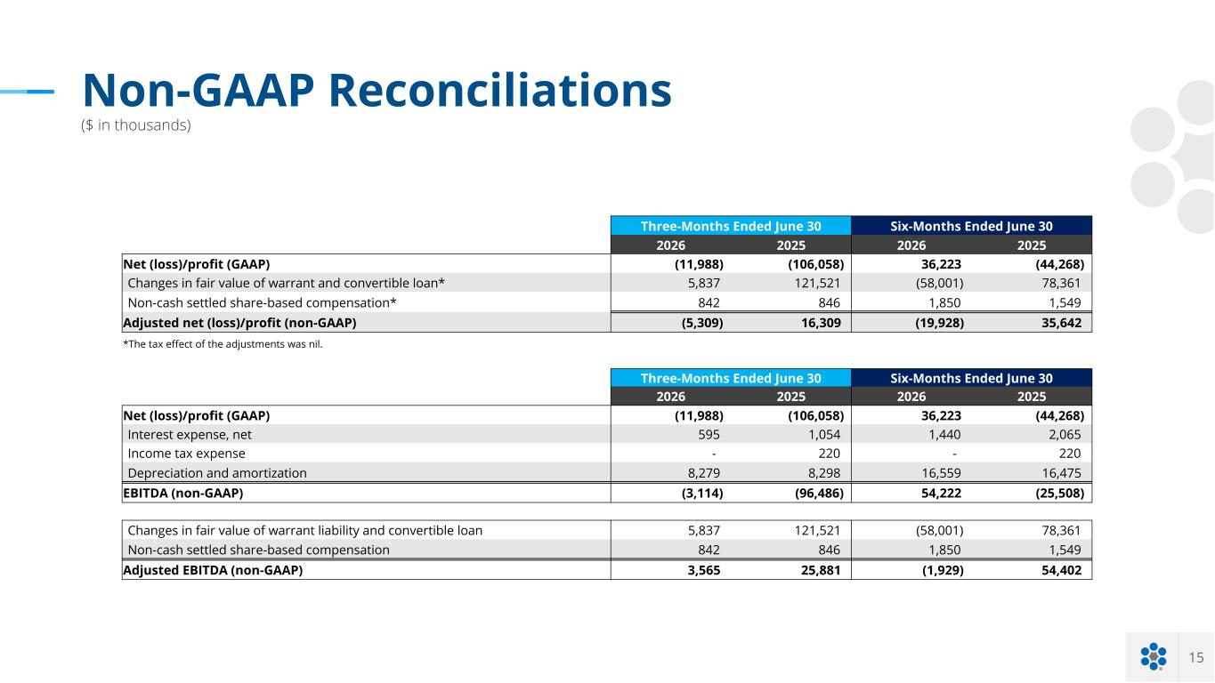
15 Non-GAAP Reconciliations ($ in thousands) Three-Months Ended June 30 Six-Months Ended June 30 2026 2025 2026 2025 Net (loss)/profit (GAAP) (11,988) (106,058) 36,223 (44,268) Changes in fair value of warrant and convertible loan* 5,837 121,521 (58,001) 78,361 Non-cash settled share-based compensation* 842 846 1,850 1,549 Adjusted net (loss)/profit (non-GAAP) (5,309) 16,309 (19,928) 35,642 *The tax effect of the adjustments was nil. Three-Months Ended June 30 Six-Months Ended June 30 2026 2025 2026 2025 Net (loss)/profit (GAAP) (11,988) (106,058) 36,223 (44,268) Interest expense, net 595 1,054 1,440 2,065 Income tax expense - 220 - 220 Depreciation and amortization 8,279 8,298 16,559 16,475 EBITDA (non-GAAP) (3,114) (96,486) 54,222 (25,508) Changes in fair value of warrant liability and convertible loan 5,837 121,521 (58,001) 78,361 Non-cash settled share-based compensation 842 846 1,850 1,549 Adjusted EBITDA (non-GAAP) 3,565 25,881 (1,929) 54,402

