UNITED STATES

SECURITIES AND EXCHANGE COMMISSION

Washington, D.C. 20549

 |  |  | FORM 8-K
 |  |  | CURRENT REPORT
 |  |  | PURSUANT TO SECTION 13 OR 15(d)
 |  |  | OF THE SECURITIES EXCHANGE ACT OF 1934
 | Date of Report (Date of earliest event reported): February 1, 2021
 |  |  | TUSCAN HOLDINGS CORP.
 |  | (Exact Name of Registrant as Specified in its Charter)
Delaware | 001-38826 |  |  |  |  | 83-2530757
(State or other jurisdiction |  |  | (Commission file number) |  |  | (IRS Employer
of incorporation) |  |  |  |  |  | Identification No.)
 |  |  | 135 E. 57th Street, 18th Floor
 |  |  | New York, NY 10022
 |  |  | (Address of principal executive offices) (Zip Code)
 | Registrant’s telephone number, including area code: (646) 948-7100
 |  |  | Not Applicable
 | (Former Name, or Former Address, if Changed Since Last Report)

Check the appropriate box below if the Form 8-K filing is intended to simultaneously satisfy the filing obligation of the registrant under any of the following provisions:

- Written communications pursuant to Rule 425 under the Securities Act (17 CFR 230.425) ☒ Soliciting material pursuant to Rule 14a-12 under the Exchange Act (17 CFR 240.14a-12)
- Pre-commencement communications pursuant to Rule 14d-2(b) under the Exchange Act (17 CFR 240.14d-2(b))

- Pre-commencement communications pursuant to Rule 13e-4(c) under the Exchange Act (17 CFR 240.13e-4(c))

Securities registered pursuant to Section 12(b) of the Act:
Title of each class |  | Trading Symbol(s) |  | Name of each exchange on which registered
Units, each consisting of one share of common stock |  | THCBU |  | The Nasdaq Stock Market LLC
and one-half of one redeemable warrant
Common stock, par value $0.0001 per share |  | THCB |  | The Nasdaq Stock Market LLC
Redeemable warrants, exercisable for shares of |  | THCBW |  | The Nasdaq Stock Market LLC
common stock at an exercise price of $11.50 per
share

Indicate by check mark whether the registrant is an emerging growth company as defined in Rule 405 of the Securities Act of 1933 (§230.405 of this chapter) or Rule 12b-2 of the Securities Exchange Act of 1934 (§240.12b-2 of this chapter).

Emerging growth company ☒

If an emerging growth company, indicate by check mark if the registrant has elected not to use the extended transition period for complying with any new or revised financial accounting standards provided pursuant to Section 13(a) of the Exchange Act. ☐

Item 7.01 Regulation FD Disclosure.

On February 1, 2021, Tuscan Holdings Corp., a Delaware corporation (“Parent”), and Microvast, Inc., a Delaware corporation (the “Company”), jointly issued a press release announcing the execution of an agreement and plan of merger (the “Merger Agreement”) among Parent, the Company, and TSCN Merger Sub Inc., a Delaware corporation and wholly-owned subsidiary of Parent (“Merger Sub”), pursuant to which Merger Sub will be merged with and into the Company, with the Company surviving the Merger as a wholly-owned direct subsidiary of Parent (the “Merger,” together with the other transactions related thereto, the “Proposed Transaction”). A copy of the press release is attached hereto as Exhibit 99.1 and incorporated herein by reference.

Attached as Exhibit 99.2 to this Current Report on Form 8-K and incorporated herein by reference is the form of presentation to be used by Parent in presentations for certain of Parent’s stockholders and other persons regarding the Proposed Transaction.

Attached hereto as Exhibit 99.3 is the transcript of a pre-recorded joint conference call held on February 1, 2021, by Parent and the Company in connection with the announcement of their entry into the Merger Agreement.

The foregoing exhibits and the information set forth therein shall not be deemed to be filed for purposes of Section 18 of the Securities Exchange Act of 1934, as amended (the “Exchange Act”), or otherwise be subject to the liabilities of that section, nor shall it be deemed to be incorporated by reference in any filing under the Securities Act of 1933, as amended (the “Securities Act”), or the Exchange Act.

Additional Information and Where to Find It

In connection with the Proposed Transaction involving Parent and the Company, Parent intends to file relevant materials with the SEC, including a proxy statement. This document is not a substitute for the proxy statement. INVESTORS AND SECURITY HOLDERS AND OTHER INTERESTED PARTIES ARE URGED TO READ THE PROXY STATEMENT AND ANY OTHER RELEVANT DOCUMENTS THAT ARE FILED OR WILL BE FILED WITH THE SEC, AS WELL AS ANY AMENDMENTS OR SUPPLEMENTS TO THESE DOCUMENTS, CAREFULLY AND IN THEIR ENTIRETY WHEN THEY BECOME AVAILABLE BECAUSE THEY WILL CONTAIN IMPORTANT INFORMATION ABOUT PARENT, THE COMPANY, THE PROPOSED TRANSACTION AND RELATED MATTERS. The proxy statement and other documents relating to the Proposed Transaction (when they are available) can be obtained free of charge from the SEC’s website at www.sec.gov. These documents (when they are available) can also be obtained free of charge from Parent upon written request to Parent at: Tuscan Holdings Corp., 135 E. 57th St., 17th Floor, New York, NY 10022.

No Offer or Solicitation

This Current Report on Form 8-K is for informational purposes only and is not intended to and shall not constitute a proxy statement or the solicitation of a proxy, consent or authorization with respect to any securities or in respect of the Proposed Transaction and is not intended to and shall not constitute an offer to sell or the solicitation of an offer to sell or the solicitation of an offer to buy or subscribe for any securities or a solicitation of any vote of approval, nor shall there be any sale, issuance or transfer of securities in any jurisdiction in which such offer, solicitation or sale would be unlawful prior to registration or qualification under the securities laws of any such jurisdiction.

Participants in Solicitation

This Current Report on Form 8-K is not a solicitation of a proxy from any investor or securityholder. However, Parent, the Company, and certain of their directors and executive officers may be deemed to be participants in the solicitation of proxies in connection with the Proposed Transaction under the rules of the SEC. Information about Parent’s directors and executive officers and their ownership of Parent’s securities is set forth in Parent’s filings with the SEC, including Parent’s Annual Report on Form 10-K for the fiscal year ended December 31, 2019, which was filed with the SEC on March 13, 2020. To the extent that holdings of Parent’s securities have changed since the amounts included in Parent’s Annual Report, such changes have been or will be reflected on Statements of Change in Ownership on Form 4 filed with the SEC. Additional information regarding the participants will also be included in the proxy statement, when it becomes available. When available, these documents can be obtained free of charge from the sources indicated above.

1

Cautionary Statement Regarding Forward-Looking Statements

This Current Report on Form 8-K contains “forward-looking statements” within the meaning of the Private Securities Litigation Reform Act of 1995. Such statements include, but are not limited to, statements about future financial and operating results, our plans, objectives, expectations and intentions with respect to future operations, products and services; and other statements identified by words such as “will likely result,” “are expected to,” “will continue,” “is anticipated,” “estimated,” “believe,” “intend,” “plan,” “projection,” “outlook” or words of similar meaning. These forward-looking statements include, but are not limited to, statements regarding the Company’s industry and market sizes, future opportunities for Parent, the Company and the combined company, Parent’s and the Company’s estimated future results and the Proposed Transaction, including the implied enterprise value, the expected transaction and ownership structure and the likelihood and ability of the parties to successfully consummate the Proposed Transaction. Such forward-looking statements are based upon the current beliefs and expectations of our management and are inherently subject to significant business, economic and competitive uncertainties and contingencies, many of which are difficult to predict and generally beyond our control. Actual results and the timing of events may differ materially from the results anticipated in these forward-looking statements.

In addition to factors previously disclosed in Parent’s reports filed with the SEC and those identified elsewhere in this communication, the following factors, among others, could cause actual results and the timing of events to differ materially from the anticipated results or other expectations expressed in the forward-looking statements: (1) inability to complete the Proposed Transaction or, if Parent does not complete the Proposed Transaction, any other business combination; (2) the inability to complete the Proposed Transaction due to the failure to meet the closing conditions to the Proposed Transaction, including the inability to obtain approval of Parent’s stockholders, the inability to consummate the contemplated PIPE financing, the failure to achieve the minimum amount of cash available following any redemptions by Parent stockholders, the failure to meet the Nasdaq listing standards in connection with the consummation of the Proposed Transaction, or the occurrence of any event, change or other circumstances that could give rise to the termination of the definitive agreement; (3) costs related to the Proposed Transaction; (4) a delay or failure to realize the expected benefits from the Proposed Transaction; (5) risks related to disruption of management time from ongoing business operations due to the Proposed Transaction; (6) the impact of the ongoing COVID-19 pandemic; (7) changes in the highly competitive market in which the Company competes, including with respect to its competitive landscape, technology evolution or regulatory changes; (8) changes in the markets that the Company targets; (9) risk that the Company may not be able to execute its growth strategies or achieve profitability;

- the risk that the Company is unable to secure or protect its intellectual property; (11) the risk that the Company’s customers or third-party suppliers are unable to meet their obligations fully or in a timely manner; (12) the risk that the Company’s customers will adjust, cancel or suspend their orders for the Company’s products; (13) the risk that the Company will need to raise additional capital to execute its business plan, which may not be available on acceptable terms or at all; (14) the risk of product liability or regulatory lawsuits or proceedings relating to the Company’s products or services, and (15) the risk that the Company may not be able to develop and maintain effective internal controls; (16) the outcome of any legal proceedings that may be instituted against Parent, the Company or any of their respective directors or officers following the announcement of the Proposed Combination; (17) risks of operations in the People’s Republic of China; and (18) the failure to realize anticipated pro forma results and underlying assumptions, including with respect to estimated stockholder redemptions and purchase price and other adjustments.

Actual results, performance or achievements may differ materially, and potentially adversely, from any projections and forward-looking statements and the assumptions on which those forward-looking statements are based. There can be no assurance that the data contained herein is reflective of future performance to any degree. You are cautioned not to place undue reliance on forward-looking statements as a predictor of future performance as projected financial information and other information are based on estimates and assumptions that are inherently subject to various significant risks, uncertainties and other factors, many of which are beyond our control. All information set forth herein speaks only as of the date hereof in the case of information about Parent and the Company or the date of such information in the case of information from persons other than Parent or the Company, and we disclaim any intention or obligation to update any forward-looking statements as a result of developments occurring after the date of this communication. Forecasts and estimates regarding The Company’s industry and end markets are based on sources we believe to be reliable, however there can be no assurance these forecasts and estimates will prove accurate in whole or in part. Annualized, pro forma, projected and estimated numbers are used for illustrative purpose only, are not forecasts and may not reflect actual results.

Item 8.01 Other Events.

The disclosure set forth above in Item 7.01 of this Current Report on Form 8-K is incorporated by reference herein.

Item 9.01 | Financial Statements and Exhibits.
(d) Exhibits.
99.1 | Press Release, dated February 1, 2021.
99.2 | Investor Presentation.
99.3 | Transcript of Investor Call.
104 | Cover Page Interactive File (the cover page tags are embedded within the Inline XBRL document).
 | 2

SIGNATURES

Pursuant to the requirements of the Securities Exchange Act of 1934, the registrant has duly caused this report to be signed on its behalf by the undersigned hereunto duly authorized.

 | TUSCAN HOLDINGS CORP.
Date: February 1, 2021 | By: /s/ Stephen A. Vogel
 |  | Name: | Stephen A. Vogel
 |  | Title: | Chief Executive Officer
 | 3

Exhibit 99.1


Microvast, a Leading Innovator of EV Battery Technologies, to List on Nasdaq Through Merger with Tuscan Holdings Corp.

- Microvast is a leading global provider of next-generation battery technologies for commercial and specialty electric vehicles participating in a $30 billion commercial EV total addressable market

- It has an established, and industry-leading, portfolio of battery technologies that out-perform its competitors on battery life, charging times, safety and total cost of ownership

- These field-proven technologies generated over $100 million in 2020 revenue, and have been deployed worldwide in nearly 30K vehicles across many EV types, with over 3.8 billion miles traveled to date

- Merger provides up to $822 million in gross cash proceeds to the combined company, including $282 million of cash held by Tuscan in trust assuming no redemptions and an oversubscribed $540 million fully committed common stock PIPE at $10.00 per share¹

- Transaction to fund capacity expansion to 9 gigawatt hours by 2022, positioning the company to capitalize on its signed contracts with total value of over $1.5 billion

- Noted technology SPAC sponsor InterPrivate is serving as co-sponsor and advisor to Tuscan

- PIPE anchor investors include strategic partner Oshkosh Corporation as well as funds and accounts managed by BlackRock, Koch Strategic Platforms and InterPrivate

- Estimated pre-money value of $2.1 billion and post-transaction equity value of approximately $3 billion, inclusive of over $800 million of expected proceeds based upon current assumptions

- Expected to be listed on the Nasdaq under the ticker symbol MVST following an anticipated transaction close in the second quarter of 2021

HOUSTON, TX – February 1, 2021 – Microvast, Inc., a leading global provider of next-generation battery technologies for commercial and specialty vehicles (“Microvast” or the “Company”) and Tuscan Holdings Corp. (Nasdaq: THCB) (“Tuscan”), a publicly-traded special purpose acquisition company (“SPAC”), announced today that they have entered into a definitive merger agreement that will result in Microvast becoming a publicly listed company. Upon the closing of the transaction, the combined company will be named Microvast Holdings, Inc. and is expected to be listed on the Nasdaq Stock Market under the new ticker symbol “MVST.”

- Includes the exchange, pursuant to the definitive merger agreement, of $57.5 million of bridge notes issued by Microvast to a PIPE investor and its affiliates, for shares of common stock of Tuscan upon the closing of the transaction.

1

Microvast, founded in Houston in 2006, develops disruptive battery technologies for commercial and specialty vehicles, with research and development and production capabilities that span battery materials, multiple battery cell chemistries, modules and packs. The Company’s lower-cost batteries are designed specifically for commercial electric vehicles (EVs) that feature best-in-class fast-charging capabilities, high energy density, significantly longer cycle life and proven safety performance. Microvast’s batteries are now integrated in almost 30,000 vehicles, running in 160 cities in 19 countries, for a total of over 3.8 billion miles traveled on its batteries to date.

Microvast’s battery solutions are powered by its broad, proprietary intellectual property portfolio that spans all four major battery components and is fully owned and protected by more than 550 patents. Due to its highly differentiated, vertically integrated R&D and industrialization system, we believe Microvast delivers faster product development, tighter cost control and greater customization to its customers than does its competitors. As a result, the Company is supported by marquee customer partnerships with industry leaders, including CNH Industrial, Oshkosh Corporation and a leading German luxury sports car company, among others, as well as R&D partnerships with BMW, the United States Council for Automotive Research and Argonne National Laboratory.

The market opportunities for Microvast are significant, with a focus on commercial vehicles such as light, medium and heavy-duty trucks, vans, buses, trains, automated guided vehicles, port equipment and mining trucks. Currently, this is generating a robust, and probability weighted, pipeline estimated at $4.1 billion through 2025, and signed contracts with total value of over $1.5 billion through 2027.

Given its unique focus on battery solutions for commercial EVs, Microvast believes it is poised to capitalize on a large and rapidly growing global commercial vehicle market comprising over $1 trillion in annual sales, more than 10 million vehicles, and a commercial EV total addressable market of $30 billion.² Commercial EV sales currently

represent 1.5% of the market but penetration is expected to reach almost 9% in 2025, representing a CAGR of 55%, from 2020 to 2025,³ as battery solutions like Microvast’s continue to displace traditional combustion engines due to improving cost and performance, as well as favorable government regulations to address climate change. Battery developers are expected to play a pivotal role in the EV value chain, with 30 – 40% of an EV’s value residing within the battery itself.⁴

- Global commercial vehicle (“CV”) unit sales based on Bloomberg New Energy Finance (BNEF) estimates; annual sales estimates based on industry research; Microvast’s estimated 2025 total addressable market, calculated as $1 trillion annual CV sales * 9% EV penetration * 35% (mid-point) battery share of EV value is
estimated at $30 billion.
- Based on sales in key markets (U.S, Europe, China, Japan & South Korea), which comprise the majority of global sales and where EV penetration is expected to occur

first; sales in additional global markets could provide further upside potential.
- Implied battery demand (GwH) based on BNEF estimates; available until 2030.

2

Commenting on today’s significant milestones, Microvast’s founder, Chairman, CEO and President, Yang Wu, said, “In 2008, we set out to power a mobility revolution by building disruptive battery technologies that would allow electric vehicles to compete with internal combustion engine vehicles. Since that time we have launched three generations of battery technologies that have provided our customers with battery performance far superior to our competitors and that successfully satisfy, over many years of operation, the stringent requirements of commercial vehicle operators. Today’s announcement marks the beginning of our next chapter working with our marquee customers and R&D partners to pave the way for the mass adoption of commercial electric vehicles, and we are thrilled to team up with Tuscan to advance the path to electrification.”

“In Microvast we have found a disruptive technology company operating in a large, addressable market with a long runway of future growth that has developed long-term competitive advantages and has established a multi-year track record of proving its capabilities. We believe that climate change is one of the world’s greatest challenges and opportunities. It will take a concerted global effort to reengineer the economy in a manner that empowers citizens of the world to thrive sustainably. We are encouraged by the progress and are fortunate to be in a position to help support a company that we believe can play an important role in that future,” said Stephen Vogel, Chairman and CEO of Tuscan. “Mr. Wu and his excellent management team have established Microvast as precisely that pioneering leader within the electric vehicle battery industry.”

Ahmed Fattouh, CEO of InterPrivate Capital, said, “The Microvast team has not only developed cutting-edge battery technology that is highly attractive to its suite of market-leading customers and partners, generating over $100 million in 2020 revenue, but also operates a vertically integrated production process for its battery solutions that is unique in the industry, enabling both enhanced customer service and the opportunity to achieve excellent margins.” InterPrivate partner, Brian Pham added, “We are pleased to help drive Microvast’s next phase of growth as it looks to capitalize on the large demand for its products that will come from the electrification of the commercial vehicle market as a public company.”

Microvast’s Co-Founder and Chief Executive Officer, Mr. Wu, will continue to lead the combined company along with the current management team. Mr. Vogel, Tuscan’s Chairman and CEO, will remain as a director of the combined company and will be joined by Dr. M. Stanley Whittingham, who was recently awarded the Nobel Prize in Chemistry for his ground-breaking work on lithium-ion batteries. InterPrivate’s CEO, Mr. Fattouh, is expected to become a board observer.

Transaction Overview

The transaction reflects an implied equity value of the combined company of $3 billion, based on current assumptions, with a $10.00 per share PIPE subscription price. The transaction is supported by strategic partner Oshkosh Corporation as well as funds and accounts managed by BlackRock, Koch Strategic Platforms and InterPrivate Investment Partners. Upon closing, the combined company will receive up to $822 million in cash, comprised of an oversubscribed $540 million PIPE and up to $282 million in cash held in trust by Tuscan, assuming no redemptions by THCB stockholders.

The boards of directors for both Microvast and Tuscan have unanimously approved the proposed business combination, which is expected to be completed in the second quarter of 2021, subject to, among other things, the approval by Tuscan’s stockholders of the merger and the concurrent PIPE transaction, satisfaction of the conditions stated in the definitive agreement and other customary closing conditions, including that the U.S. Securities and Exchange Commission (the “SEC”) completes its review of the proxy statement, the receipt of certain regulatory approvals, and approval by The Nasdaq Stock Market to list the securities of the combined company.

3

Advisors

Barclays and Houlihan Lokey are acting as financial advisors to Microvast and Shearman & Sterling LLP is acting as legal advisor to Microvast. Morgan Stanley & Co. LLC is acting as financial advisor to Tuscan, EarlyBirdCapital, Inc. is acting as capital markets advisor to Tuscan, and InterPrivate Capital is acting as strategic advisor to Tuscan. Greenberg Traurig LLP is acting as legal advisor to Tuscan, and Graubard Miller is acting as special SPAC counsel to Tuscan. Morgan Stanley & Co. LLC is acting as sole placement agent for the PIPE financing. Davis Polk & Wardwell LLP is acting as legal advisor to Morgan Stanley & Co. LLC.

Conference Call and Webcast Information

Investors may listen to a pre-recorded call discussing the proposed business combination later today at 8:00 am EST. The call may be accessed by dialing 1 (877) 407-3982 for domestic callers or 1 (201) 493-6780 for international callers. Once connected with the operator, please ask to join the “Tuscan Holdings Corp. and Microvast, Inc. Business Combination Announcement Conference Call.”

A replay of the call will also be available today from 11:00 am EST to 11:59 pm EST on Monday, February 15, 2021. To access the replay, the domestic toll-free access number is 1 (844) 512-2921 and the international number is 1 (412) 317-6671. Participants should provide the conference ID of “13715815.”

To access the webcast, please visit the Investor Info section of Microvast’s website at www.microvast.com.

About Microvast

Microvast, Inc. is a technology innovator that designs, develops and manufactures lithium-ion battery solutions. Founded in 2006 and headquartered in Houston, TX, Microvast is renowned for its cutting-edge cell technology and its vertical integration capabilities which extends from core battery chemistry (cathode, anode, electrolyte, and separator) to battery packs. By integrating the process from raw material to system assembly, Microvast has developed a family of products covering a broad breadth of market applications. More information can be found on the corporate website: www.microvast.com.

About Tuscan

Tuscan Holdings Corp. is a blank check company whose business purpose is to effect a merger, capital stock exchange, asset acquisition, stock purchase, reorganization or similar business combination with one or more businesses. Tuscan’s management team is led by Stephen Vogel, Chairman and Chief Executive Officer. Tuscan is listed on Nasdaq under the ticker symbol “THCB.”

About InterPrivate

InterPrivate Capital is a private investment firm that invests on behalf of a consortium of family offices. The firm’s unique independent co-sponsor structure provides its investors with the deep sector expertise and transaction execution capabilities of veteran deal-makers from the world’s leading private equity and venture capital firms. Affiliates of InterPrivate Capital act as sponsors, co-sponsors and advisors of SPACs, and manage a number of investment vehicles on behalf of its family office co-investors that participate in private and public opportunities, including PIPE investments in support of the firm’s sponsored business combinations. For more information regarding InterPrivate Capital, please visit www.interprivate.com. For more information regarding InterPrivate’s SPAC strategy, please visit www.ipvspac.com.

4

Additional Information and Where to Find It

In connection with the proposed transaction (the “Proposed Transaction”) involving Tuscan Holdings Corp., a Delaware corporation (“Tuscan”) and Microvast, Inc. a Delaware corporation (“Microvast”), Tuscan intends to file relevant materials with the SEC, including a proxy statement. This document is not a substitute for the proxy statement.

INVESTORS AND SECURITY HOLDERS AND OTHER INTERESTED PARTIES ARE URGED TO READ THE PROXY STATEMENT AND ANY OTHER RELEVANT DOCUMENTS THAT ARE FILED OR WILL BE FILED WITH THE SEC, AS WELL AS ANY AMENDMENTS OR SUPPLEMENTS TO THESE DOCUMENTS, CAREFULLY AND IN THEIR ENTIRETY WHEN THEY BECOME AVAILABLE BECAUSE THEY WILL CONTAIN IMPORTANT INFORMATION ABOUT MICROVAST, TUSCAN, THE PROPOSED TRANSACTION AND RELATED MATTERS. The proxy statement and other documents relating to the Proposed Transaction (when they are available) can be obtained free of charge from the SEC’s website at www.sec.gov. These documents (when they are available) can also be obtained free of charge from Tuscan upon written request to Tuscan at Tuscan Holdings Corp., 135 E. 57th St., 17th Floor, New York, NY 10022.

No Offer or Solicitation

This communication is for informational purposes only and is not intended to and shall not constitute a proxy statement or the solicitation of a proxy, consent or authorization with respect to any securities in respect of the Proposed Transaction and shall not constitute an offer to sell or the solicitation of an offer to buy or subscribe for any securities or a solicitation of any vote of approval, nor shall there be any sale, issuance or transfer of securities in any jurisdiction in which such offer, solicitation or sale would be unlawful prior to registration or qualification under the securities laws of any such jurisdiction.

Participants in Solicitation

This communication is not a solicitation of a proxy from any investor or securityholder. However, Tuscan, Microvast, and certain of their directors and executive officers may be deemed to be participants in the solicitation of proxies in connection with the Proposed Transaction under the rules of the SEC. Information about Tuscan’s directors and executive officers and their ownership of Tuscan’s securities is set forth in Tuscan’s filings with the SEC, including Tuscan’s Annual Report on Form 10-K for the fiscal year ended December 31, 2019, which was filed with the SEC on March 13, 2020. To the extent that holdings of Tuscan’s securities have changed since the amounts included in Tuscan’s Annual Report, such changes have been or will be reflected on Statements of Change in Ownership on Form 4 filed with the SEC. Additional information regarding the participants will also be included in the proxy statement, when it becomes available. When available, these documents can be obtained free of charge from the sources indicated above.

Cautionary Statement Regarding Forward-Looking Statements

This communication contains “forward-looking statements” within the meaning of the Private Securities Litigation Reform Act of 1995. Such statements include, but are not limited to, statements about future financial and operating results, our plans, objectives, expectations and intentions with respect to future operations, products and services; and other statements identified by words such as “will likely result,” “are expected to,” “will continue,” “is anticipated,” “estimated,” “believe,” “intend,” “plan,” “projection,” “outlook” or words of similar meaning. These forward-looking statements include, but are not limited to, statements regarding Microvast’s industry and market sizes, future opportunities for Tuscan, Microvast and the combined company, Tuscan’s and Microvast’s estimated future results and the Proposed Transaction, including the implied equity value, the expected transaction and ownership structure and the likelihood and ability of the parties to successfully consummate the Proposed Transaction. Such forward-looking statements are based upon the current beliefs and expectations of our management and are inherently subject to significant business, economic and competitive uncertainties and contingencies, many of which are difficult to predict and generally beyond our control. Actual results and the timing of events may differ materially from the results anticipated in these forward-looking statements.

5

In addition to factors previously disclosed in Tuscan’s reports filed with the SEC and those identified elsewhere in this communication, the following factors, among others, could cause actual results and the timing of events to differ materially from the anticipated results or other expectations expressed in the forward-looking statements: (1) inability to complete the Proposed Transaction or, if Tuscan does not complete the Proposed Transaction, any other business combination; (2) the inability to complete the Proposed Transaction due to the failure to meet the closing conditions to the Proposed Transaction, including the inability to obtain approval of Tuscan’s stockholders, the inability to consummate the contemplated PIPE financing, the failure to achieve the minimum amount of cash available following any redemptions by Tuscan stockholders, the failure to meet the Nasdaq listing standards in connection with the consummation of the Proposed Transaction, or the occurrence of any event, change or other circumstances that could give rise to the termination of the definitive agreement; (3) costs related to the Proposed Transaction; (4) a delay or failure to realize the expected benefits from the Proposed Transaction; (5) risks related to disruption of management time from ongoing business operations due to the Proposed Transaction; (6) the impact of the ongoing COVID-19 pandemic; (7) changes in the highly competitive market in which Microvast competes, including with respect to its competitive landscape, technology evolution or regulatory changes; (8) changes in the markets that Microvast targets; (9) risk that Microvast may not be able to execute its growth strategies or achieve profitability; (10) the risk that Microvast is unable to secure or protect its intellectual property; (11) the risk that Microvast’s customers or third-party suppliers are unable to meet their obligations fully or in a timely manner; (12) the risk that Microvast’s customers will adjust, cancel, or suspend their orders for Microvast’s products; (13) the risk that Microvast will need to raise additional capital to execute its business plan, which may not be available on acceptable terms or at all; (14) the risk of product liability or regulatory lawsuits or proceedings relating to Microvast’s products or services; (15) the risk that Microvast may not be able to develop and maintain effective internal controls; (16) the outcome of any legal proceedings that may be instituted against Tuscan, Microvast or any of their respective directors or officers following the announcement of the Proposed Combination;

- risks of operations in the People’s Republic of China; and (18) the failure to realize anticipated pro forma results and underlying assumptions, including with respect to estimated stockholder redemptions and purchase price and other adjustments.

Actual results, performance or achievements may differ materially, and potentially adversely, from any projections and forward-looking statements and the assumptions on which those forward-looking statements are based. There can be no assurance that the data contained herein is reflective of future performance to any degree. You are cautioned not to place undue reliance on forward-looking statements as a predictor of future performance as projected financial information and other information are based on estimates and assumptions that are inherently subject to various significant risks, uncertainties and other factors, many of which are beyond our control. All information set forth herein speaks only as of the date hereof in the case of information about Tuscan and Microvast or the date of such information in the case of information from persons other than Tuscan or Microvast, and we disclaim any intention or obligation to update any forward-looking statements as a result of developments occurring after the date of this communication. Forecasts and estimates regarding Microvast’s industry and end markets are based on sources we believe to be reliable, however there can be no assurance these forecasts and estimates will prove accurate in whole or in part. Annualized, pro forma, projected and estimated numbers are used for illustrative purpose only, are not forecasts and may not reflect actual results.

Contacts

Microvast Investor Relations

IR@microvast.com

(346) 309-2562

Microvast Public Relations

media@microvast.com

Tuscan Holdings Corp.

Investor Relations, ICR

TuscanIR@icrinc.com

InterPrivate Capital

Charlotte Luer

Investor Relations

ir@interprivate.com

6

Exhibit 99.2


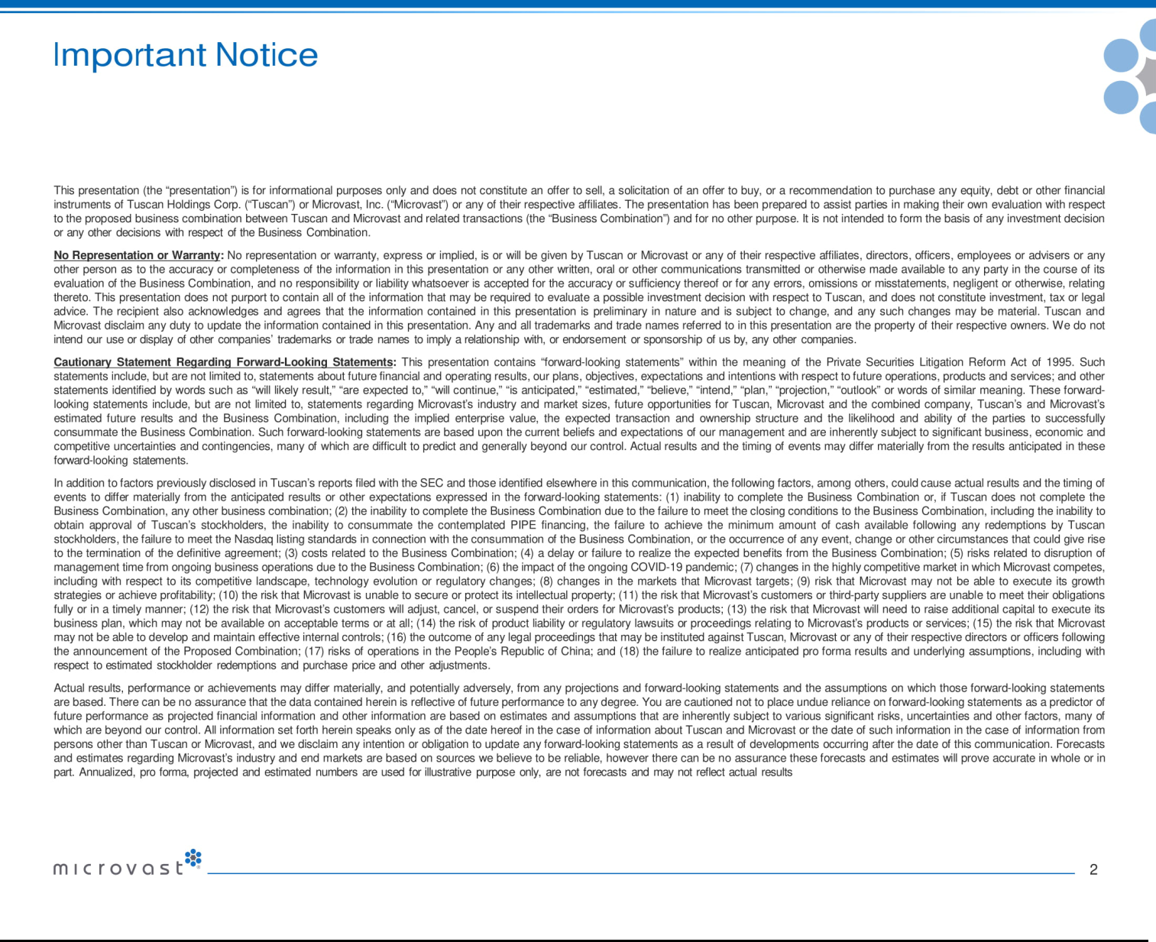

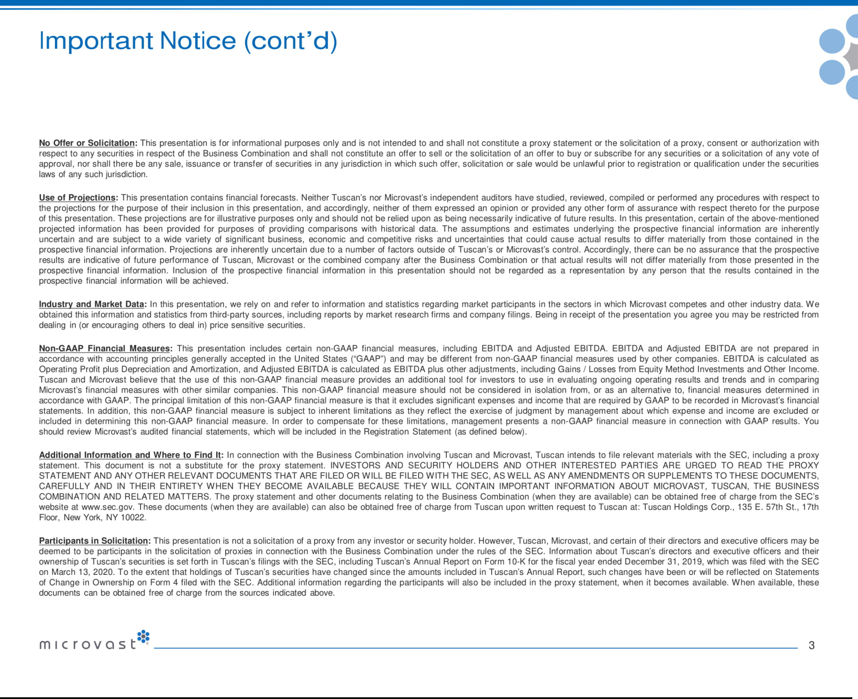

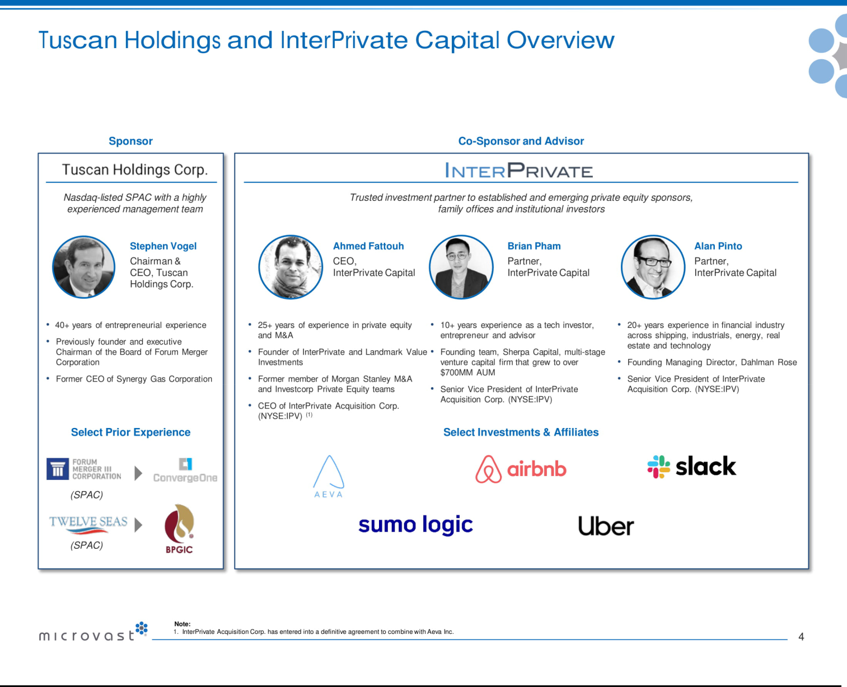

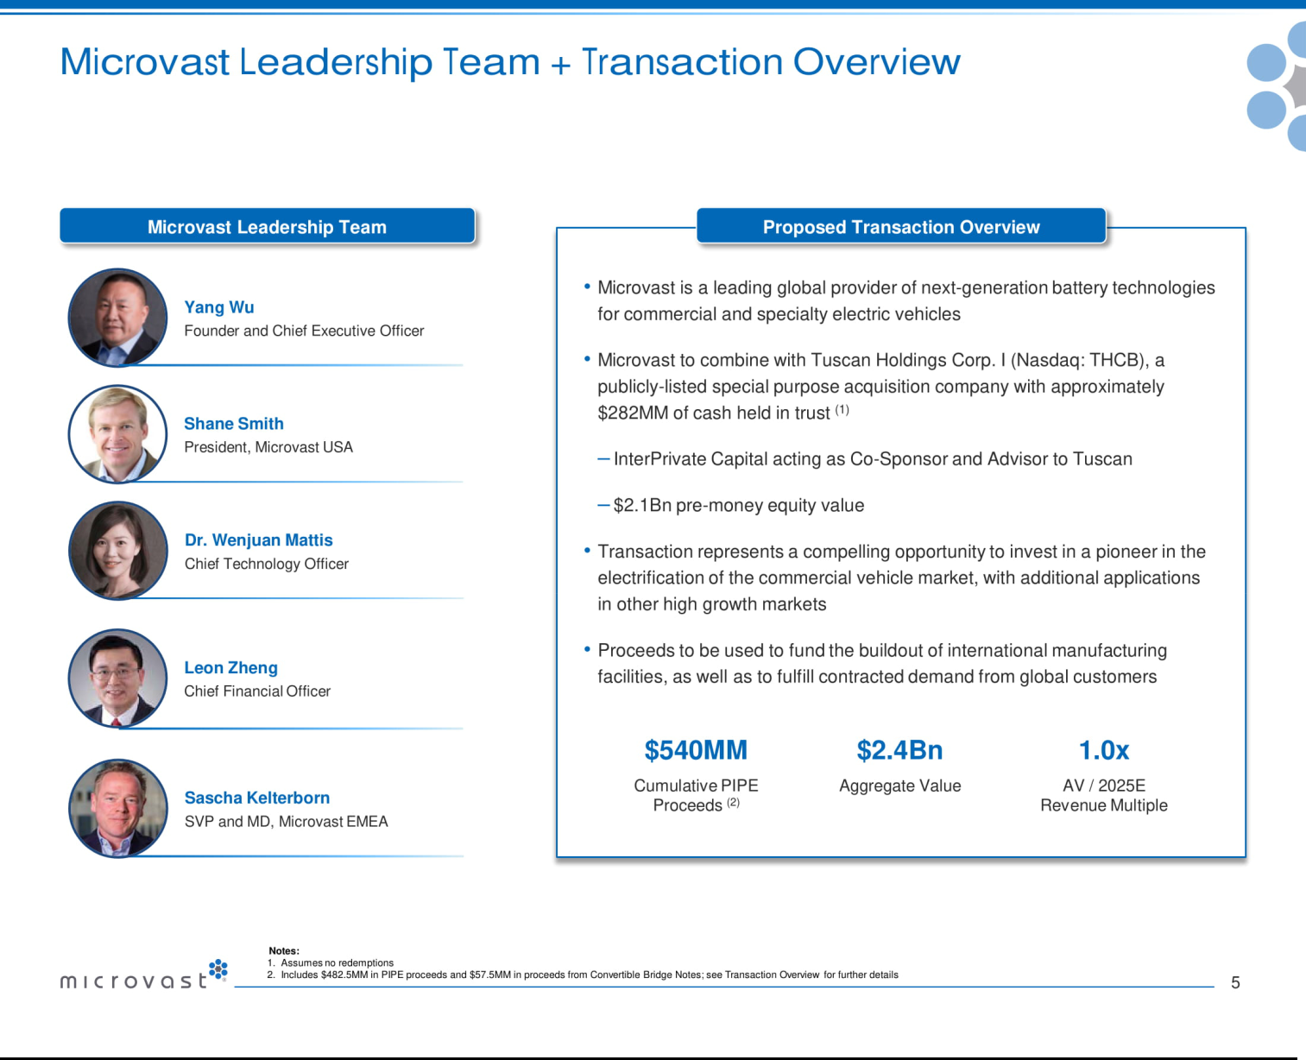

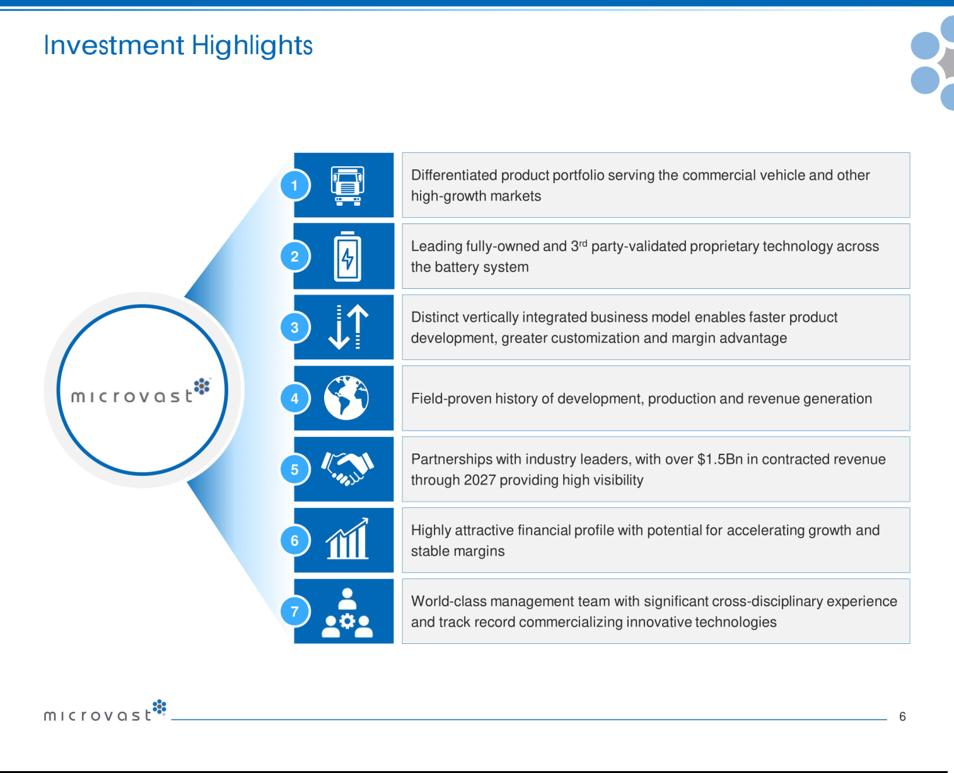



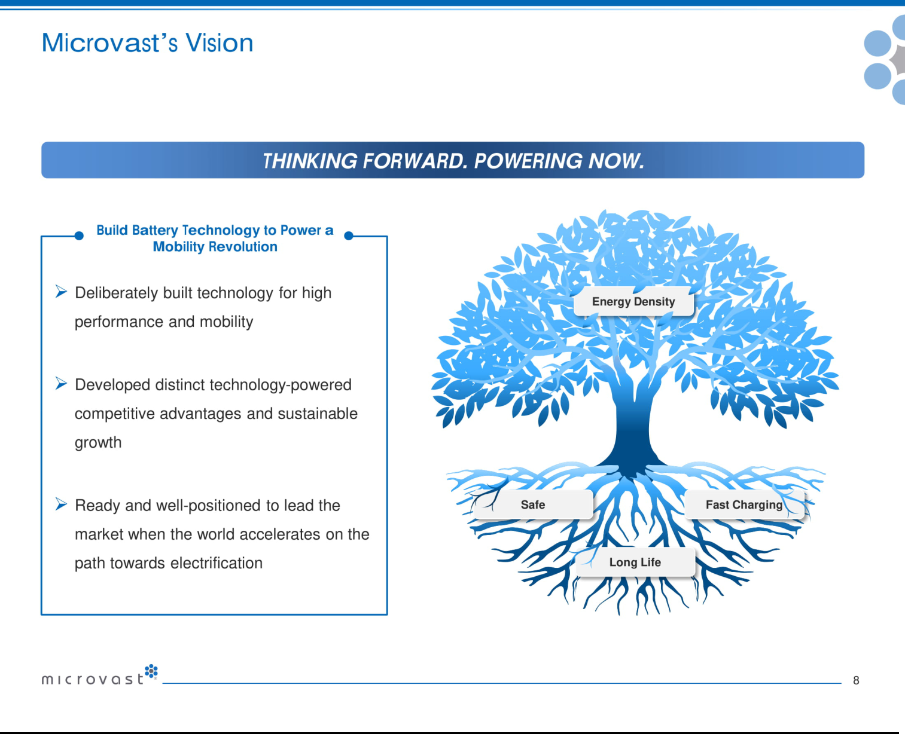

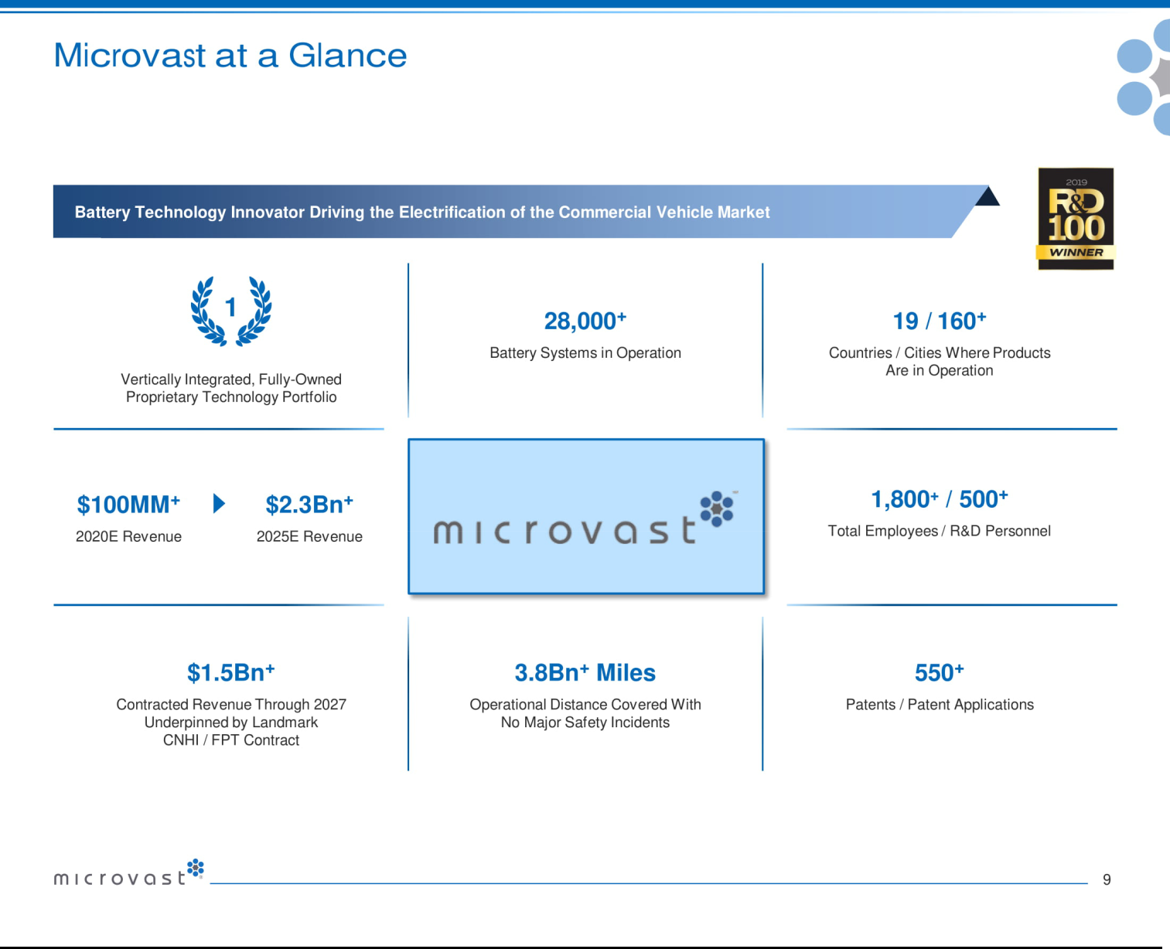

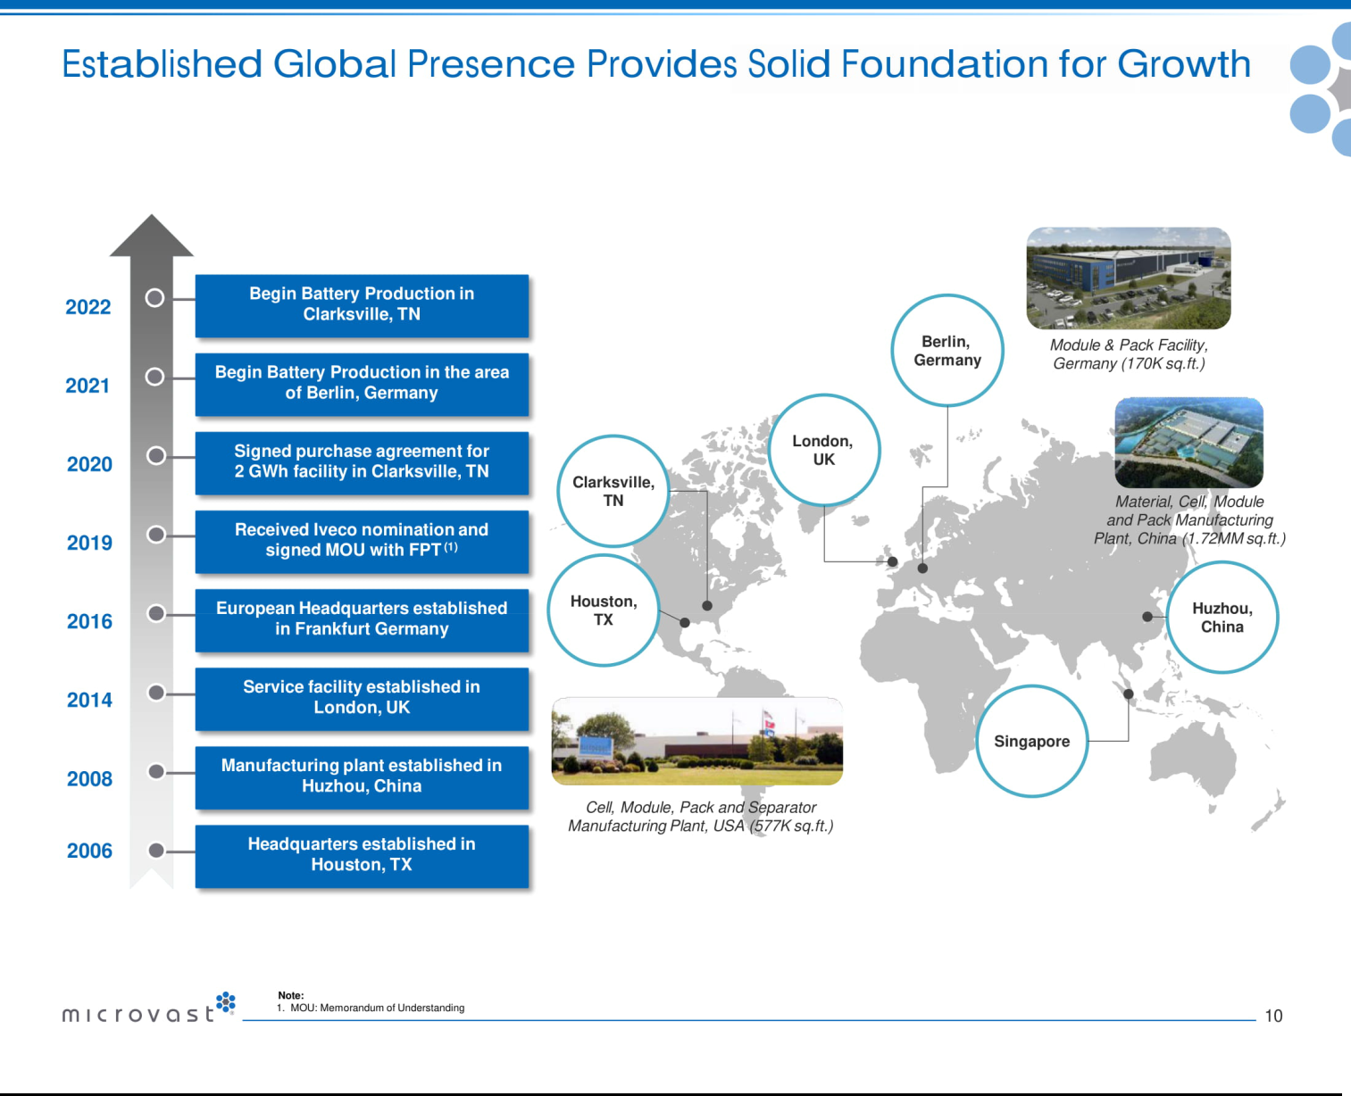

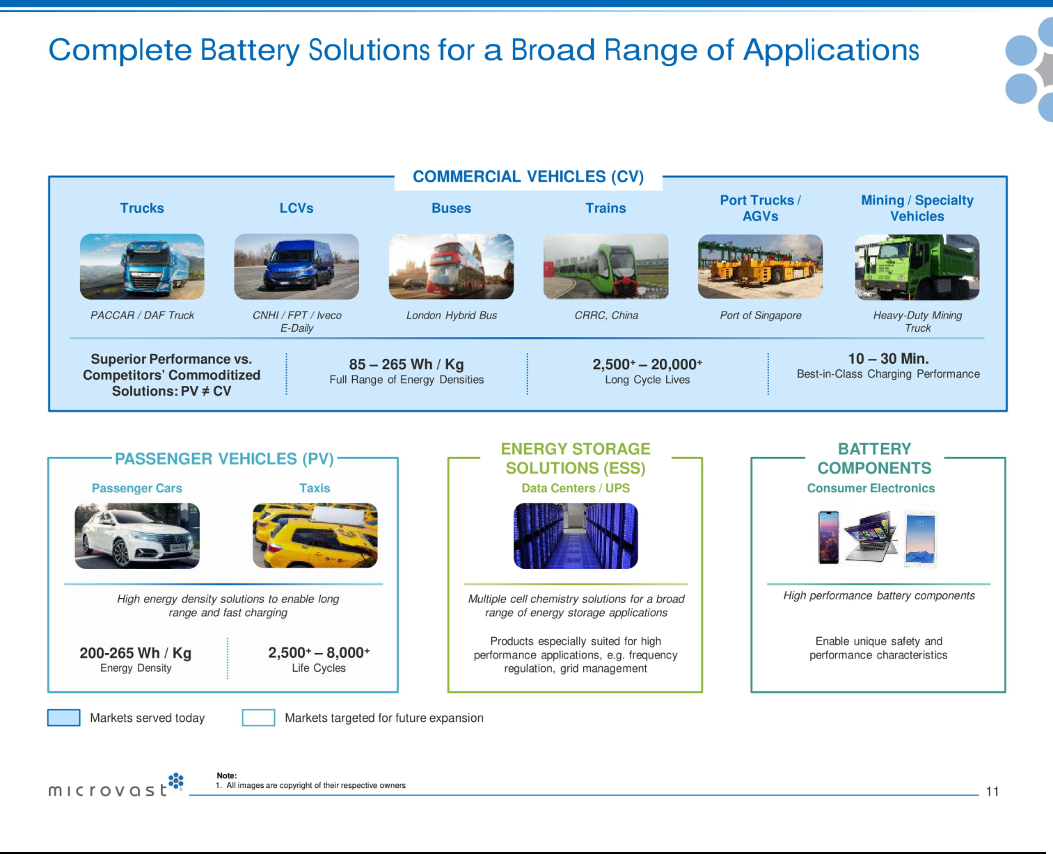

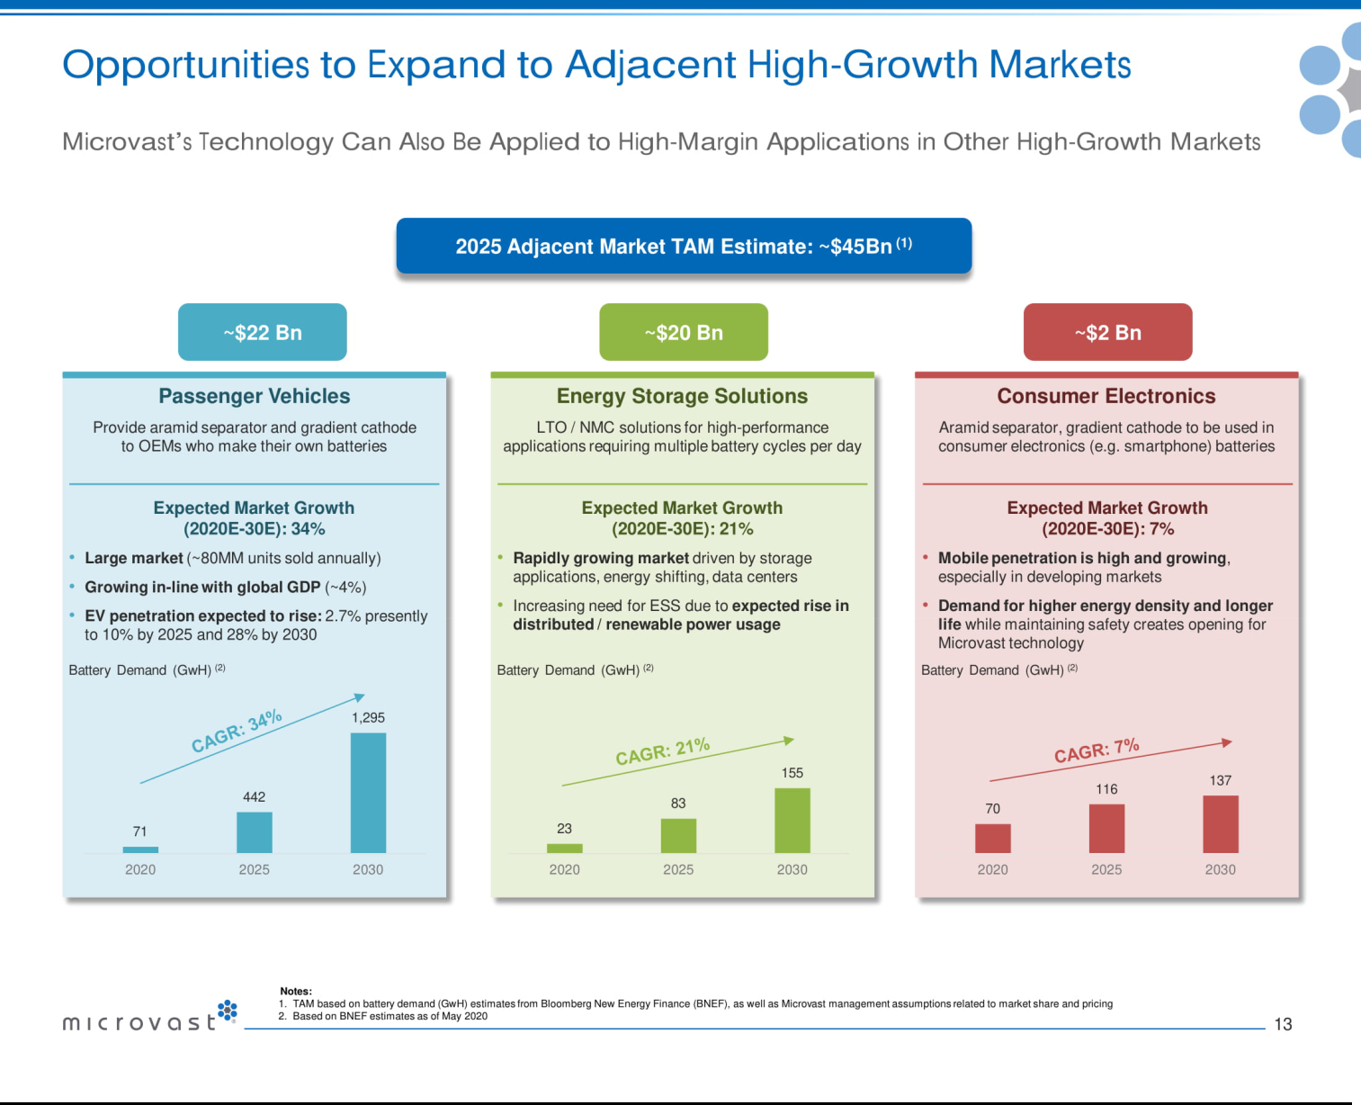

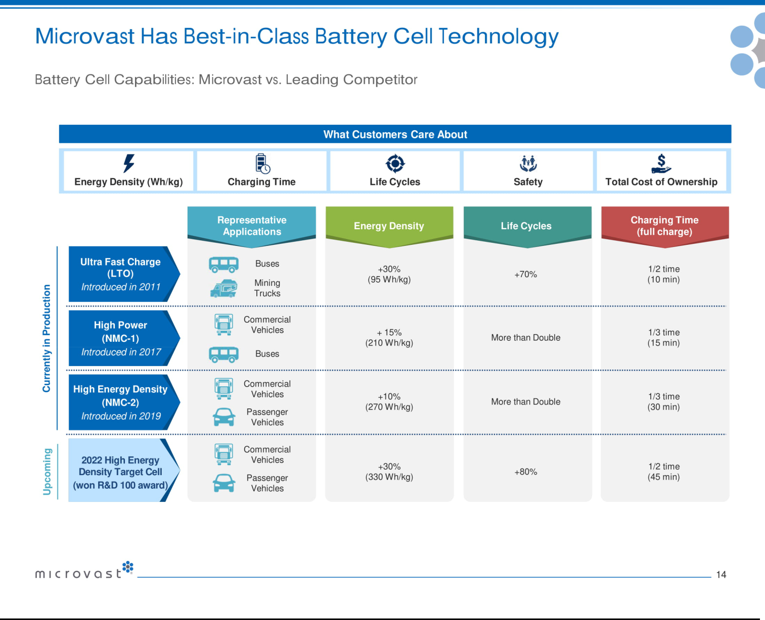

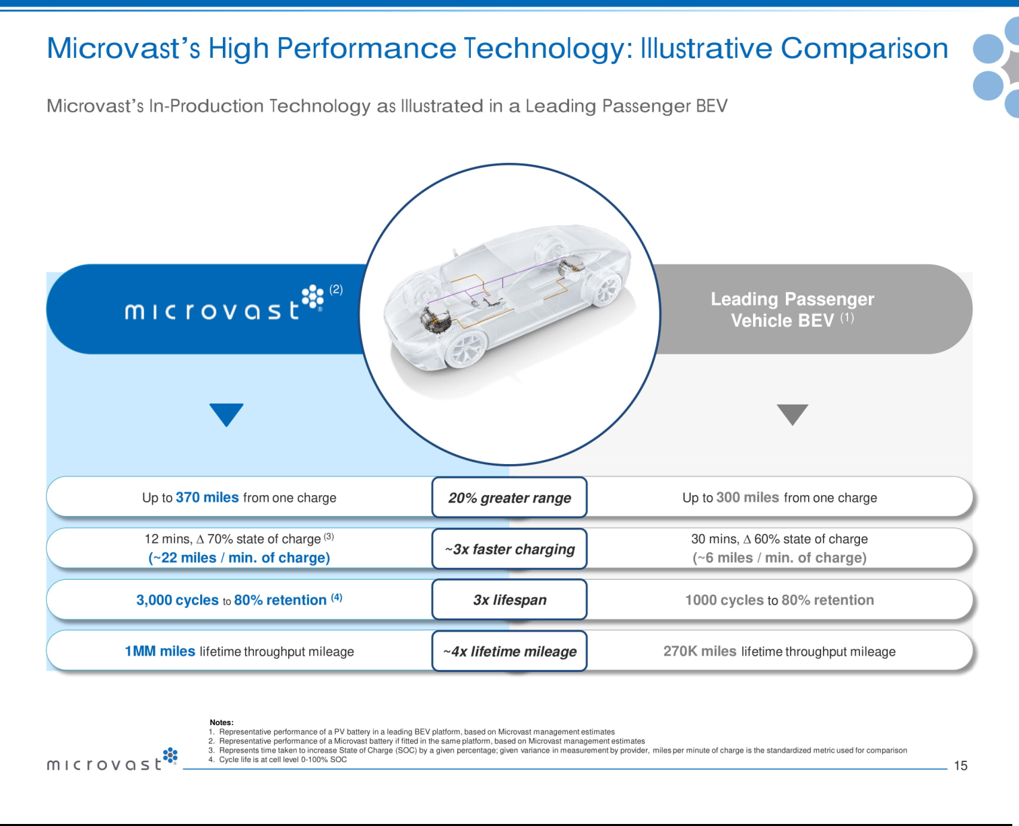

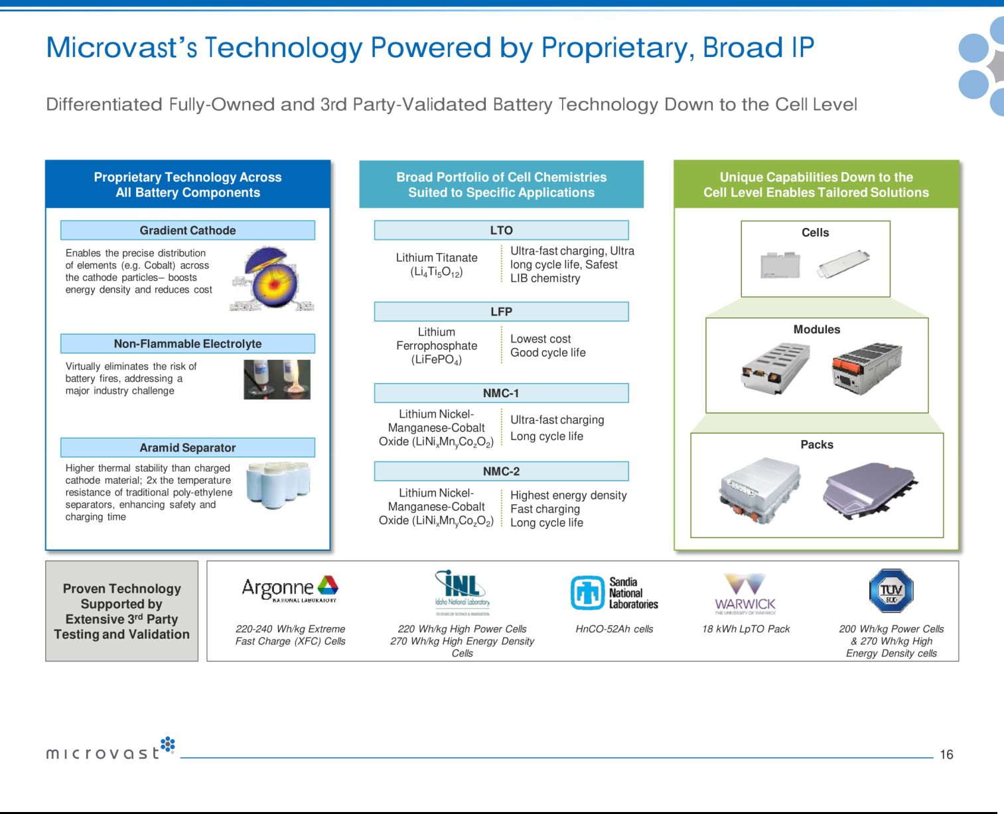

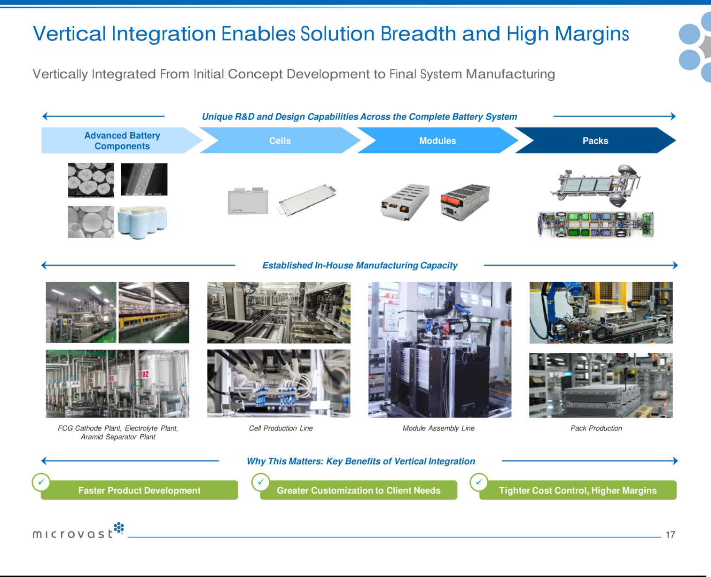

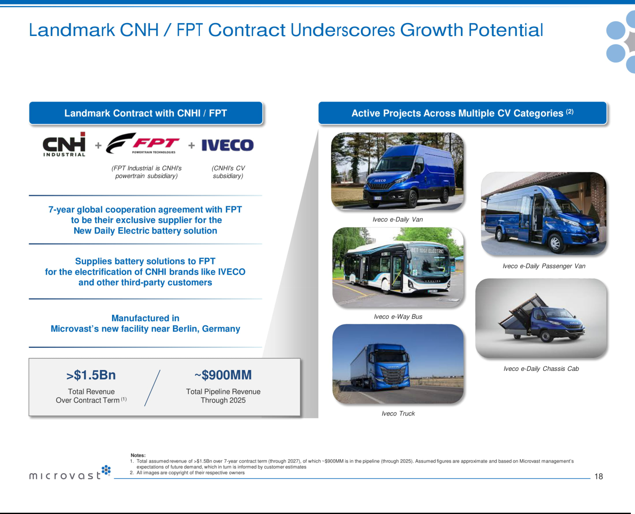

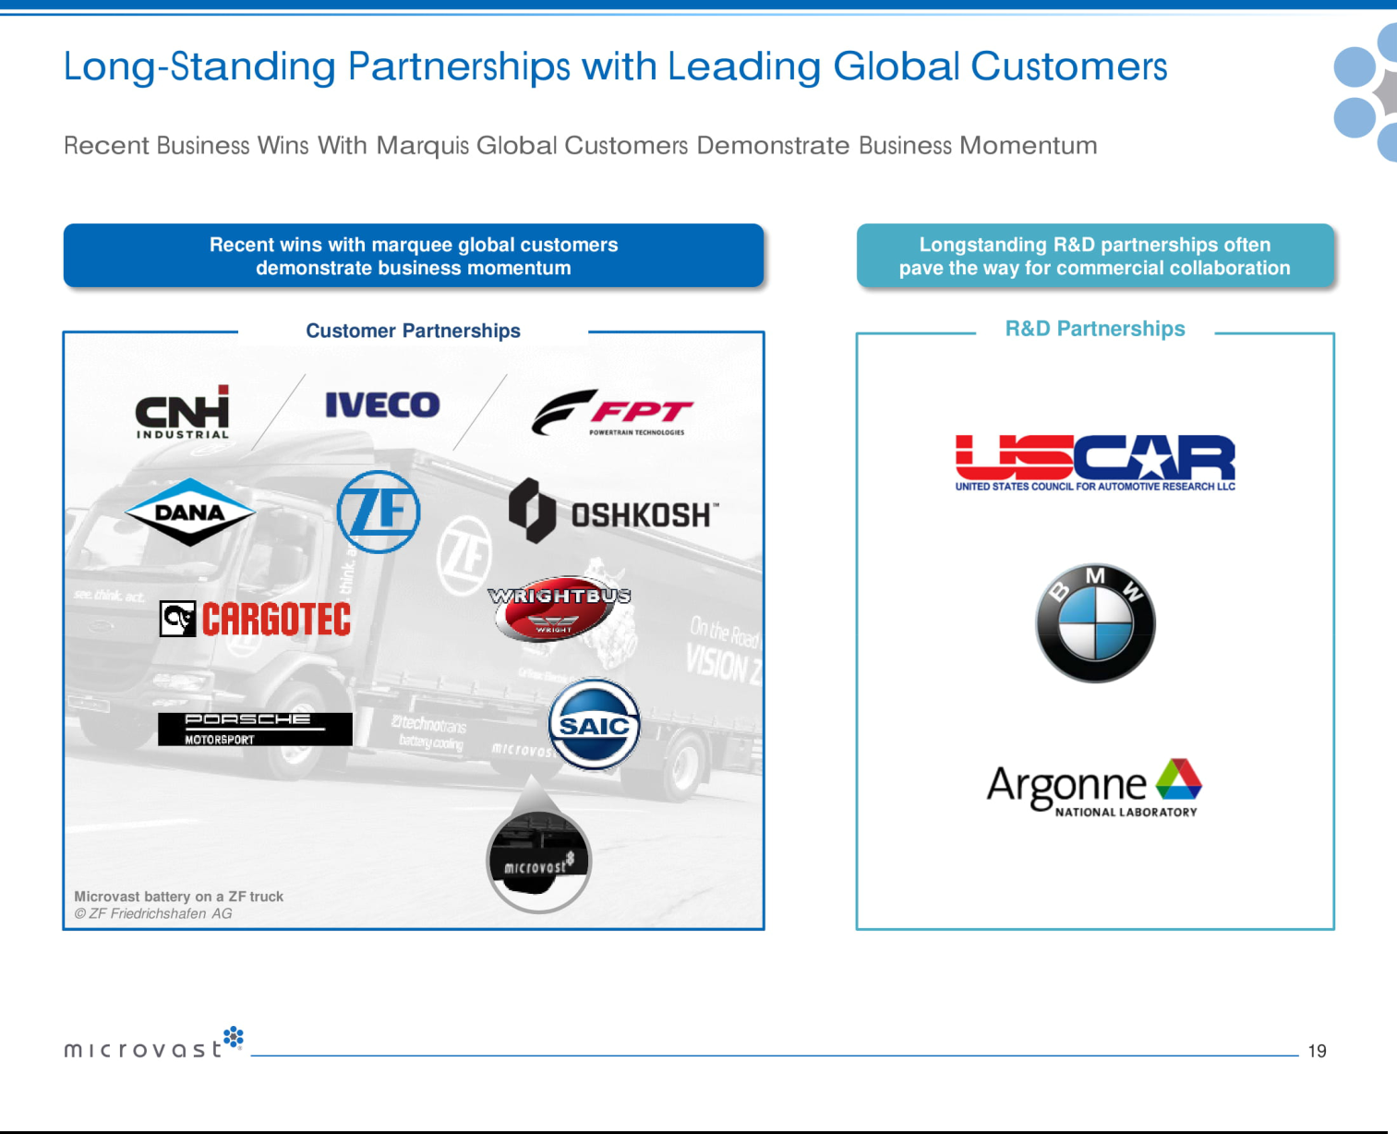

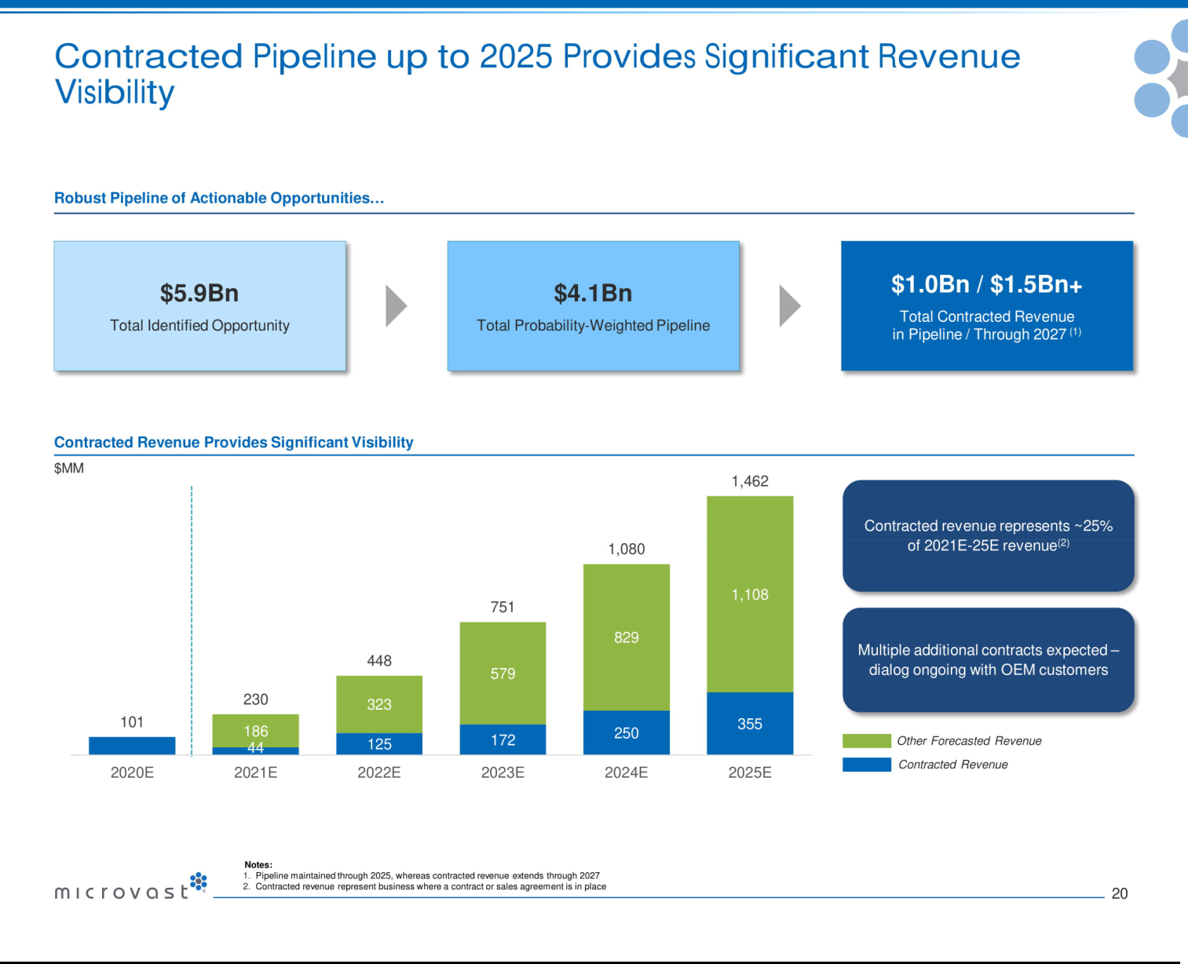

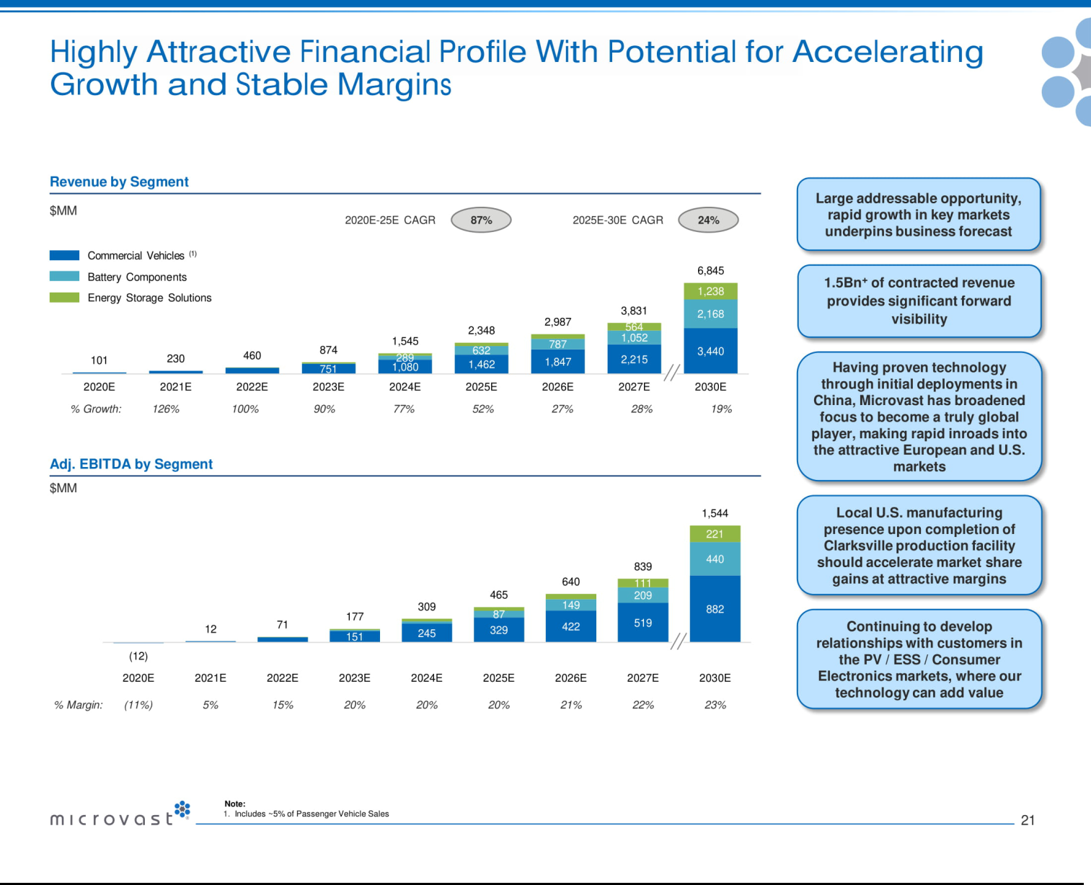

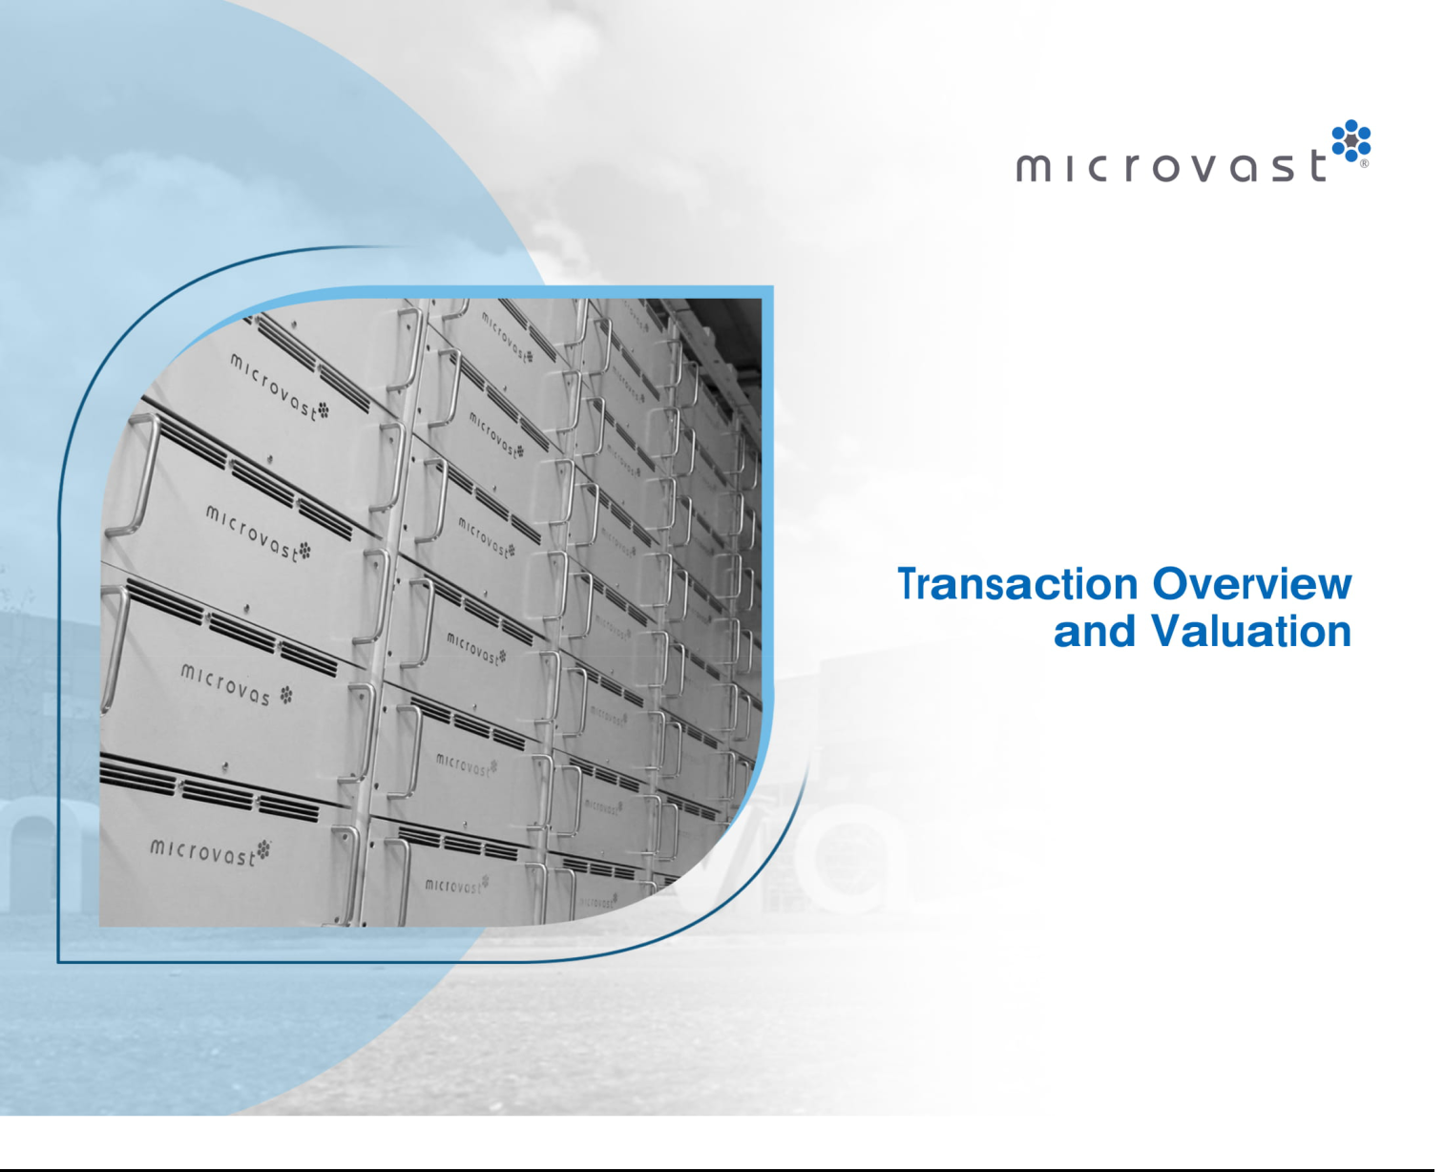

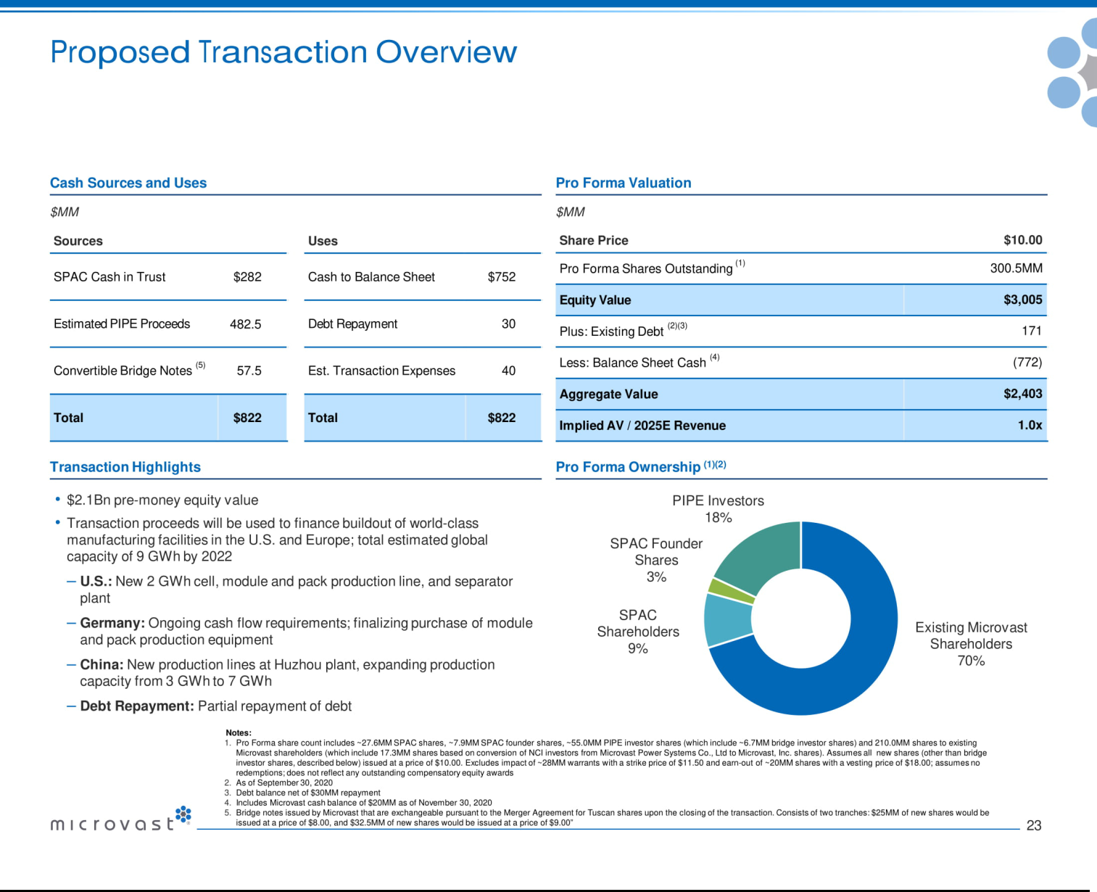

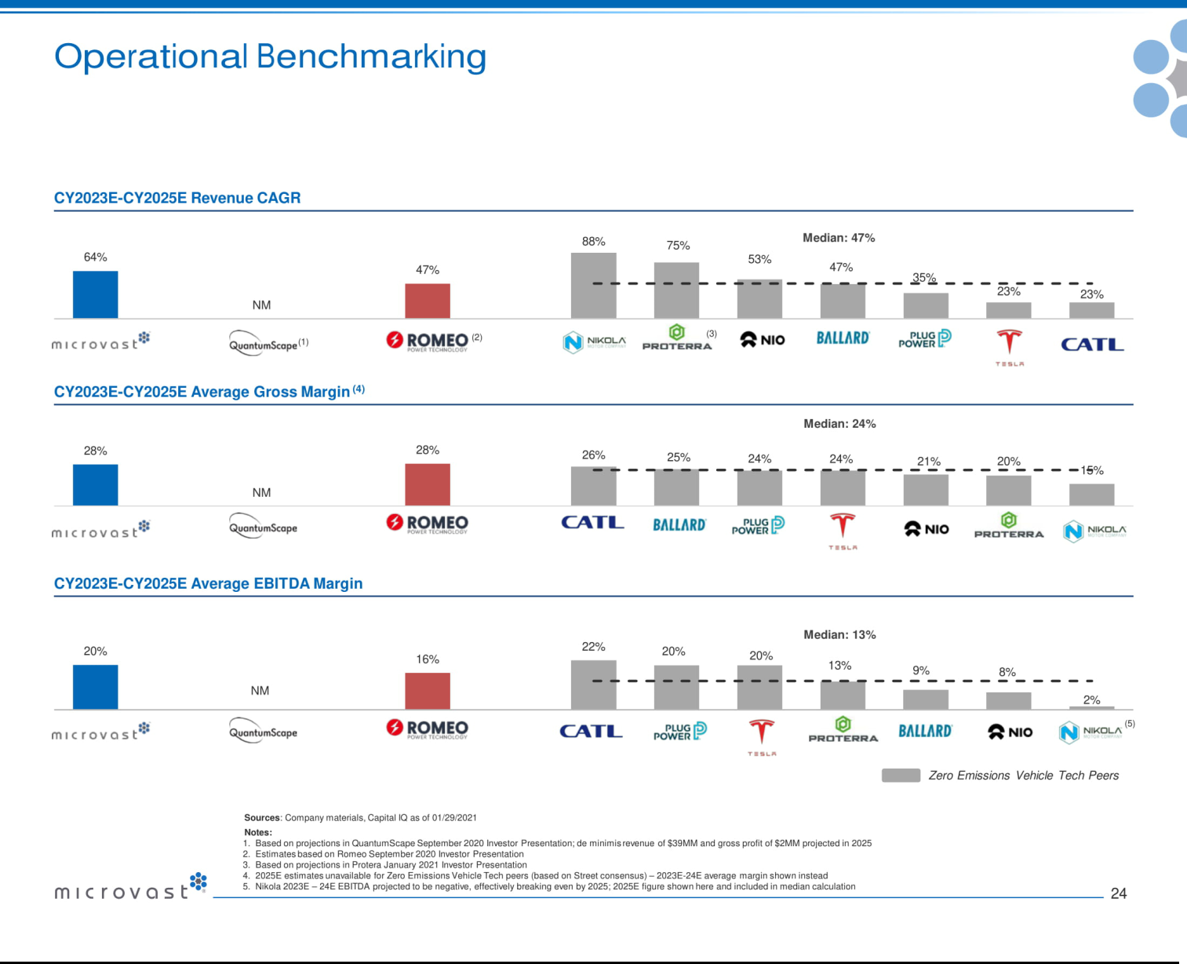

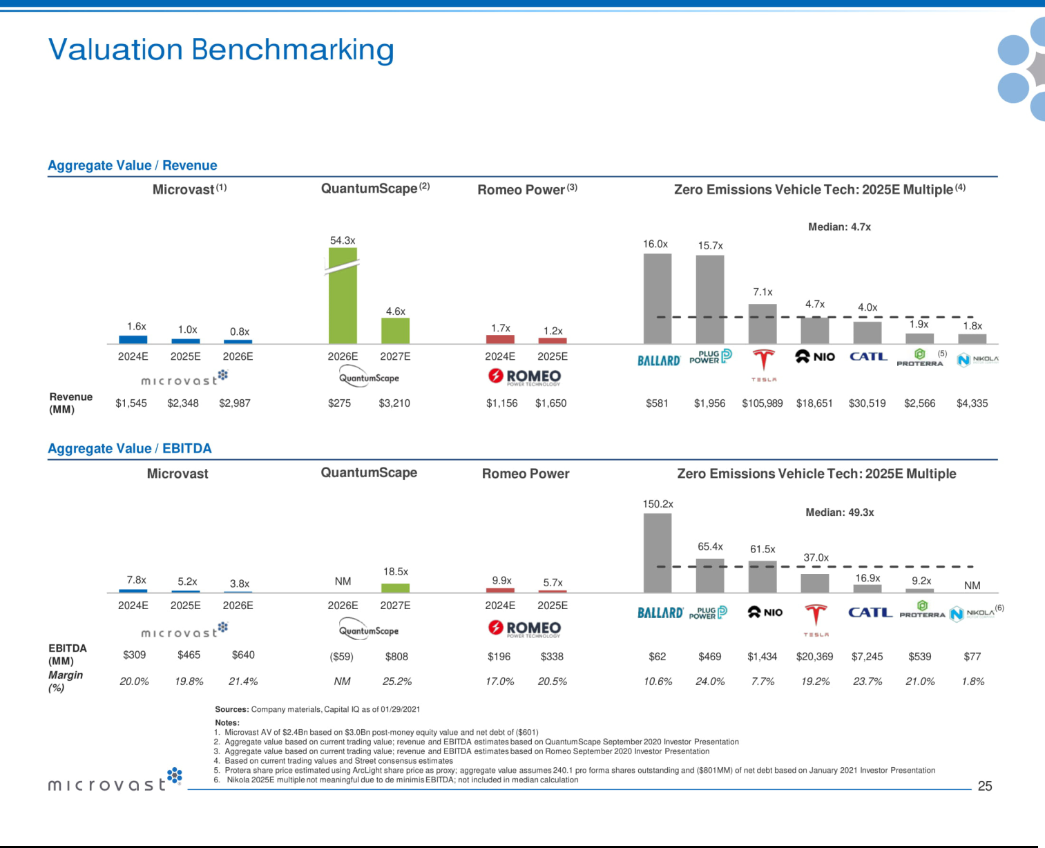

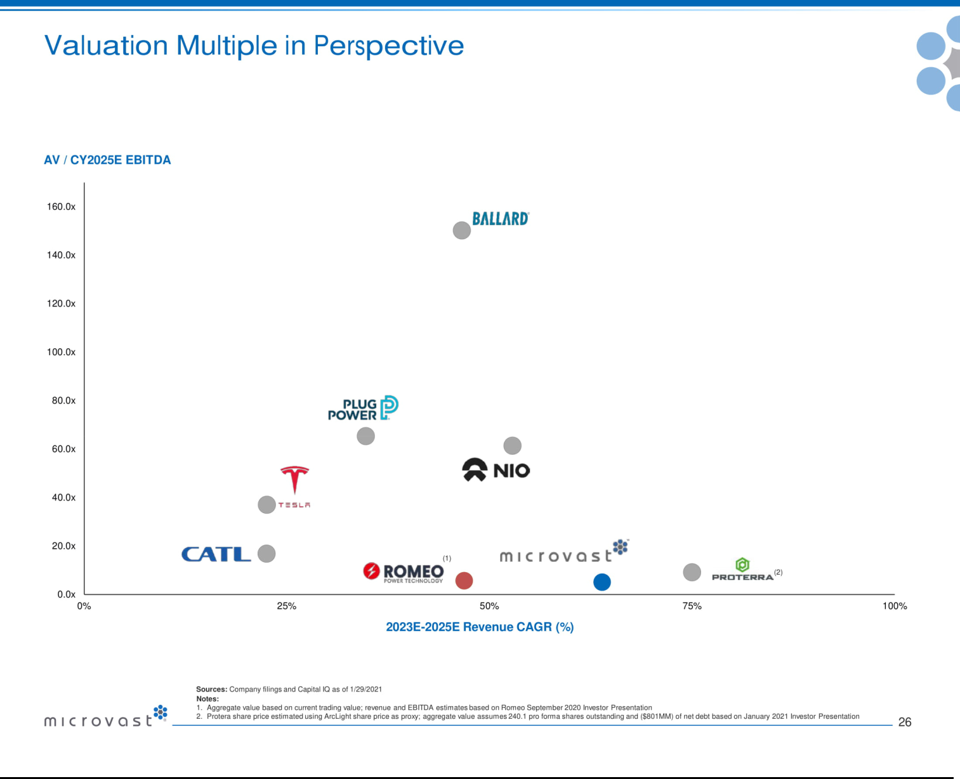

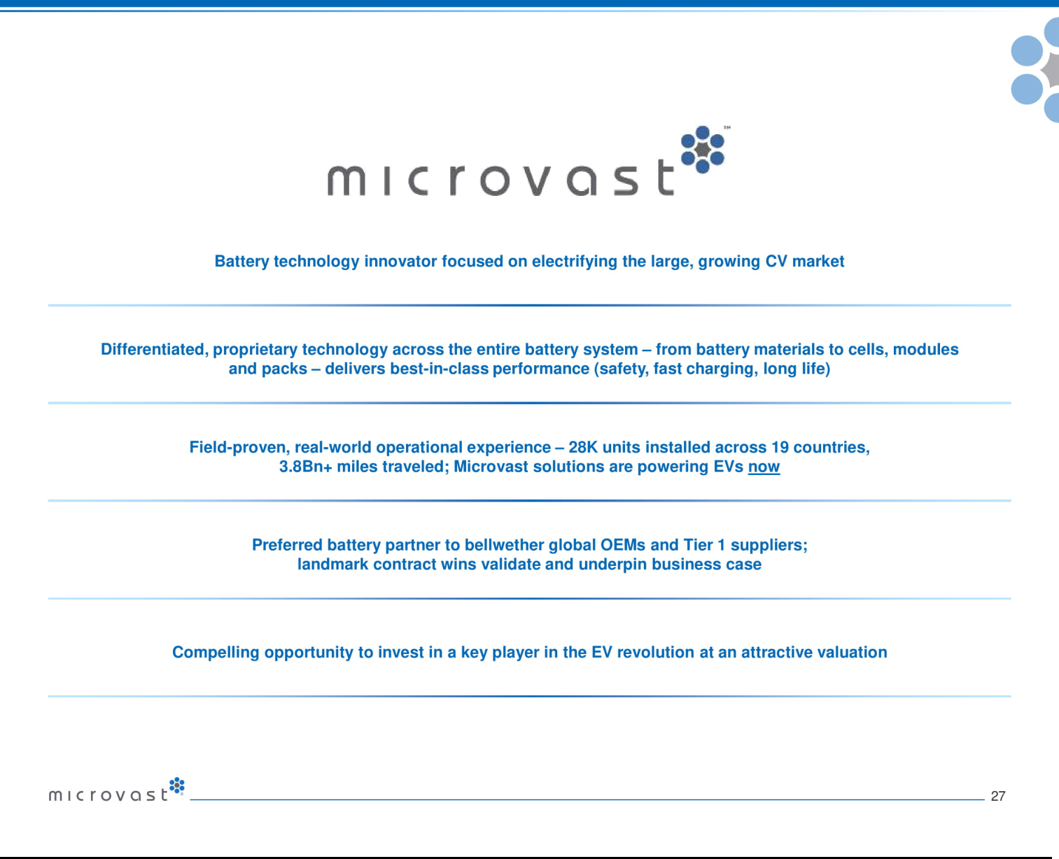



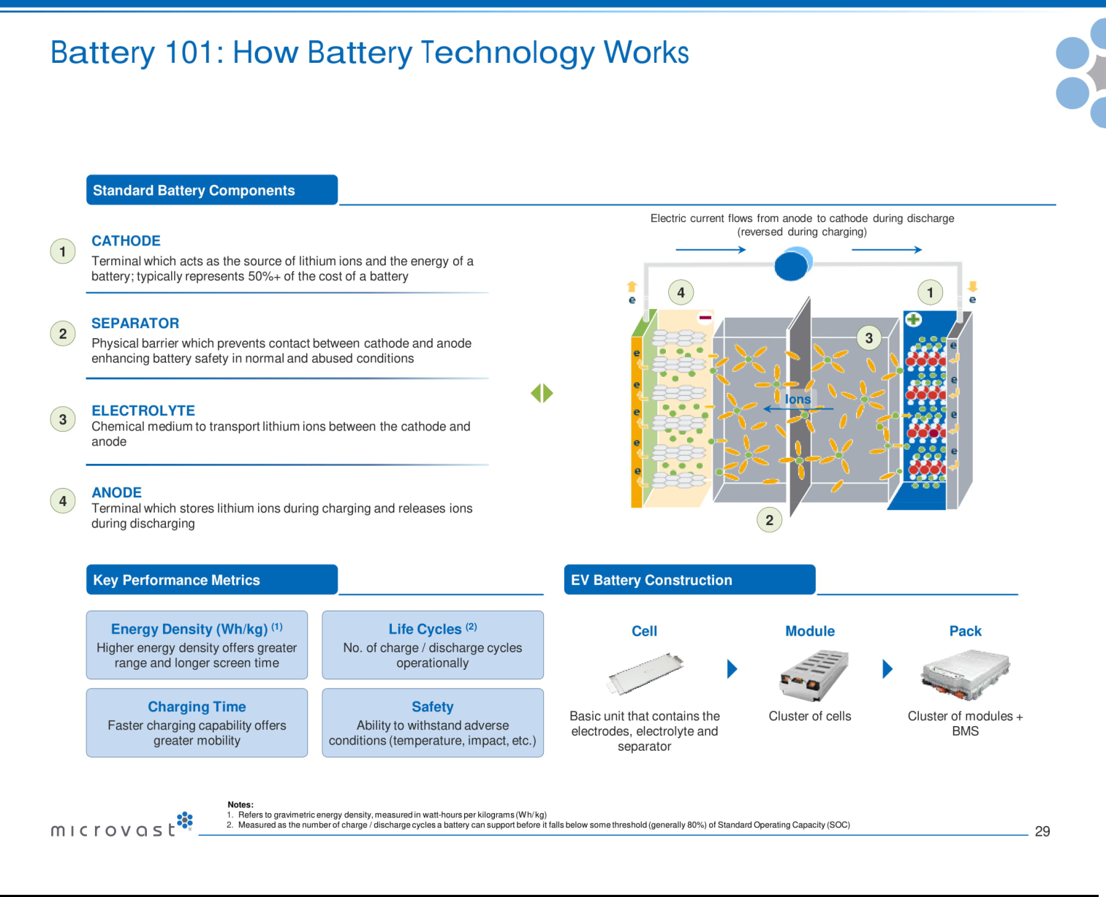

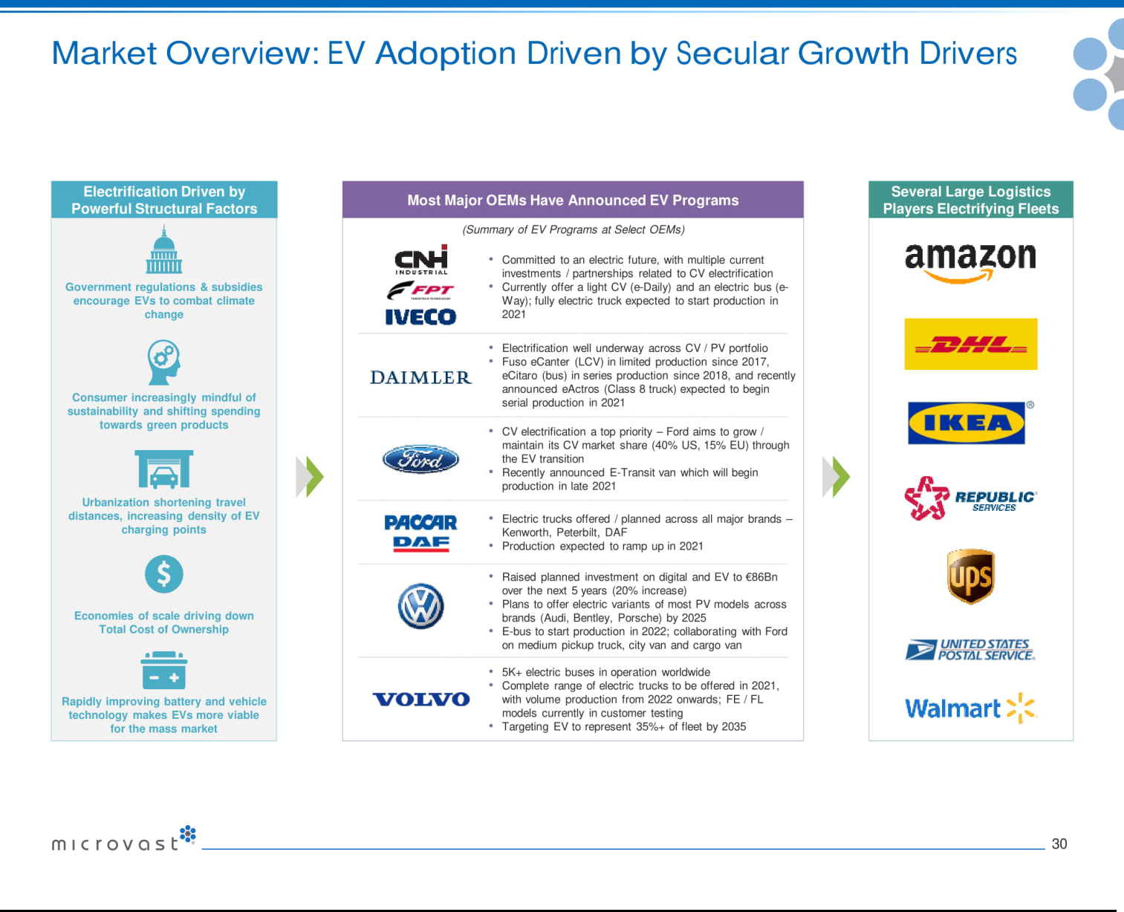



Exhibit 99.3


Tuscan Holdings Corp. and Microvast, Inc.

Conference Call Script

February 1, 2021

No Offer or Solicitation: This communication regarding the business combination of Microvast, Inc. and Tuscan Holdings Corp. (the “Business Combination”) is for informational purposes only and is not intended to and shall not constitute a proxy statement or the solicitation of a proxy, consent or authorization with respect to any securities in respect of the Business Combination and shall not constitute an offer to sell or the solicitation of an offer to buy or subscribe for any securities or a solicitation of any vote of approval, nor shall there be any sale, issuance or transfer of securities in any jurisdiction in which such offer, solicitation or sale would be unlawful prior to registration or qualification under the securities laws of any such jurisdiction.

Additional Information and Where to Find It: In connection with the Business Combination involving Tuscan and Microvast, Tuscan intends to file relevant materials with the SEC, including a proxy statement. This document is not a substitute for the proxy statement. INVESTORS AND SECURITY HOLDERS AND OTHER INTERESTED PARTIES ARE URGED TO READ THE PROXY STATEMENT AND ANY OTHER RELEVANT DOCUMENTS THAT ARE FILED OR WILL BE FILED WITH THE SEC, AS WELL AS ANY AMENDMENTS OR SUPPLEMENTS TO THESE DOCUMENTS, CAREFULLY AND IN THEIR ENTIRETY WHEN THEY BECOME AVAILABLE BECAUSE THEY WILL CONTAIN IMPORTANT INFORMATION ABOUT MICROVAST, TUSCAN, THE BUSINESS COMBINATION AND RELATED MATTERS. The proxy statement and other documents relating to the Business Combination (when they are available) can be obtained free of charge from the SEC’s website at www.sec.gov. These documents (when they are available) can also be obtained free of charge from Tuscan upon written request to Tuscan at: Tuscan Holdings Corp., 135 E. 57th St., 17th Floor, New York, NY 10022.

Participants in Solicitation: This presentation is not a solicitation of a proxy from any investor or securityholder. However, Tuscan, Microvast, and certain of their directors and executive officers may be deemed to be participants in the solicitation of proxies in connection with the Business Combination under the rules of the SEC. Information about Tuscan’s directors and executive officers and their ownership of Tuscan’s securities is set forth in Tuscant’s filings with the SEC, including Tuscan’s Annual Report on Form 10-K for the fiscal year ended December 31, 2019, which was filed with the SEC on March 13, 2020. To the extent that holdings of Tuscan’s securities have changed since the amounts printed in Tuscan’s proxy statement, such changes have been or will be reflected on Statements of Change in Ownership on Form 4 filed with the SEC. Additional information regarding the participants will also be included in the proxy statement, when it becomes available. When available, these documents can be obtained free of charge from the sources indicated above.

1

Tuscan Holdings Corp. and Microvast, Inc.

Conference Call Script

February 1, 2021

Cautionary Statement Regarding Forward-Looking Statements: This call contains “forward-looking statements” within the meaning of the Private Securities Litigation Reform Act of 1995. Such statements include, but are not limited to, statements about future financial and operating results, our plans, objectives, expectations and intentions with respect to future operations, products and services; and other statements identified by words such as “will likely result,” “are expected to,” “will continue,” “is anticipated,” “estimated,” “believe,” “intend,” “plan,” “projection,” “outlook” or words of similar meaning. These forward-looking statements include, but are not limited to, statements regarding Microvast’s industry and market sizes, future opportunities for Tuscan, Microvast and the combined company, Tuscan’s and Microvast’s estimated future results and the Business Combination, including the implied enterprise value, the expected transaction and ownership structure and the likelihood and ability of the parties to successfully consummate the Business Combination. Such forward-looking statements are based upon the current beliefs and expectations of our management and are inherently subject to significant business, economic and competitive uncertainties and contingencies, many of which are difficult to predict and generally beyond our control. Actual results and the timing of events may differ materially from the results anticipated in these forward-looking statements.

In addition to factors previously disclosed in Tuscan’s reports filed with the SEC and those identified elsewhere in this communication, the following factors, among others, could cause actual results and the timing of events to differ materially from the anticipated results or other expectations expressed in the forward-looking statements: (1) inability to complete the Business Combination or, if Tuscan does not complete the Business Combination, any other business combination; (2) the inability to complete the Business Combination due to the failure to meet the closing conditions to the Business Combination, including the inability to obtain approval of Tuscan’s stockholders, the inability to consummate the contemplated PIPE financing, the failure to achieve the minimum amount of cash available following any redemptions by Tuscan stockholders, the failure to meet the Nasdaq listing standards in connection with the consummation of the Business Combination, or the occurrence of any event, change or other circumstances that could give rise to the termination of the definitive agreement; (3) costs related to the Business Combination; (4) a delay or failure to realize the expected benefits from the Business Combination; (5) risks related to disruption of management time from ongoing business operations due to the Business Combination; (6) the impact of the ongoing COVID-19 pandemic; (7) changes in the highly competitive market in which Microvast competes, including with respect to its competitive landscape, technology evolution or regulatory changes; (8) changes in the markets that Microvast targets; (9) risk that Microvast may not be able to execute its growth strategies or achieve profitability; (10) the risk that Microvast is unable to secure or protect its intellectual property; (11) the risk that Microvast’s customers or third-party suppliers are unable to meet their obligations fully or in a timely manner; (12) the risk that Microvast’s customers will adjust, cancel, or suspend their orders for Microvast’s products; (13) the risk that Microvast will need to raise additional capital to execute its business plan, which may not be available on acceptable terms or at all; (14) the risk of product liability or regulatory lawsuits or proceedings relating to Microvast’s products or services; (15) the risk that Microvast may not be able to develop and maintain effective internal controls; (16) the outcome of any legal proceedings that may be instituted against Tuscan, Microvast or any of their respective directors or officers following the announcement of the Business Combination;

- risks of operations in the People’s Republic of China; and (18) the failure to realize anticipated pro forma results and underlying assumptions, including with respect to estimated stockholder redemptions and purchase price and other adjustments.

2

Tuscan Holdings Corp. and Microvast, Inc.

Conference Call Script

February 1, 2021

Actual results, performance or achievements may differ materially, and potentially adversely, from any projections and forward-looking statements and the assumptions on which those forward-looking statements are based. There can be no assurance that the data contained herein is reflective of future performance to any degree. You are cautioned not to place undue reliance on forward-looking statements as a predictor of future performance as projected financial information and other information are based on estimates and assumptions that are inherently subject to various significant risks, uncertainties and other factors, many of which are beyond our control. All information set forth herein speaks only as of the date hereof in the case of information about Tuscan and Microvast or the date of such information in the case of information from persons other than Tuscan or Microvast, and we disclaim any intention or obligation to update any forward-looking statements as a result of developments occurring after the date of this communication. Forecasts and estimates regarding Microvast’s industry and end markets are based on sources we believe to be reliable, however there can be no assurance these forecasts and estimates will prove accurate in whole or in part. Annualized, pro forma, projected and estimated numbers are used for illustrative purpose only, are not forecasts and may not reflect actual results.

Operator

Welcome to today’s conference call announcing the business combination of Microvast, Inc. and Tuscan Holdings Corp. Joining us on the call are Stephen Vogel, Chairman and CEO of Tuscan, Ahmed Fattouh the CEO of InterPrivate, Microvast founder and CEO/President Mr. Yang Wu, and Microvast Executive Vice President Shane Smith.

We would first like to remind everyone that this call contains forward-looking statements including, but not limited to, Microvast’s and Tuscan’s expectations or predictions of financial and business performance and conditions, competitive and industry outlook; the cash resources, plans and prospects of the combined entity; expected valuations of the combined entity; and the timing and completion of the transaction. Commentary on these topics constitutes forward-looking statements within the meaning of the Safe Harbor provisions of the Private Securities Litigation Reform Act. Forward-looking statements are predictions, projections and other statements about future events that are based on current expectations and assumptions and, as a result, are subject to risks and uncertainties. We encourage you to read the press release issued today, the accompanying presentation, and Tuscan’s public filings with the SEC, including a proxy statement that will be filed in the coming days and available on the SEC’s website, and, in particular, to the section or sections titled Risk Factors and Forward-Looking Statements, for a discussion of the risks that can affect the transaction, Microvast’s and Tuscan’s businesses, and the outlook of the combined company.

Microvast and Tuscan are under no obligation and expressly disclaim any obligation to update, alter or otherwise revise any forward-looking statements, whether as a result of new information, future events or otherwise, except as required by law.

This communication is for informational purposes only and is not intended to and shall not constitute an offer sell or the solicitation of an offer to sell or the solicitation of an offer to buy or subscribe for any securities or a solicitation of any vote of approval, nor shall there be any sale, issuance or transfer of securities in any jurisdiction in which such offer, solicitation or sale would be unlawful prior to registration or qualification under the securities laws of any such jurisdiction.

And now, I would like to introduce Stephen Vogel, CEO of Tuscan Holdings Corp.

3

Tuscan Holdings Corp. and Microvast, Inc.

Conference Call Script

February 1, 2021

Stephen Vogel, Tuscan Holdings Corp.

Good morning, everyone. Tuscan Holdings Corp. is a special purpose acquisition company with approximately $282 million in trust. Together with InterPrivate, our co-sponsor, our management team is comprised of highly experienced, entrepreneurial investors and advisors, with a breadth of experience in technology, capital markets and energy.

Tuscan and InterPrivate had three primary criteria for selecting the optimal partner. First, we wanted to find a company with a proven track record of successfully operating in a large market, with a long runway of future growth. Second, we wanted a highly capable management team that had the experience necessary to execute that opportunity. And finally, and perhaps most critically, we wanted a company that had, and that we believe, would continue to build, long-term competitive advantages.

As Mr. Wu and Shane will walk through in greater detail, Microvast designs, develops, and manufactures ultra-fast charging, long-life battery power systems with superior safety for commercial electric vehicles. Microvast also built a significant IP portfolio with over 550 patents and patent applications, a substantial revenue base of over $100 million, and a marquee customer base consisting of global OEMs, with expected revenue provided by signed contracts with total value of approximately $1.5 billion.

The commercial vehicle market is attractive because it is poised to undergo rapid electrification, creating a once-in-a century-opportunity to overhaul the global vehicle fleet. We believe Microvast is uniquely positioned to capitalize on this opportunity, with its differentiated focus on battery systems for commercial electric vehicles, which contrasts with the rest of the industry’s focus on passenger EVs. We believe that Microvast’s cross-disciplinary management team, with its impressive track record commercializing innovative technologies, has the experience needed to make Microvast a market leader. We believe the company’s vertically integrated business model provides a considerable competitive advantage, enabling faster product development, greater customization and higher margins. And now I would like to introduce my co-sponsor and partner, Ahmed Fattouh, InterPrivate’s CEO.

4

Tuscan Holdings Corp. and Microvast, Inc.

Conference Call Script

February 1, 2021

Ahmed Fattouh, InterPrivate

Thanks, Stephen. Before I get into the transaction details, I want to highlight that over the past few months as InterPrivate conducted its due diligence on the company, Microvast’s business experienced tremendous customer momentum and saw acceleration in Western markets.

Now I'll add a few words about the parameters of the deal: the implied equity value of the business combination is approximately $3.0 billion, with a $2.4 billion post money enterprise value. That implies a compelling valuation multiple of 1x projected 2025 revenue. Tuscan’s PIPE was oversubscribed and total proceeds are $540 million, which includes bridge financing of $58 million. The PIPE includes strategic partner and leading specialty vehicle OEM Oshkosh Corporation, highlighting the strength of Microvast’s commercial partnerships. Other anchor investors include BlackRock, Koch Industries and our own fund, InterPrivate Investment Partners, among other leading institutional shareholders. We expect that the transaction will result in over $800 million in cash to the combined company before expenses, assuming no redemptions by Tuscan stockholders. Importantly, Microvast’s shareholders and management are rolling over 100% of their equity into the transaction, showing both their commitment and belief in the company’s long-term growth potential.

With that, I would now like to turn the call over to the founder and CEO of Microvast, Mr. Yang Wu to tell you more about the company.

Mr. Yang Wu, Microvast, Inc.

Thanks, Ahmed. Good morning everybody. I am excited to tell you more about the company I have been building over the last 14 years.

In 2008, we set out to build battery technologies to power a mobility revolution. We sought to alter the commercial vehicle landscape by building a disruptive battery that would allow electric vehicles to compete with combustion engine vehicles. At the time, batteries were an obstacle to wider adoption of electric vehicles in the commercial vehicle space. It took 6 or more hours to fully charge a battery, the range was not great, and they presented safety issues due to their flammability. Further, the relatively high cost of the battery coupled with the fact that batteries are generally not repairable, made electrification of commercial fleets a risky investment proposition.

5

Tuscan Holdings Corp. and Microvast, Inc.

Conference Call Script

February 1, 2021

We decided to view these obstacles as an opportunity. We determined that we could pave the way for mass adoption of electric vehicles if we developed a lower cost battery that had high energy density and that was safe, fast-charging and where the life of the battery would match that of the vehicle. A battery with those qualities would allow electric vehicles to compete with combustion engine vehicles. In 2010, our first ultra-fast charge batteries were integrated into public transit buses in Chong Qing, China.

Unlike our peers who redesigned existing battery products to adapt to EVs, we started from scratch and specifically designed our products to address the critical constraints that faced commercial electric vehicle development. We believe this approach created the foundation of our superior battery technology.

Today, we believe Microvast has developed the world’s leading battery cells. A comparison of Microvast’s battery cell capabilities to those of its leading competitors shows that our high energy density cells have best-in-class energy density, resulting in 10-20% greater range on a single charge; best-in-class life cycles, which is 2 to 3 times as long as a leading competitor; and best-in-class charging times, fully charging in 30 minutes and reaching a 70% SOC in 12 minutes. Our exceptional battery solutions are market-validated, both through customer wins and extensive third-party testing. Our batteries are integrated in almost 30,000 vehicles, running in 160 cities in 19 countries, for a total of over 3.8 billion miles traveled on our batteries to date.

We believe that not only are Microvast’s existing battery cells best in class, but our technology pipeline is equally impressive. We are very excited about our next-generation, silicon-containing anode battery cell that features an outstanding 320 Wh/kg energy density and still offers fast charging and long cycle life capabilities. This technology has already been validated and won an R&D100 award in 2019.

6

Tuscan Holdings Corp. and Microvast, Inc.

Conference Call Script

February 1, 2021

Our technology portfolio has empowered us to build significant and accelerating commercial traction. We are proud to work with leading OEMs and Tier 1 suppliers, including CNH Industrial, Iveco S.p.A, FPT Industrial S.p.A., ZF Friedrichshafen AG, Oshkosh Corporation and Dana Incorporated. The merger with Tuscan will allow Microvast to finance the buildout of world-class manufacturing facilities with 9 gigawatt hours of capacity by 2022 and convert our substantial backlog into revenue.

Shane Smith, Microvast, Inc.

Thank you Mr. Wu. As Mr. Wu mentioned, Microvast’s primary focus is on the commercial vehicle market, specifically on developing and producing batteries for a range of commercial EVs, such as light, medium and heavy duty trucks; buses, trains, mining trucks and specialty vehicles.

The global commercial vehicle market is large and rapidly growing, with annual volumes of over 10 million vehicles and over $1 trillion in sales. By 2025, Bloomberg NEF estimates the total addressable market for commercial EV batteries at $30 billion. While only 1.5% of 2020 commercial vehicle sales were EVs, this number is forecasted to grow to almost 9% in 2025, representing a compound annual growth rate of 55%. Battery developers play a critical role in the EV value chain, with 30 to 40% of the EV value residing in the battery itself. We believe that Microvast is the best positioned company in this space for several reasons.

First, Microvast’s vertically integrated supply chain model is highly differentiated and enables faster product development, greater customization to client needs, tighter cost control and ultimately, higher margins. We also believe Microvast is the only battery company with a highly vertically integrated R&D and industrialization system. We manage every aspect of the process from initial concept development to final system manufacturing across the entire battery system. This gives us complete control which can drastically reduce trial production time, lower production costs and ensure adherence to quality control. It also provides more flexibility, allowing us to easily and affordably provide high levels of customization to our customers. We believe this has been a critical factor in our recent wins with leading global customers.

7

Tuscan Holdings Corp. and Microvast, Inc.

Conference Call Script

February 1, 2021

Second, Microvast is uniquely positioned because of its focus on commercial vehicles. Our battery products are designed to meet the high-performance requirements needed to power commercial vehicles, where continuous operations and longer lifetime are essential. We believe our technology developed for commercial vehicles can be adapted for the passenger EV market to outperform existing passenger EV technologies.

Third, our technology is powered by our own broad, proprietary IP portfolio, which is comprised of differentiated, innovative, third-party-validated battery technologies down to the battery cell components. Battery performance is fundamentally dependent on the battery materials used. In Microvast’s 10+ years of R&D, it has developed its own proprietary technology across all battery components. We believe that the innovations of the battery cell components are going to provide a long-term competitive advantage for us since no one else can use our patented materials and technologies without a license.

Finally, we believe the adaptability of our battery technology allows us to easily expand into other adjacent high-growth market segments, thereby insulating us from the risks of a single market strategy. The technologies in our CV product portfolio provide innovative solutions to customers in the passenger vehicle, energy storage and consumer electronics markets, providing an additional TAM of approximately $45 billion.

We believe our unique and strategic positioning is validated by an estimated $4.1 billion probability weighted pipeline through 2025, which includes signed contracts with a value of up to approximately $1 billion. In 2020, we signed a 7-year global cooperation agreement with CNH Industrial and its subsidiary FPT Industrial S.p.A. that provides significant revenue opportunities from the many projects we are working on together. Under this umbrella agreement, Microvast will be FPT Industrial’s exclusive supplier for the New Daily Electric battery solution to be launched in 2022. We will also jointly develop and supply battery solutions to FPT Industrial’s third–party customers.

8

Tuscan Holdings Corp. and Microvast, Inc.

Conference Call Script

February 1, 2021

Microvast is also in advanced discussions with two other marquee global customers which, if executed, could provide an additional $3 billion in contracted revenue through 2028.

Turning to our financial outlook, we believe Microvast has a highly attractive financial profile with potential for accelerating growth and stable margins. Specifically, over the course of the next five years, we project that our top line will grow at an 87% compound annual growth rate to $2.3 billion dollars. At the same time, we are planning to increase R&D investments to sustain our technology advantages and capitalize on the inflection in demand for commercial and passenger EVs. Accordingly, we expect to generate approximately 20% contribution margins over the forecast period. We believe these forecasts are conservative with potential for greater margins as the industry transitions to commercial EVs.

In summary, we believe our combination with Tuscan will enable us to capitalize on our existing pipeline, expand Microvast’s product reach, drive scale and outpace our competitors in capturing market share.

And by strategically deploying the proceeds from the transaction, we intend to accelerate our growth plans and, most importantly, maximize shareholder value.

To that end, today represents a major step for our company and we couldn’t be more excited as we take Microvast to the next level.

In closing:

- Microvast has helped drive electrification of commercial vehicles since launching its first CV-focused battery solution in 2010

- Today, electrification of the commercial vehicle industry is being driven by powerful structural factors and is approaching an inflection point

- Our highly vertically-integrated supply chain enables solution breadth and high margins

- Recent business wins with marquis global customers validate our innovative products and their ability to take advantage of the favorable industry conditions, especially in the US and Europe, where we plan to build our world class facilities to capitalize on this demand.

- We expect proceeds of the transaction will fund the buildout of our global manufacturing facilities and allow Microvast to fulfill contracted demand

Thank you again for joining us. We look forward to updating you on our progress.

9

