UNITED STATES
SECURITIES AND EXCHANGE COMMISSION
Washington, DC 20549
_____________

SCHEDULE 14A
_____________
(Rule 14a-101)
SCHEDULE 14A INFORMATION
Proxy Statement Pursuant to Section 14(a) of
the Securities Exchange Act of 1934
(Amendment No.)
Filed by the Registrant |  | ☑
Filed by a Party Other than the Registrant |  | o
Check the appropriate box:
o | Preliminary Proxy Statement
o | Confidential, for Use of the Commission Only (as permitted by Rule 14a-6(e)(2))
o | Definitive Proxy Statement
☑ | Definitive Additional Materials
o | Soliciting Material under §240.14a-12
MICROVAST HOLDINGS, INC.
(Name of Registrant as Specified in its Charter)
(Name of Person(s) Filing Proxy Statement, if other than the Registrant)
Payment of Filing Fee (Check all boxes that apply):
☑ | No fee required
o | Fee paid previously with preliminary materials
o | Fee computed on table in exhibit required by Item 25(b) per Exchange Act Rules 14a-6(i)(1) and 0-11

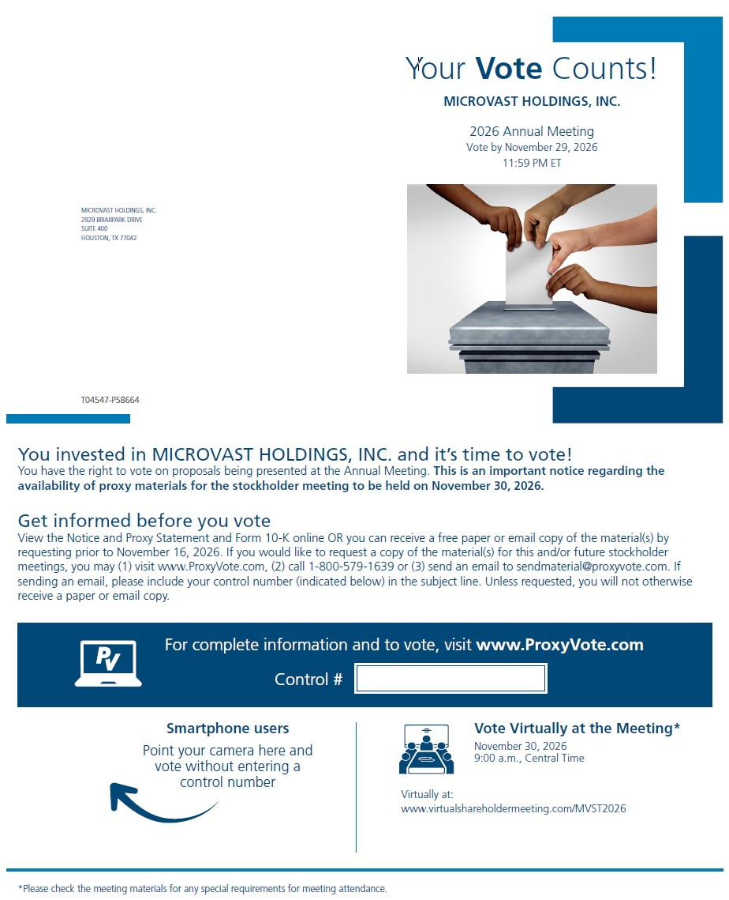
Your Vote Counts MICROVAST HOLDINGS, INC. 2026 Annual Meeting Vote by November 29, 2026 11:59 PM ET MICROVAST HOLDINGS, INC. 2929 BRIARPARK DRIVE SUITE 400 HOUSTON, TX 77042 T04547-P58664 You invested in MICROVAST HOLDINGS, INC. and it's time to vote! You have the right to vote on proposals being presented at the Annual Meeting. This is an important notice regarding the availability of proxy materials for the stockholder meeting to be held on November 30, 2026. Get informed before you vote View the Notice and Proxy Statement and Form 10-K online OR you can receive a free paper or email copy of the material(s) by requesting prior to November 16, 2026. If you would like to request a copy of the material(s) for this and/or future stockholder meetings, you may (1) visit www.ProxyVote.com, (2) call 1-800-579-1639 or (3) send an email to sendmaterial@proxyvote.com. If sending an email, please include your control number (indicated below) in the subject line. Unless requested, you will not otherwise receive a paper or email copy. For complete information and to vote, visit www.ProxyVote.com Control # Smartphone users Point your camera here and vote without entering a control number Virtually at: Vote Virtually at the Meeting* November 30, 2026 9:00 a.m., Central Time www.virtualshareholdermeeting.com/MVST2026 *Please check the meeting materials for any special requirements for meeting attendance.
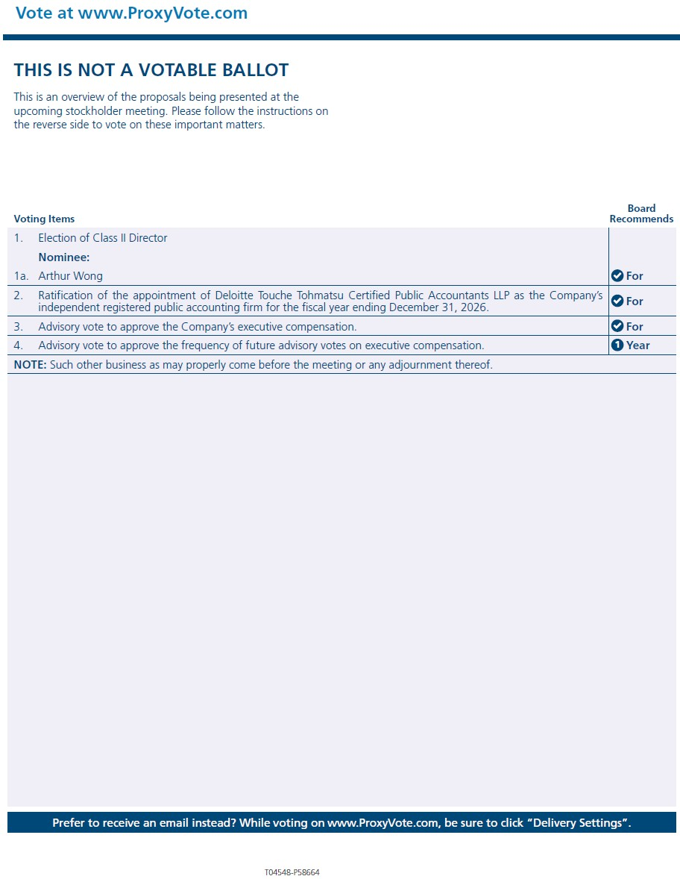
Vote at www.ProxyVote.com THIS IS NOT A VOTABLE BALLOT This is an overview of the proposals being presented at the upcoming stockholder meeting. Please follow the instructions on the reverse side to vote on these important matters. Voting Items Board Recommends -------------------------------------------------------------------------------- [PICTURE OMITTED] ------------------------------------------------------------------------------- 1. Election of Class II Director Nominee: 1a. Arthur Wong For ----------------------------------------------------------------------- 2. Ratification of the appointment of Deloitte Touche Tohmatsu Certified Public Accountants LLP as the Company's [PICTURE independent registered public accounting firm for the fiscal year ending December 31, 2026. OMITTED] For ----------------------------------------------------------------------- 3. Advisory vote to approve the Company's executive compensation. For ------------------------------------------------------------------------- 4. Advisory vote to approve the frequency of future advisory votes on executive compensation. 1 Year ------------------------------------------------------------------------- NOTE: Such other business as may properly come before the meeting or any adjournment thereof. ------------------------------------------------------------------------- Prefer to receive an email instead? While voting on www.ProxyVote.com, be sure to click "Delivery Settings". T04548-P58664

